People and fairness support
18 March 2027 | P3
Pink paper | Point, tell, write or ask an adult to write.

Ready starter
Look at the two drawings. Match the cue.
A bus seat / a vote.
You can ask an adult to read each name.

Words
fair, rule, seat, vote, group, help

Start
I match __ with __.

Model
I match Rosa Parks with the bus seat.
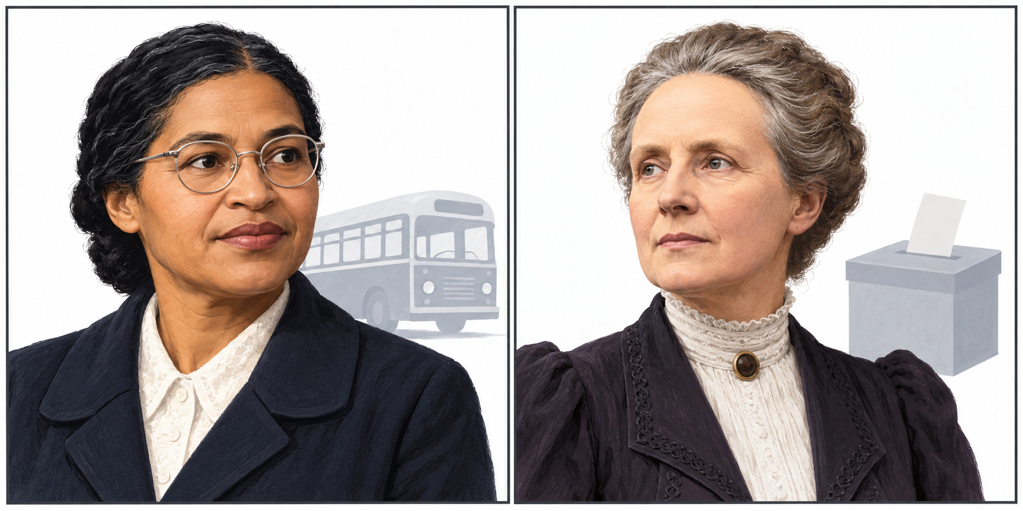
New drawings. Left: Rosa Parks. Right: Millicent Fawcett.
Show your choice in a quiet way. You can point or ask an adult to write. You can rest or ask for help.

People and fairness support continued
18 March 2027 | P3
Pink paper | Point, tell, write or ask an adult to write.

Talk frames
__ stood up for fairness.
She asked for __.

Words
fair, rule, seat, vote, group, help
fair bus rules / women can vote / many people helped
Stood up for means acted for fair rules.

Model
Rosa Parks stood up for fair bus rules.
Many people worked for change.

My book line
Pick one person. Give one line. Point, tell or ask an adult to write. Keep the name, action and fair aim in view.

Keep or change
An adult reads your words back. Keep or change them. Show one change after one next step.
You can pass or rest. Plan in any language. Use your usual aid.

