People and fairness words
18 March 2027 | P3
White paper | Point, tell, write or ask an adult to write.
Word | Meaning in this lesson
fair | People are treated with the same worth.
rule | A set way people are told to act.
seat | A place to sit.
vote | A choice about who will make rules.
group | People who work together.
help | Make it easier to do a task.
stood up for | Spoke or acted to ask for fair rules.

Start and model
__ stood up for fairness.
She asked for __.
Model: Rosa Parks stood up for fair bus rules.
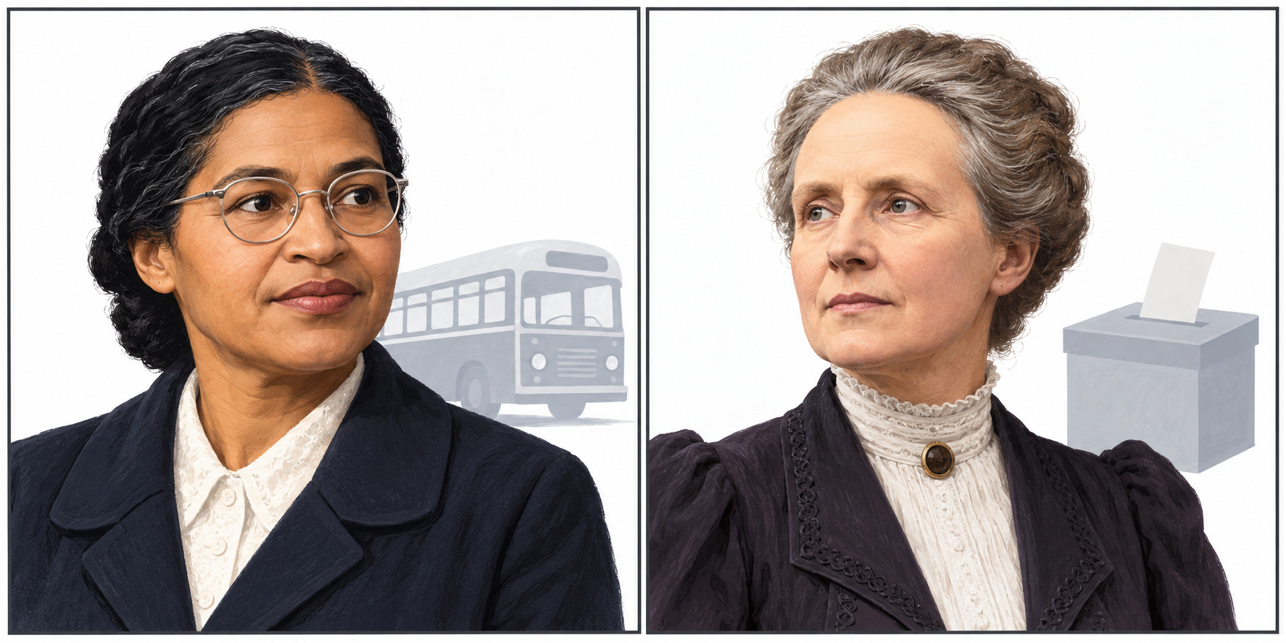
New drawings. Left: Rosa Parks. Right: Millicent Fawcett.
Point, tell or ask an adult to read. Use the words with the cards and your book line.

