Job picture cards
Pink Supported sheet
Explore jobs and what people do (careers).

Gardener
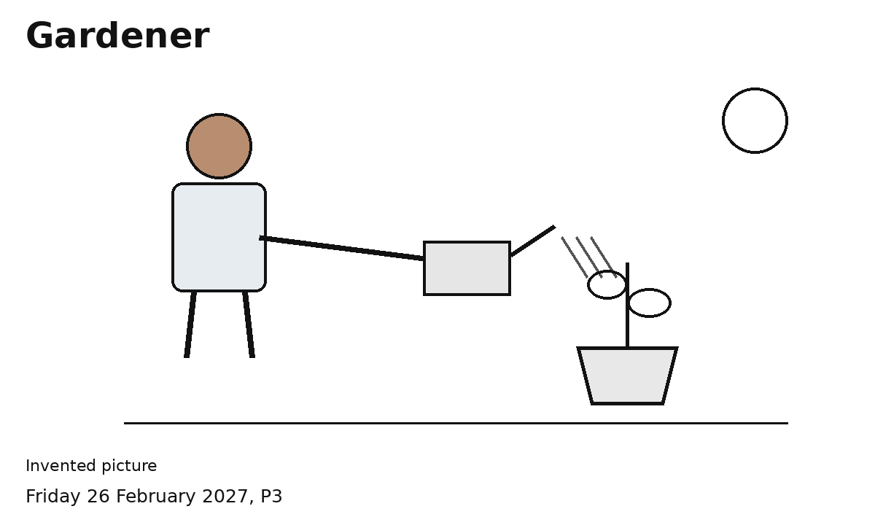
This worker waters a plant.
Invented worker example
Show or say what this worker does.
This is one way the job can look.

Cleaner
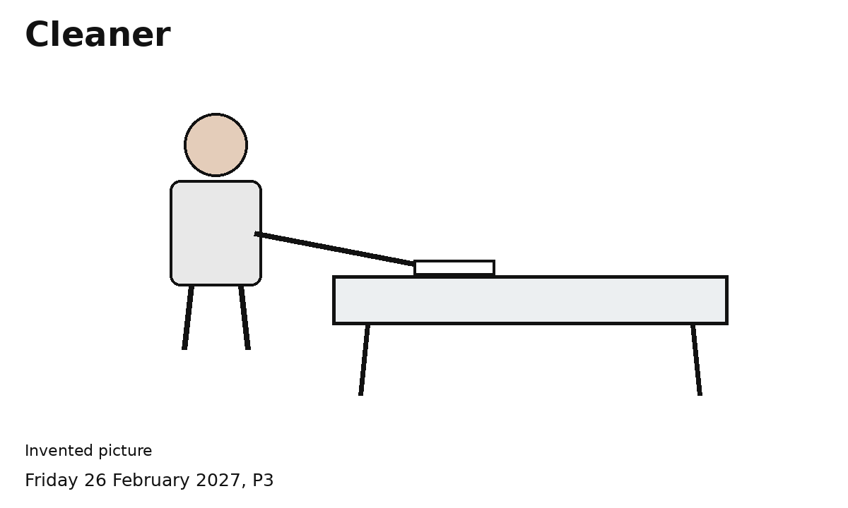
This worker wipes a table.
Invented worker example
Show or say what this worker does.
This is one way the job can look.

Shop assistant
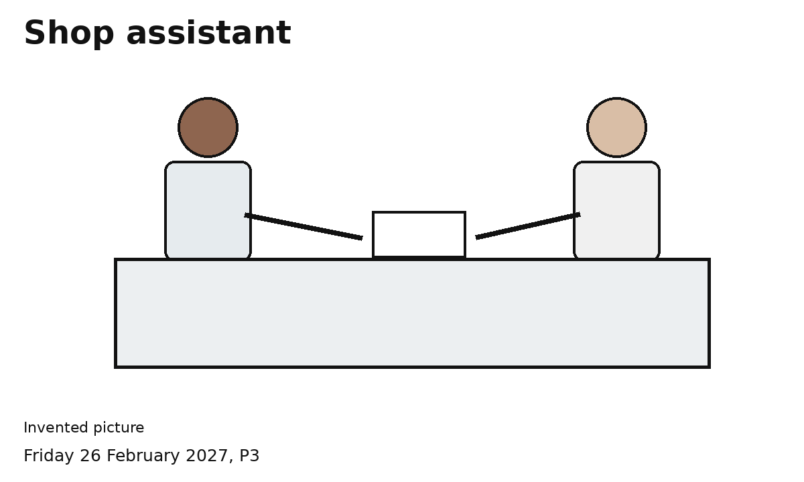
This worker helps at a counter.
Invented worker example
Show or say what this worker does.
This is one way the job can look.

Care worker
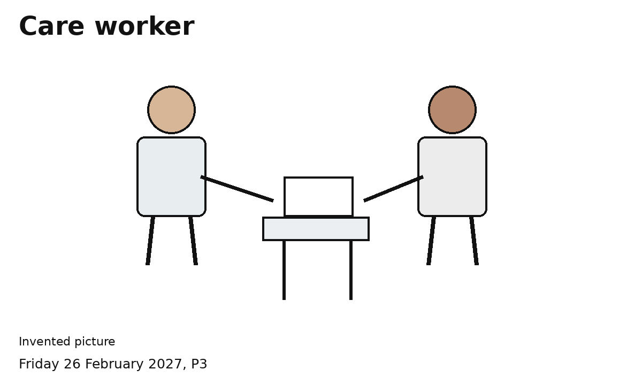
This worker helps a person.
Invented worker example
Show or say what this worker does.
This is one way the job can look.

