Dress a figure for a job task
White Standard sheet
Match tools/clothing to a job.
My job task ______________________
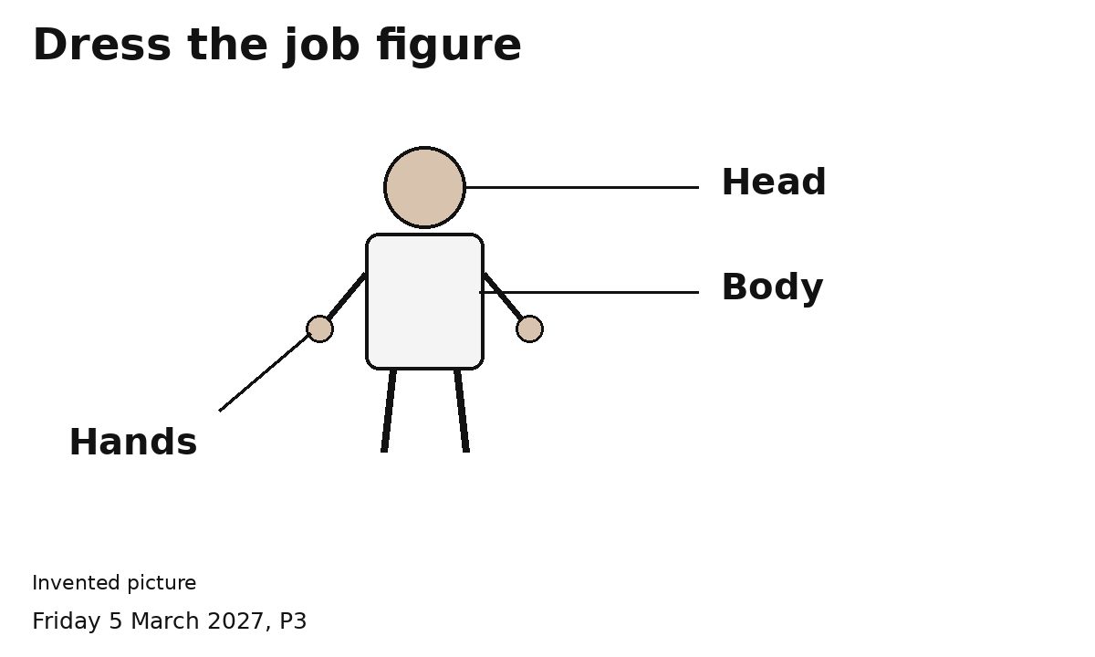
1 Choose an item for this task.
2 Point or place it by the right body part.
3 Ask an adult to check your choice.
I can use pictures.
I can ask to try a clean item. The adult checks it first.
It should fit and feel right. I can stop.

