Item matching cards
Pink Supported sheet
Match tools/clothing to a job.

Protective gloves
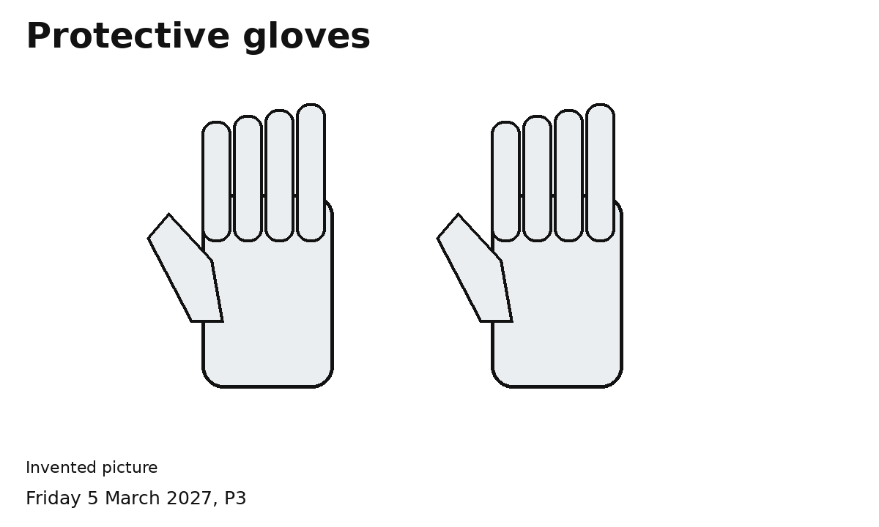
Gloves can help protect hands.
A protective item
Which task could need this item?
Ask an adult to check the choice.

Safety helmet
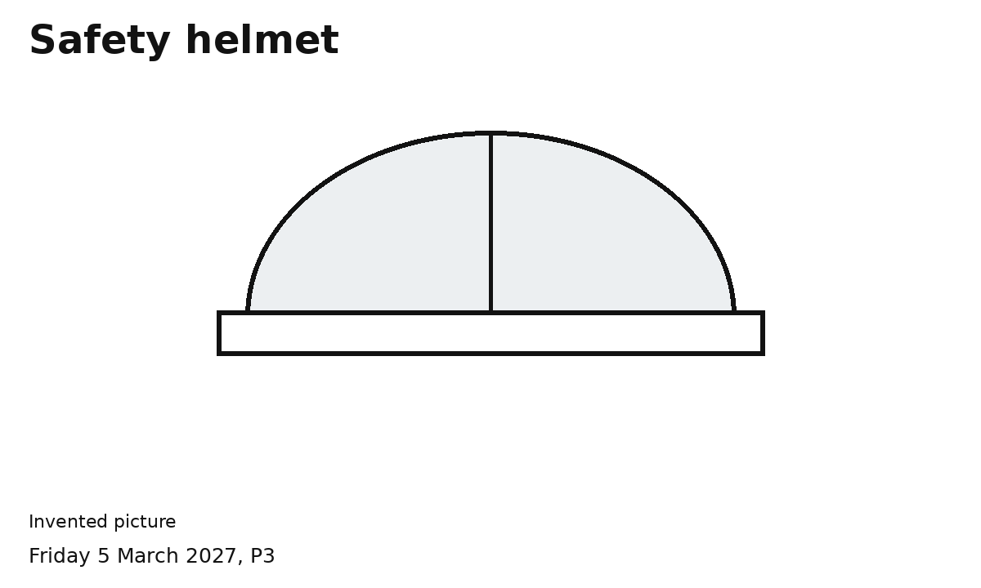
A helmet can help protect the head.
A protective item
Which task could need this item?
Ask an adult to check the choice.

High visibility vest
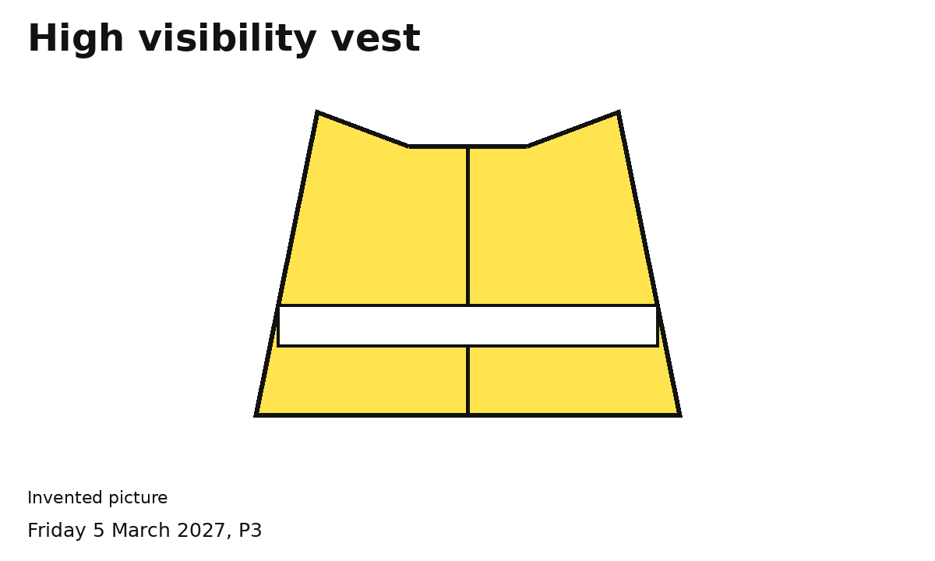
A vest helps the worker be seen.
A protective item
Which task could need this item?
Ask an adult to check the choice.

Tools
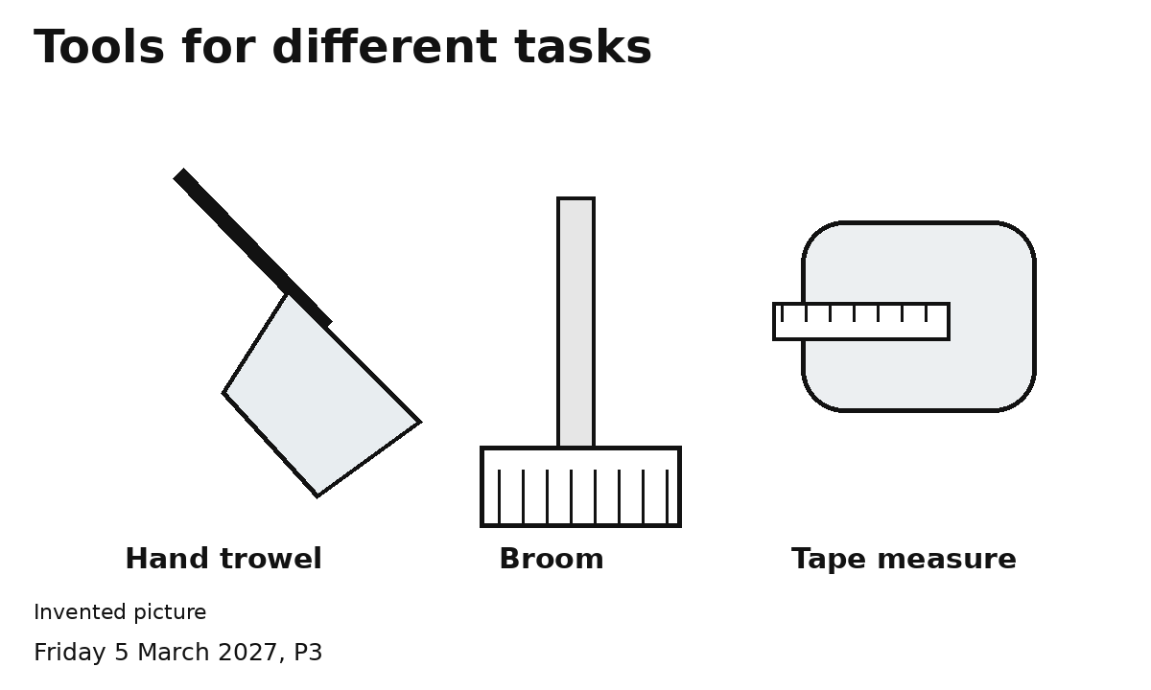
Hand trowel moves a little soil.
Broom sweeps a clear area.
Tape measure measures length.
A tool helps us do a task.
Match an item to a task card.

