Match items for a work task
White Standard sheet
Match tools/clothing to a job.
These job tasks are made up.
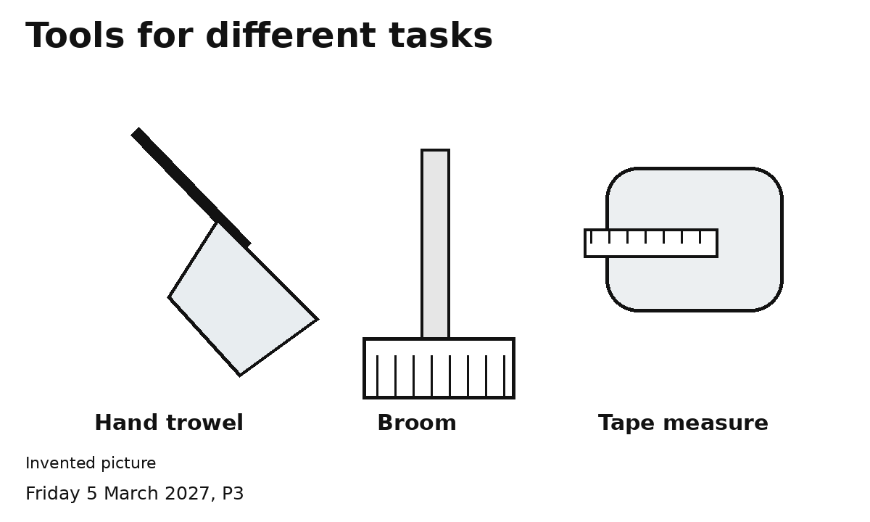
1 Pick one job task card.
2 Match a tool to the task.
3 Match a protective item. Show why.
4 Dress the figure or ask to try an item.
Ask an adult to check first.
You can point, speak or ask an adult to write.

