Set up a classroom display
Pink Supported sheet
Carry out a simple work-related task.
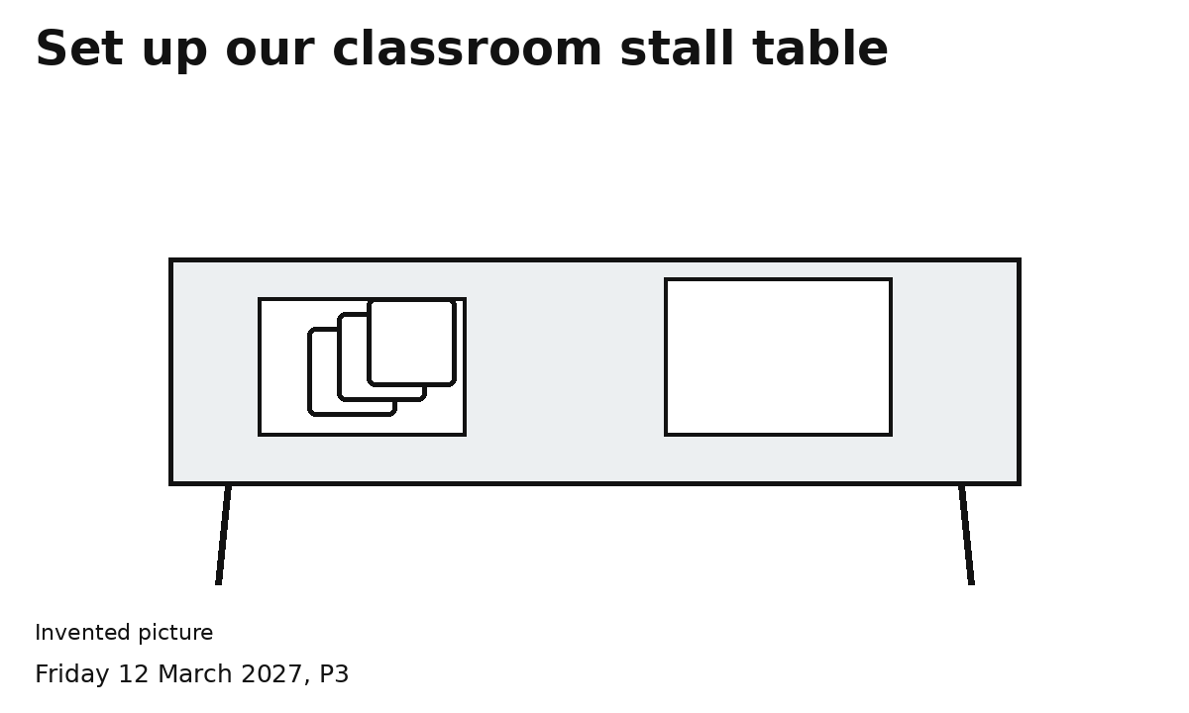
Steps 1 and 2 Clear the space. Lay the mat.
Steps 3 and 4 Set out three cards and the sign. Check.
Use the space agreed with the adult.
Ask for help with anything hard to reach.

