Check the quality of our work
Pink Supported sheet
Carry out a simple work-related task.
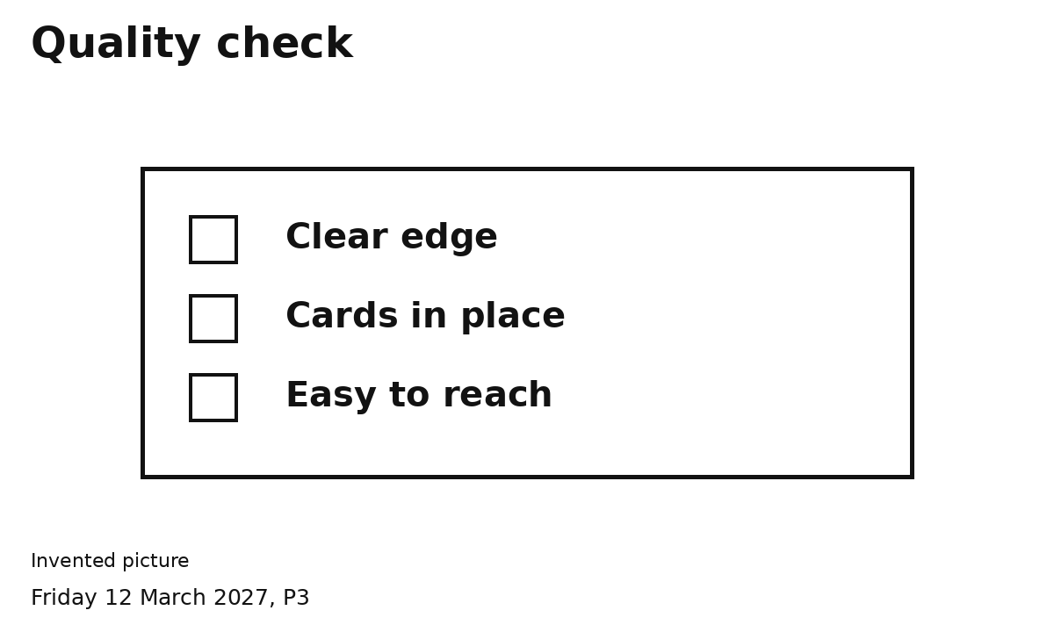
The table edge and way past are clear.
The cards and sign stay in place.
We can reach the items we need.
Point or show an adult what needs help.

My self check
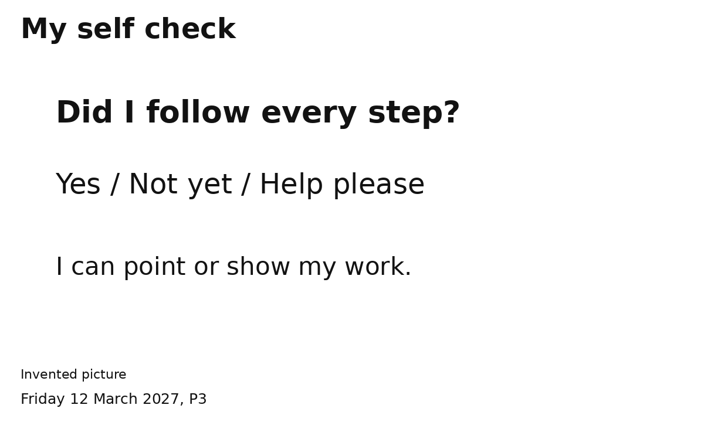
Did I follow every step?
[ ] Yes [ ] Not yet [ ] Help please
I can show the work I did or directed.
I can ask for help with the next step.

