Prepare our classroom stall
Pink Supported sheet
Practise asking and answering at 'work'.
Take part in class enterprise prep.
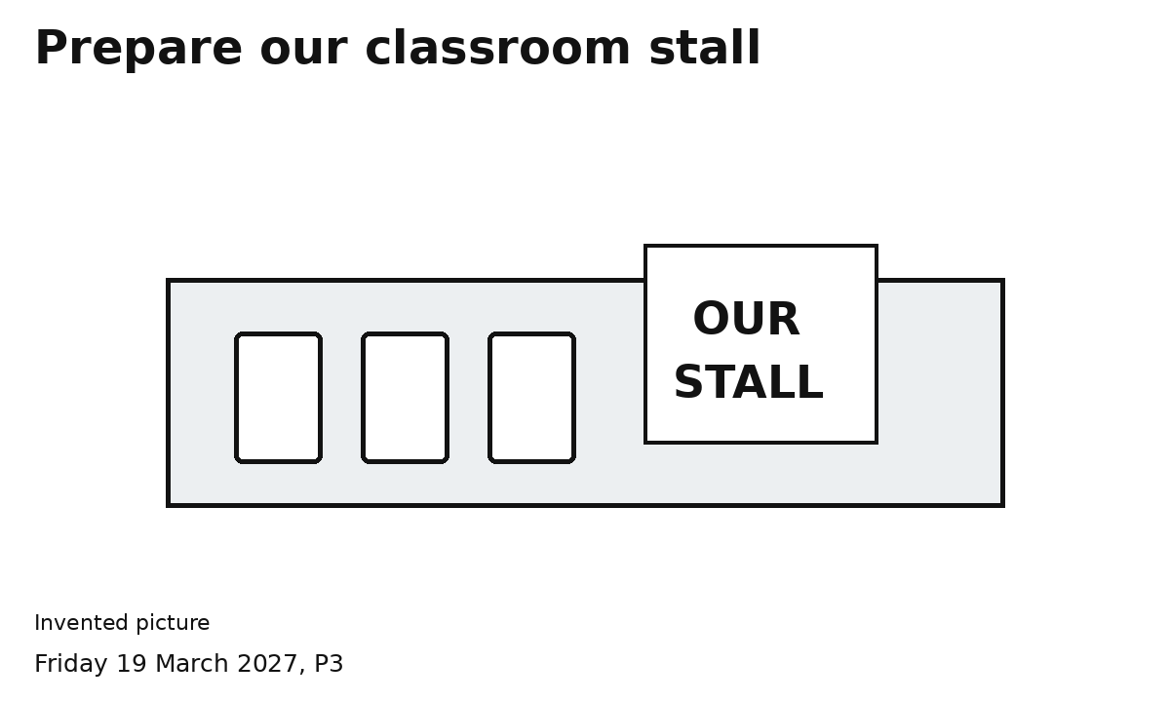

1 Choose and arrange
Three light items and a sign.

2 Check together
Items stay put. The edge and way past are clear.
Both people make a choice and help.
Use the table space agreed with an adult.

