Talk and prepare together
White Standard sheet
Practise asking and answering at 'work'.
1 Greet. Ask for help. Answer your partner.
2 Choose where the paper items will go.
3 Arrange three items and the sign together.
4 Check together. Say the job is done.
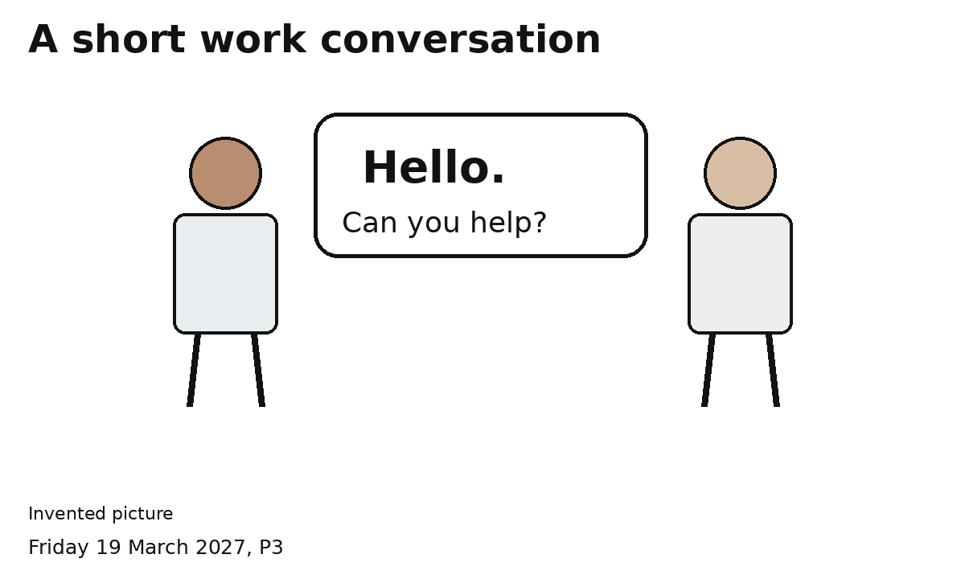
Both of us ask and answer.
Speak, point or gesture. An adult can help.

