Atlas pupil resources
Friday 26 February 2027 | P2 | 40 minutes | Year A
Humanities | GROW | Spring 2 Week 1 | HUM-GROW-S2-W01
Learning outcome: Use atlases and maps to locate climate zones and hazards.
You may point, write, type, speak in private or direct a scribe. You may pass. Reading aloud is your choice.
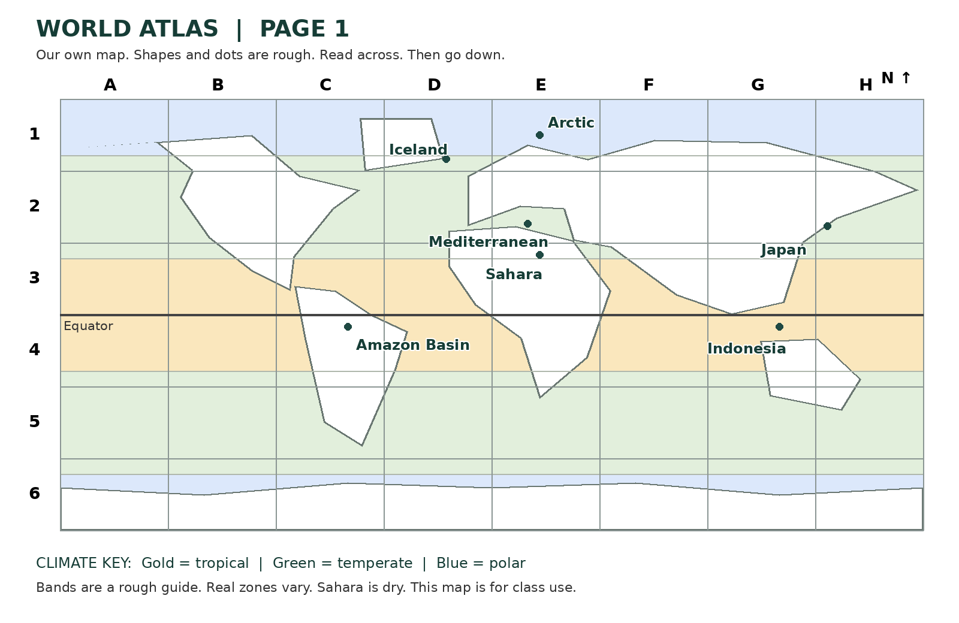

Index for page 1
Place | Grid box | Map clue
Amazon Basin | C4 | Tropical
Mediterranean | E2 | Temperate
Arctic | E1 | Polar
Japan | H2 | Earthquake
Indonesia | G4 | Volcano
Sahara | E3 | Dry
Iceland | D1 | Earthquake and volcano
The first five places are the core task. Sahara and Iceland are extra. Letter across, number down. A box is an area, not an exact point.

My map labels
Friday 26 February 2027 | P2 | 40 minutes | Year A
Humanities | GROW | Spring 2 Week 1 | HUM-GROW-S2-W01
Cut these out or ask for ready-cut labels. Place them on your own blank map in your book.
Place | Label or mark
Amazon Basin | Tropical
Mediterranean | Temperate
Arctic | Polar
Japan | Circle = earthquake
Indonesia | Triangle = volcano
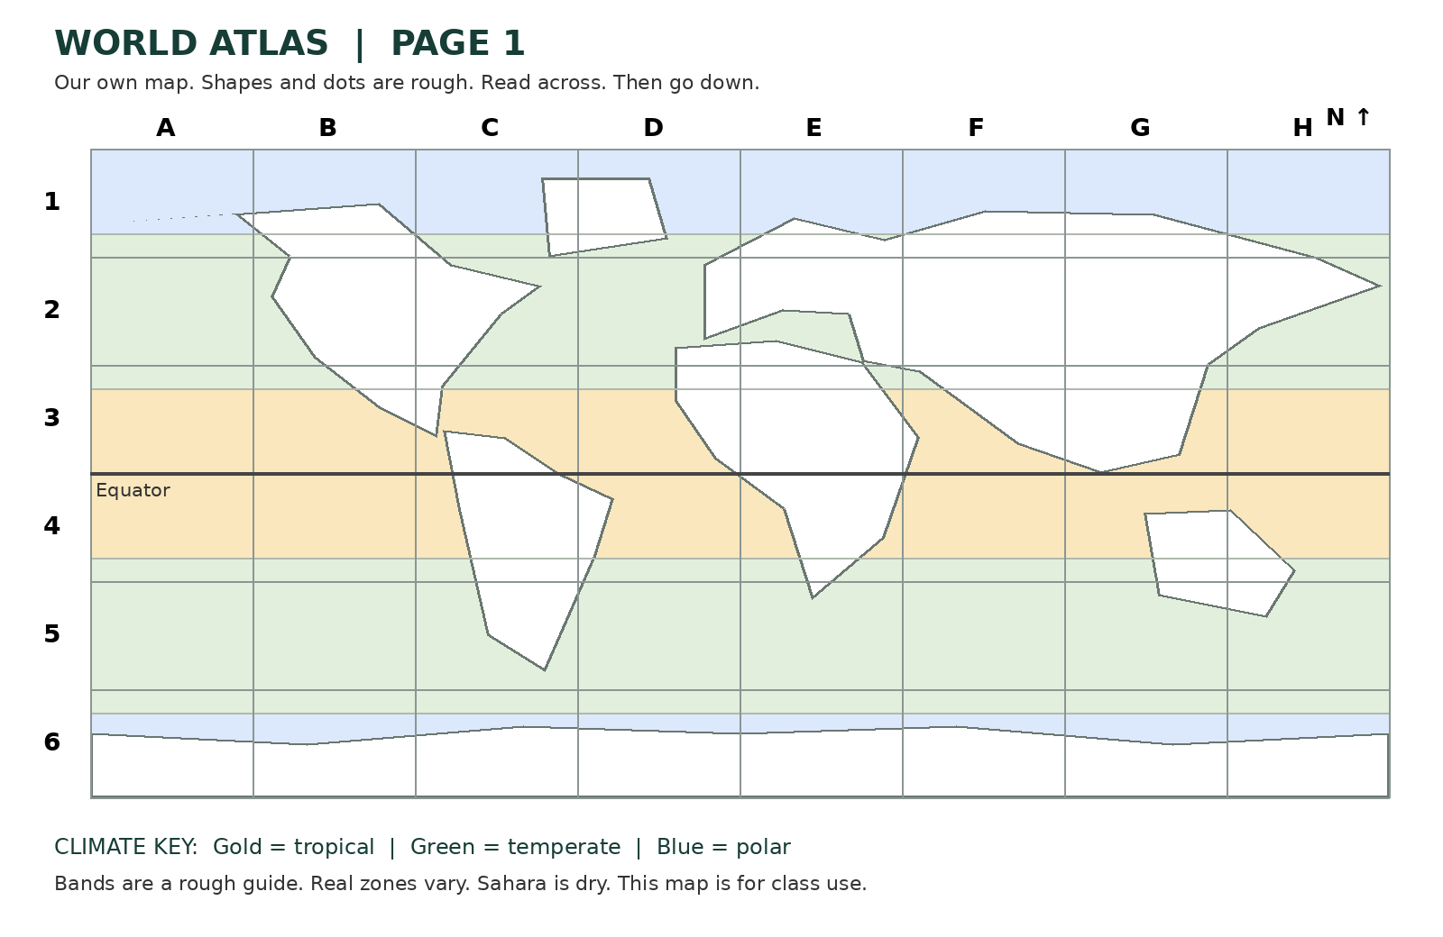
In your book, use a blank map. Label the Amazon Basin, the Mediterranean and the Arctic with their climate zones. Plot a circle for earthquake hazard in Japan and a triangle for volcano hazard in Indonesia. Add a key. Use the index and grid to check each place.

My check
I used the index and grid. I placed three climate labels and two hazard marks. I added a key. I checked one place with my partner.
Use the agreed quiet signal for a pause. Stay with the adult in the usual place. Rejoin with one map check. A neutral shape task is ready.

