Blank map for book work
Friday 26 February 2027 | P2 | 40 minutes | Year A
Humanities | GROW | Spring 2 Week 1 | HUM-GROW-S2-W01
Glue this map in your book or draw your own grid. Use the atlas index and the place cards. Add the three climate labels, two hazard marks and a key.
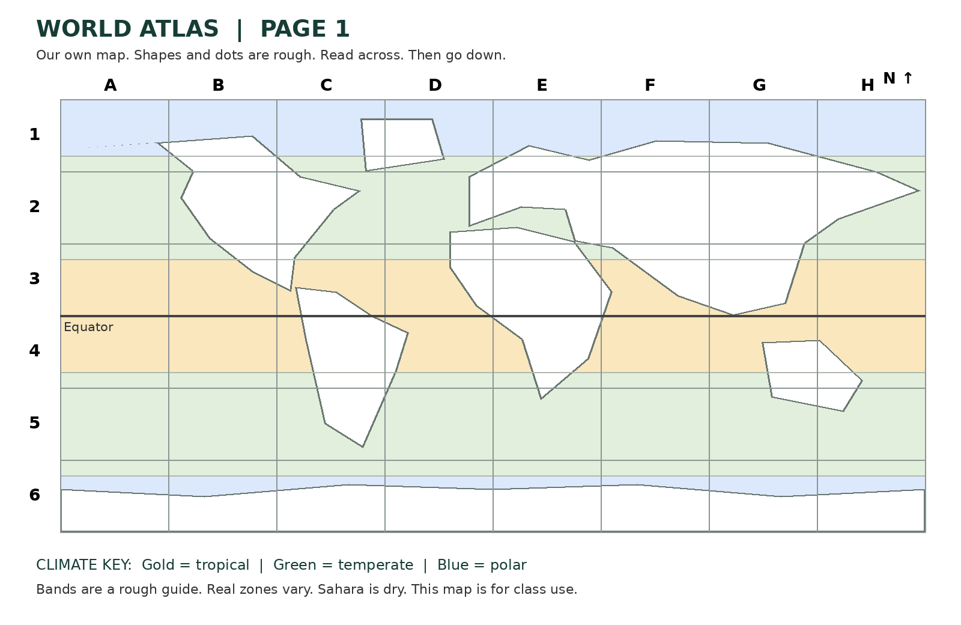

Key
Circle = earthquake hazard. Triangle = volcano hazard. Write each climate label next to its place.
I found ____ in box ____. The key shows ____. This place has ____.
Extra: add Sahara dry climate and both hazard marks for Iceland.

