Pupil facts and card codes
Friday 5 March 2027 | P2 | 40 minutes | Year A
Humanities | GROW | Spring 2 Week 2 | HUM-GROW-S2-W02
Learning outcome: Describe how a natural hazard affects people and places.
You may point, write, type, speak in private or direct a scribe. You may pass. Reading aloud is your choice.
This is one real case. We use calm words and diagrams. No one needs to share a personal story. We do not act out the hazard.
Effect Finder reads the card. Reason Checker asks which fact supports the choice. Swap after each card. If there is a third pupil, they check the time span, then rotate.
Card | Newly written fact
E1 Homes and shelter | Some homes were damaged. People used shared shelters in the first days.
E2 Roads and travel | Some roads and rail lines were damaged. This made travel hard at first.
E3 Water and power | At first, power and water supplies stopped in some areas.
E4 Rebuilding | Homes and transport routes were rebuilt over months and years.
E5 Homes for a time | Some people used temporary homes. Work to build new homes went on for years.
E6 Sea walls | Some places on the coast rebuilt sea walls over years.
Use these codes or ready-cut labels in your book. The cards are not quotations.

A guide for my book
Friday 5 March 2027 | P2 | 40 minutes | Year A
Humanities | GROW | Spring 2 Week 2 | HUM-GROW-S2-W02
In your book, make a record for cards E1 to E4. For each card, choose people, places or both. Then choose short term, long term or both. Use the card to give one reason. Finish with two linked sentences about the Japan case.
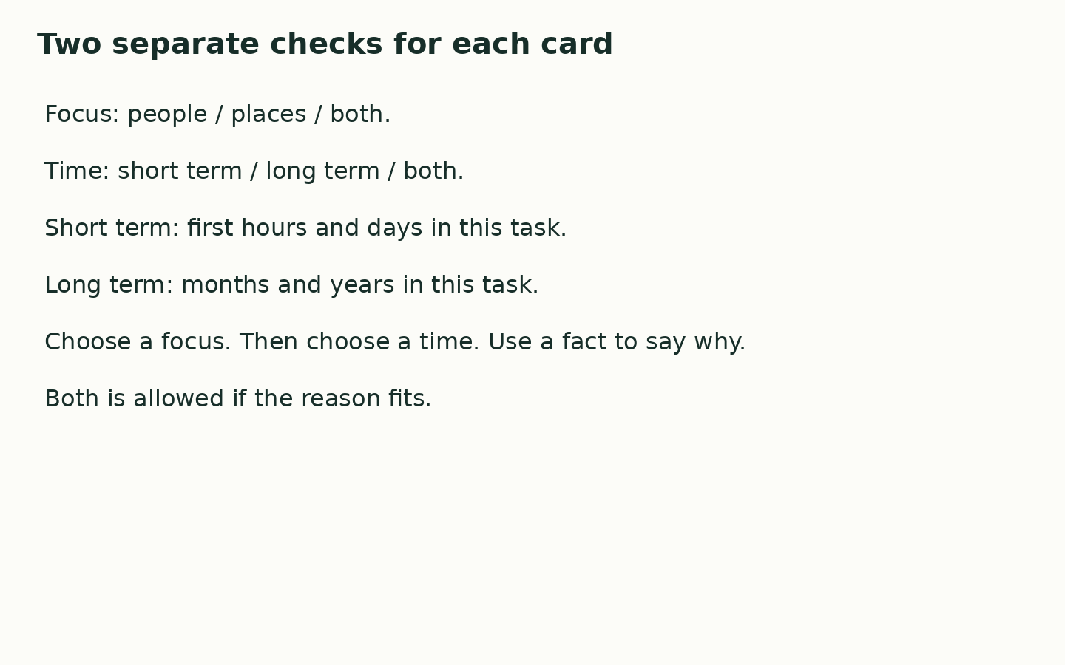
One effect was ____. It affected ____ because ____. This was ____ term because ____.

My check
I used the facts. I made my own choices. I gave a reason. I can show the help I used.
Use the agreed quiet signal for a pause. Stay with the adult in the usual place. Rejoin with one card check. A neutral shape task is ready.

