Case Story
Friday 5 March 2027 | P2 | 40 minutes | Year A
Humanities | GROW | Spring 2 Week 2 | HUM-GROW-S2-W02
On 11 March 2011, a strong earthquake happened under the sea near Japan. Part of the sea floor moved. This helped cause a tsunami, a set of large waves. The waves reached the coast of the Tohoku region. This lesson looks at some effects and the work to recover. People and places were not all affected in the same way.
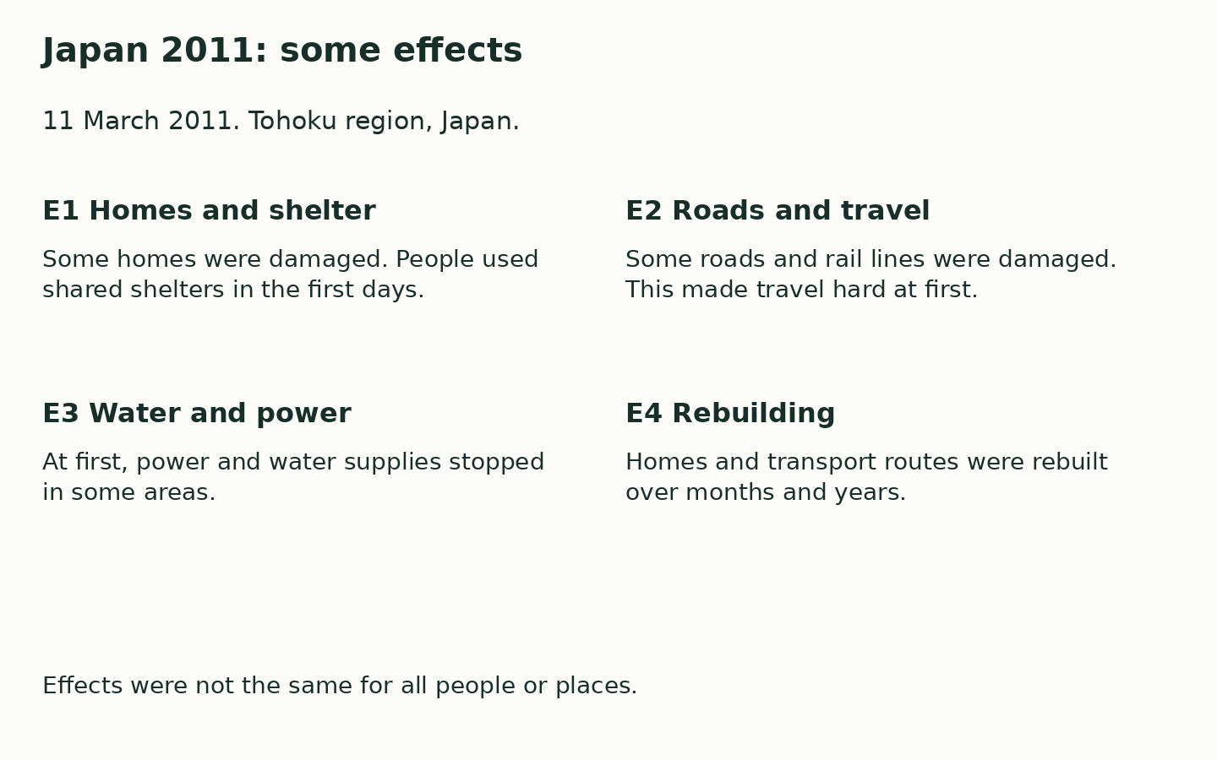
This is one real case. We use calm words and diagrams. No one needs to share a personal story. We do not act out the hazard.
The earthquake and tsunami happened on 11 March 2011. The effects and recovery lasted for different lengths of time. There is no casualty or graphic detail in this pack.

