Sort Mat
Friday 5 March 2027 | P2 | 40 minutes | Year A
Humanities | GROW | Spring 2 Week 2 | HUM-GROW-S2-W02
Use this as a guide. Make your record in your book. You do not need to write on this page.
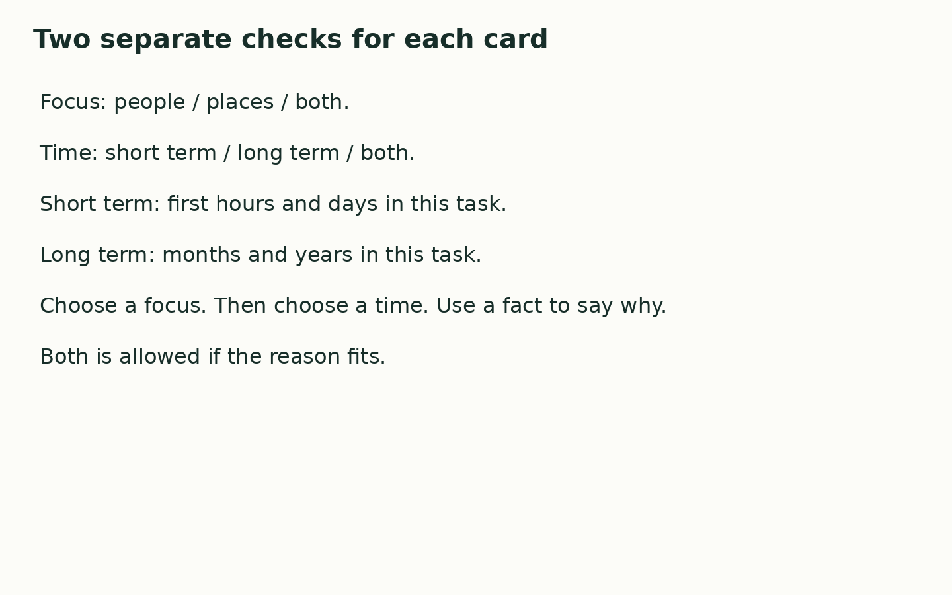
In your book, make a record for cards E1 to E4. For each card, choose people, places or both. Then choose short term, long term or both. Use the card to give one reason. Finish with two linked sentences about the Japan case.
One effect was ____. It affected ____ because ____. This was ____ term because ____.

