Pupil facts and card codes
Friday 12 March 2027 | P2 | 40 minutes | Year A
Humanities | GROW | Spring 2 Week 3 | HUM-GROW-S2-W03
Learning outcome: Investigate causes and effects of climate change.
You may point, write, type, speak in private or direct a scribe. You may pass. Reading aloud is your choice.
We use UK data and calm examples. No one needs to share a personal worry. The graph is about the whole UK. It does not measure the trend in a named local place.
Cause Finder reads a card. Evidence Checker asks where it fits and why. Swap after each card. If there is a third pupil, they check the graph label, then rotate.
Card | Newly written fact
C1 Burning fuels | Burning coal, oil and gas adds carbon dioxide to the air.
C2 Removing forests | Fewer trees can mean less carbon dioxide is taken from the air. Clearing forests can also release stored carbon.
C3 Farming and gas | Some farming adds methane to the air. Methane is a greenhouse gas.
C4 Warmer conditions | More trapped heat raises Earth's long-term mean temperature.
C5 Rising seas | Melting ice on land adds water to the sea. Warm sea water also expands. Sea level can rise.
C6 Heat and heavy rain | Warmer conditions can bring more hot spells. Warmer air can hold more water, which can make heavy rain more intense.
Use these codes or ready-cut labels in your book. The cards are not quotations.

A guide for my book
Friday 12 March 2027 | P2 | 40 minutes | Year A
Humanities | GROW | Spring 2 Week 3 | HUM-GROW-S2-W03
In your book, sort C1 to C6 into causes and effects. Build one cause-to-effect chain with at least three steps. Read the graph to find the highest and lowest selected year. Finish one sentence about what this could mean for a general UK region.
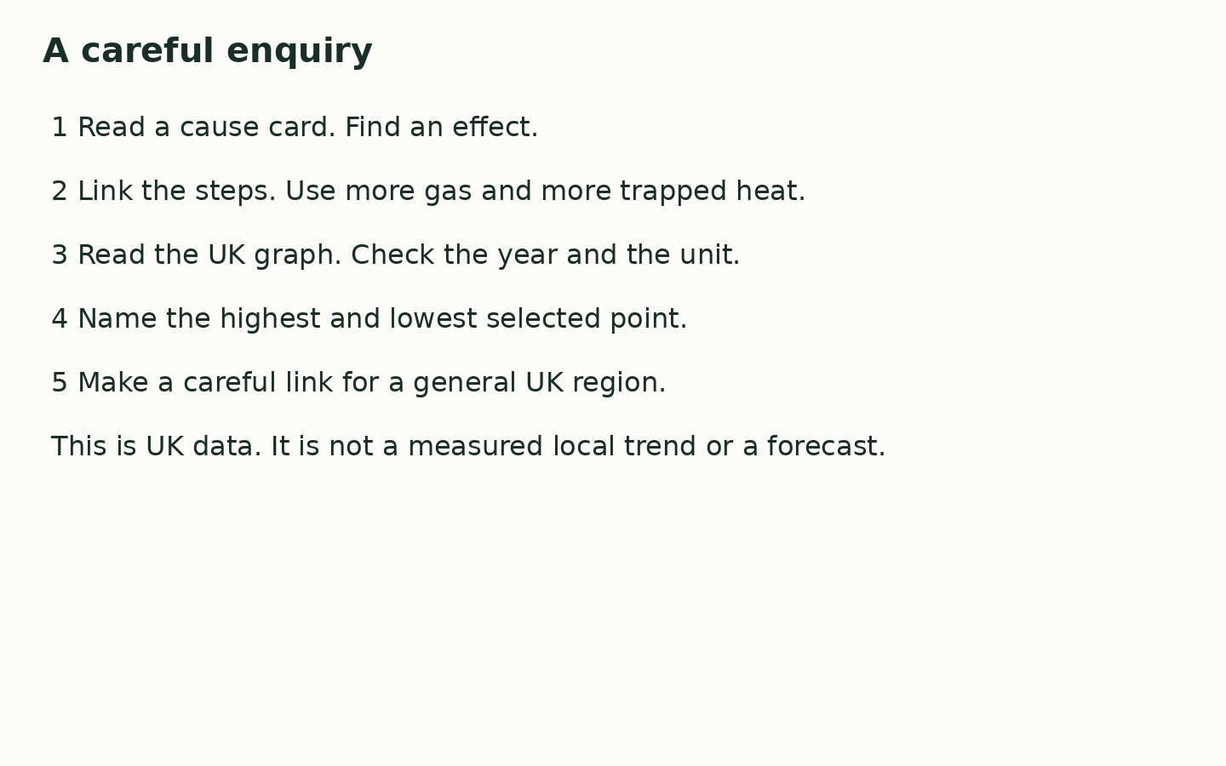
____ adds gas to the air. More heat is trapped, so ____. For our UK region, this can mean ____.

My check
I used the facts. I made my own choices. I gave a reason. I can show the help I used.
Use the agreed quiet signal for a pause. Stay with the adult in the usual place. Rejoin with one card check. A neutral shape task is ready.

