Enquiry Mat
Friday 12 March 2027 | P2 | 40 minutes | Year A
Humanities | GROW | Spring 2 Week 3 | HUM-GROW-S2-W03
Use this as a guide. Make your record in your book. You do not need to write on this page.
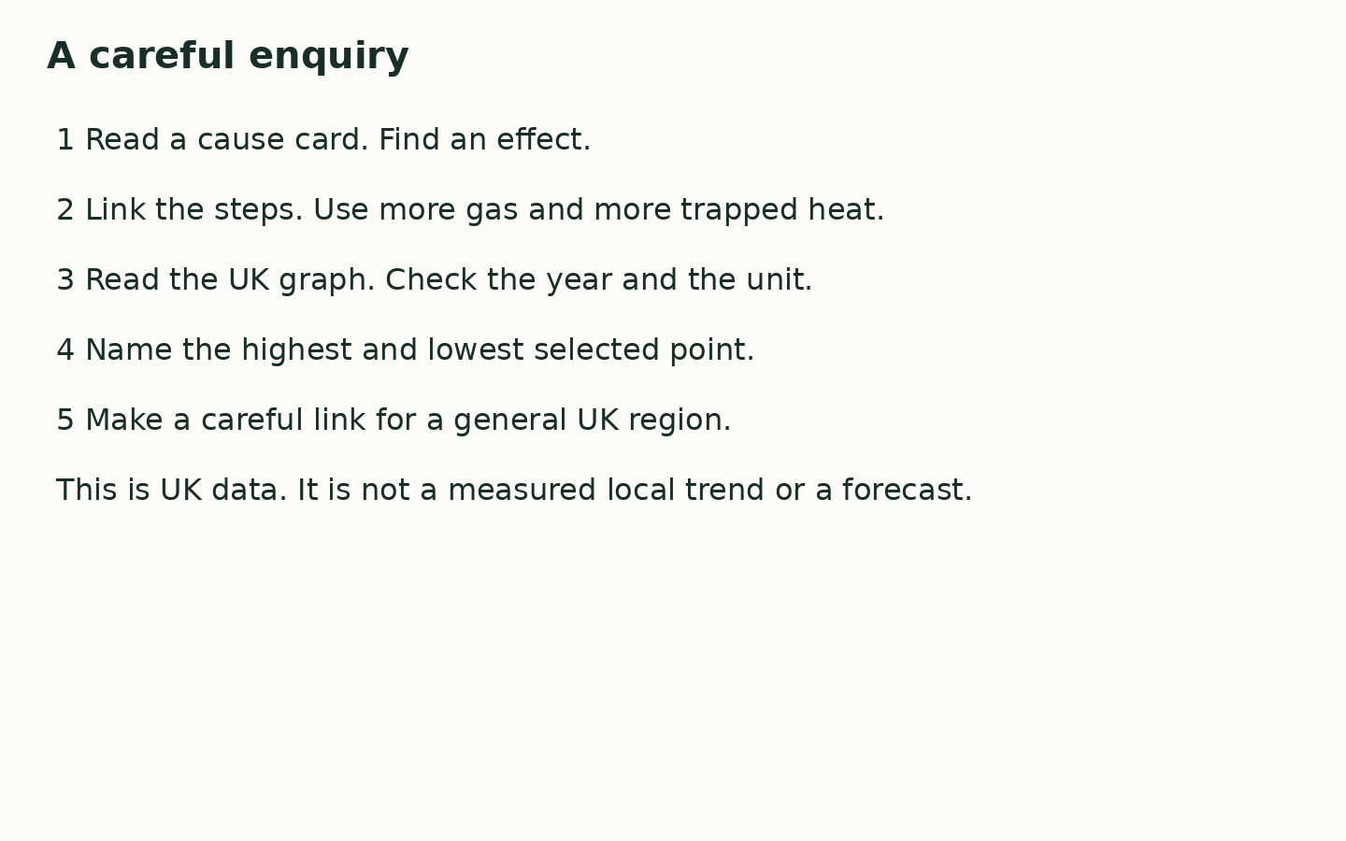
In your book, sort C1 to C6 into causes and effects. Build one cause-to-effect chain with at least three steps. Read the graph to find the highest and lowest selected year. Finish one sentence about what this could mean for a general UK region.
____ adds gas to the air. More heat is trapped, so ____. For our UK region, this can mean ____.

