Evidence Page
Friday 12 March 2027 | P2 | 40 minutes | Year A
Humanities | GROW | Spring 2 Week 3 | HUM-GROW-S2-W03
Climate is the usual weather over many years. Human actions add gases that trap more heat. Burning coal, oil and gas adds carbon dioxide to the air. This strengthens the greenhouse effect and warms Earth. This does not mean each year or each place gets warmer in a straight line. We can use climate evidence to check changes over time.
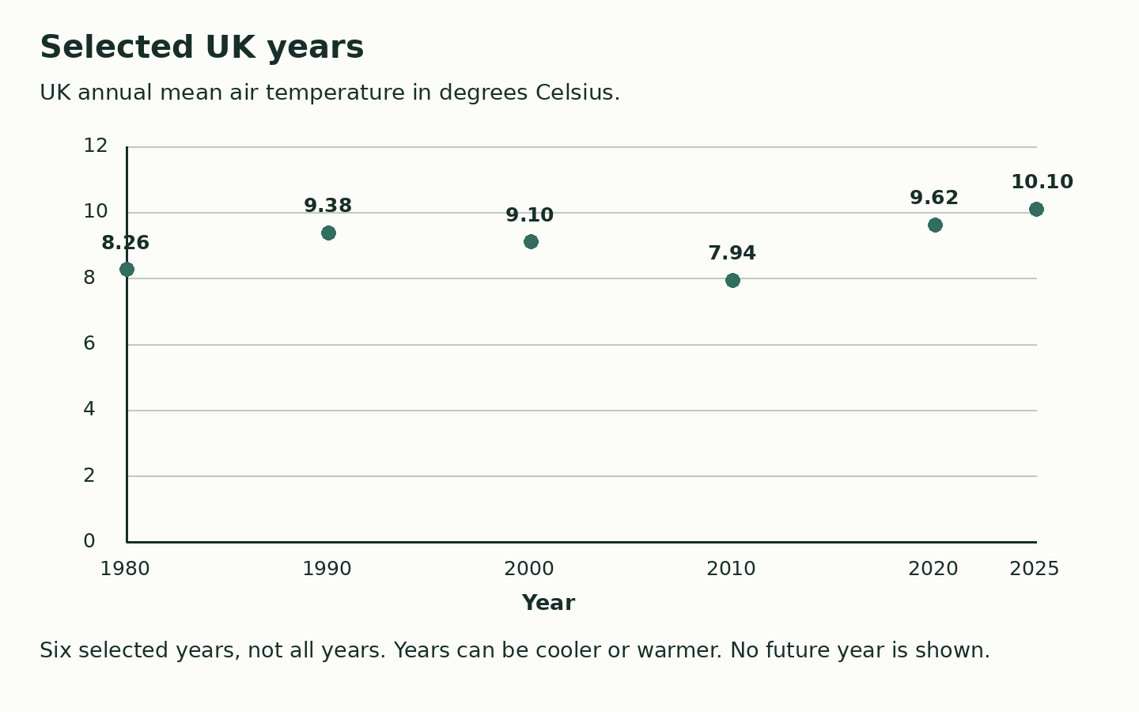
Selected year | Exact UK annual mean C
1980 | 8.26
1990 | 9.38
2000 | 9.10
2010 | 7.94
2020 | 9.62
2025 | 10.10
These are absolute mean temperatures, not change from a baseline. Dots use the exact values. The graph alone does not prove a cause. No data beyond 2025 are shown.

