Atlas and data
Friday 19 March 2027 | P2 | 40 minutes | Year A
Humanities | GROW | Spring 2 Week 4 | HUM-GROW-S2-W04
Page 1 index: UK D2 | Japan H2 | Iceland D1. Read the letter across, then the number down. A dot marks a place; it is not a country border.
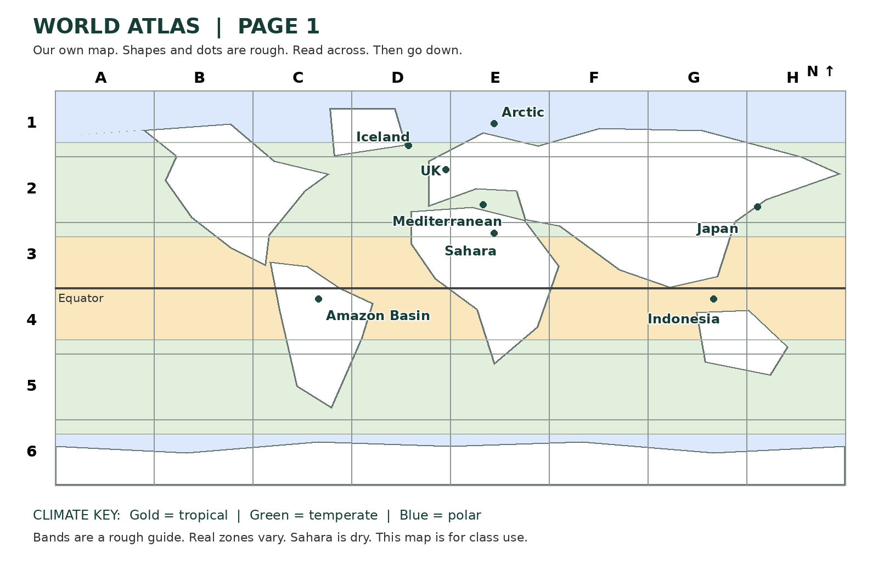
Selected year | Exact UK annual mean C
1980 | 8.26
1990 | 9.38
2000 | 9.10
2010 | 7.94
2020 | 9.62
2025 | 10.10
These are six selected complete UK years. Values are absolute means, not a change from a baseline. The map and UK data do not measure local trends or predict a future day.

