Report Guide
Friday 19 March 2027 | P2 | 40 minutes | Year A
Humanities | GROW | Spring 2 Week 4 | HUM-GROW-S2-W04
Use this as a guide. Make your record in your book. You do not need to write on this page.
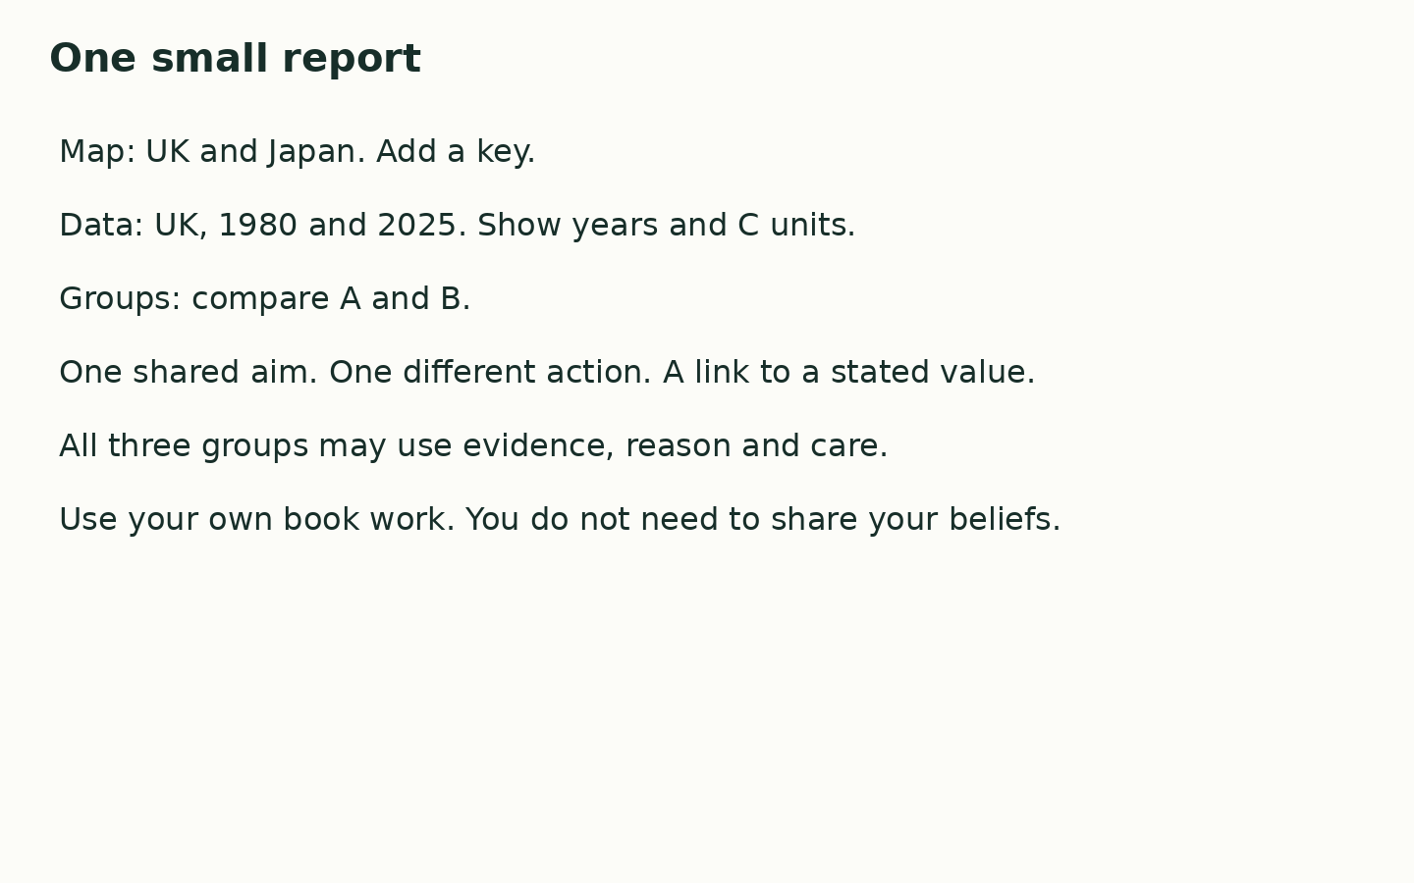
In your book, make one small report. Keep your own map check: locate UK and Japan, then add a key. Present the UK values for 1980 and 2025 with years and C units. Give one careful data statement. Compare Groups A and B: one shared aim, one different action and a link to a stated value.
My map shows ____. The UK mean was ____ C in ____ and ____ C in ____. Both groups ____. Group A ____, while Group B ____. One reason is ____.

