Designing for a useful purpose
Design and Technology LAUNCH Spring 2 Week 1 Thursday 25 February 2027 P1 Year A
Weekly outcome verbatim: CONSTRUCTION: design a product to solve a problem.
I can plan a useful card stand, show three ideas and explain my choice.

Today I can
[ ] I can turn a small problem into clear design checks.
[ ] I can sketch three different ideas and add useful labels.
[ ] I can choose one idea and give reasons linked to the brief.

The problem
Invented client Sam needs one 80 mm by 60 mm card upright and readable. Allow a 160 mm by 120 mm table area for the whole stand including its channel. Plan for a 30-second level-table check with hands away, safe edges and removal by hand.

The design record
Brief. Three checkable points. Three different quick ideas. Two useful labels per idea. One chosen idea with two reasons. One real review change or question. Actual date, support and book page.

A useful label
Name a part and its job. For example, wide base may help the stand stay upright. This is an adult example. Keep your own ideas and reasons.

Resilience and change
A question or weak idea is useful information. Improve a feature or explanation and keep why it changed. No test is claimed before the product exists.
In your book. Plan in any language. Point, speak, sign or confirm exact scribed words.

A stand to solve a small problem
Design and Technology LAUNCH Spring 2 Week 1 Thursday 25 February 2027 P1 Year A
Invented client Sam uses one paper prompt card at a desk. The card is 80 mm wide and 60 mm high. It falls flat, so Sam cannot read it while working. Design a small tabletop stand to keep the card upright and easy to read. It must hold the card for 30 seconds with hands away on a level table. Keep the message clear and let the card be removed by hand. The whole stand, including its channel, must fit a 160 mm wide by 120 mm deep table area. It must have safe edges and no loose sharp parts.

The useful job
Sam is invented. Keep one paper card upright and readable while Sam works. No real device, heavy load or food is needed. Do not bring personal possessions.

Our design checks
Hold the actual card for 30 seconds with hands away on a level table. Keep the message clear. Let the card be removed by hand. Plan safe edges and no loose sharp parts. Allow a 160 mm by 120 mm table area for the whole stand including its channel. The default triangular body base is 120 mm by 80 mm.

The first three lessons
Today: write checks, create three annotated ideas, choose one with reasons. Week 2: choose materials, plan sizes and make a card trial. Week 3: make, adjust and improve the approved design. These steps do not claim any later result.

Size before style
The prompt card is 80 mm wide and 60 mm high. Label the card size. The default triangular body has a 120 mm wide by 80 mm deep base. Its U-shaped channel projects beyond the front; allow a 160 mm by 120 mm table area for the whole stand. Label a sensible proposed stand size in mm; the adult reviews any changed design before Week 2. A sketch is not a cutting template. Written measurements and the actual approved plan govern later cutting.

Your own words
The problem is ___. The card needs ___. One design check I can explain is ___.

Write clear design checks
Design and Technology LAUNCH Spring 2 Week 1 Thursday 25 February 2027 P1 Year A
A specification is a short list of checks your design must meet. Use the brief and write at least three in your book. A planned check is not a passed test.
Check from the brief | How it could be checked later
Holds one 80 mm wide by 60 mm high paper card without hiding its message. | Try the actual card after making; check fit and message view.
Holds the card for 30 seconds with hands away on a level table. | After adult clearance, place the actual card in the stand on a level table; hands away for 30 seconds.
Easy to move, with safe edges and no loose sharp parts. | Adult checks edges and joins before a gentle handling test.
Fits a 160 mm by 120 mm table area including the channel; possible with agreed hand tools. | Adult reviews size, material, joining and safe access before making.

Write your own checks
1 My stand must ___. I could check this by ___.
2 My stand must ___. I could check this by ___.
3 My stand must ___. I could check this by ___.

Make the words useful
Looks nice is hard to check on its own. Holds one 80 mm by 60 mm card for 30 seconds with hands away on a level table gives a clear planned check. These sizes and times are invented design targets, not standards.
Use your own words. Add a chosen appearance feature if it helps Sam, but keep card support, stability and safe handling in the checks.

Three design starting points
Design and Technology LAUNCH Spring 2 Week 1 Thursday 25 February 2027 P1 Year A
These are adult prompts for possible shapes. They are not your three designs and have not passed product tests. Change a feature or invent a different safe solution.

Folded triangle
A folded strip makes a triangular stand with a U-shaped retaining channel. Label the base, support and channel.

Slot base
A broad slot base holds an upright backplate. How will it grip or support the thin paper card? Label the slot and back.

Braced back
A back panel supports the card. Side braces help it stay upright. Label the back, braces and card rest.

One adult example of annotation
Part: wide base. Job: may help the stand stay upright on a level table. Part: shallow U channel. Job: may catch the card's lower edge. The word may keeps the claim as a prediction until making and testing.

One adult example of choosing
Adult model only: I would explore a folded triangular stand because a broad base could help it stand on the desk. A shallow U-shaped channel could catch the lower edge of the card. I still need to check the card fit, material and join before making. This is a prediction, not a passed test. Your three ideas and final reason must be your own.

What you produce
Make three quick different ideas. Draw, direct an adult sketch, or use marks and confirmed oral labels. Give each idea two useful annotations. Choose one idea with two reasons linked to your specification.

Adult model of a folded stand
Design and Technology LAUNCH Spring 2 Week 1 Thursday 25 February 2027 P1 Year A
One adult model to explain a possible idea. It is not a pupil design or a cutting template. Written measurements govern a later approved build.
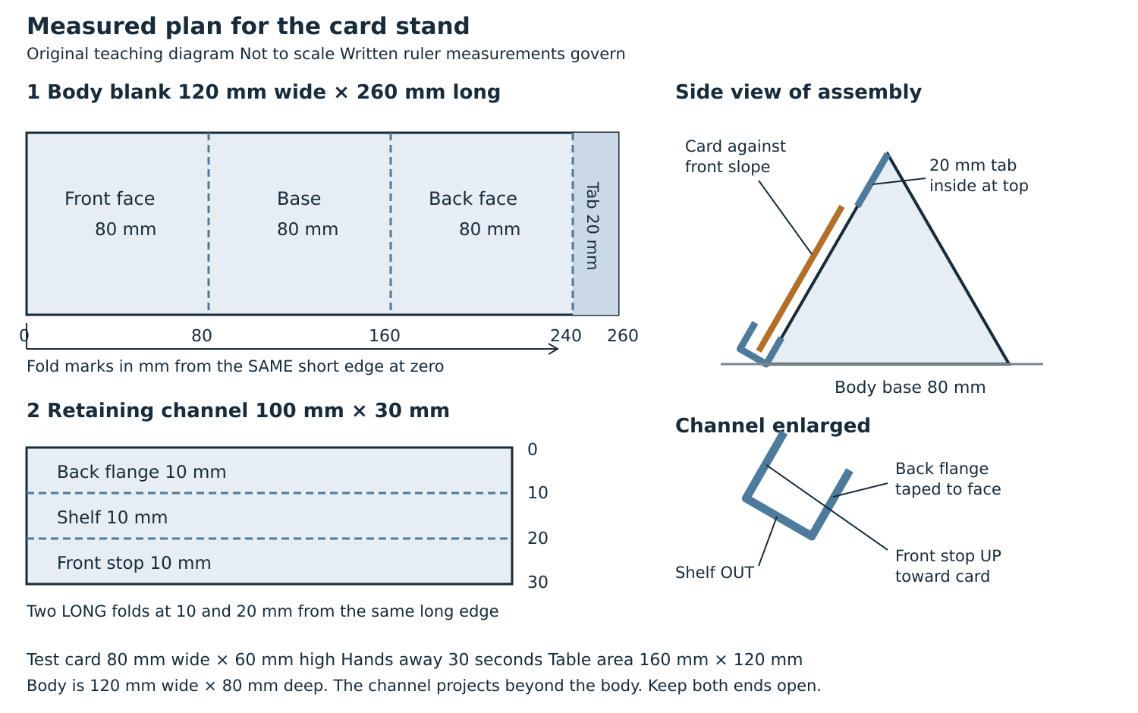

Think about its features
The broad base may help stability. The sloping face supports the card. The U channel catches the lower card edge. These are design predictions. The actual card and made stand need testing later.

Keep your own choice
Compare this with two different ideas. You can adapt the model or choose another feasible shape, but record your own labels, reasons and any adult-approved revision. No cutting or joining is required today.

My three quick annotated ideas
Design and Technology LAUNCH Spring 2 Week 1 Thursday 25 February 2027 P1 Year A
Use this page or your book. Draw three different shapes. Each needs two labels that name a part and explain its job. Rough sketches are enough. Any adult drawing must follow your directions.
No | Quick sketch or book location | Two useful annotations
1 |  | Part ___  Job ___  Part ___  Job ___
2 |  | Part ___  Job ___  Part ___  Job ___
3 |  | Part ___  Job ___  Part ___  Job ___

Card size: 80 mm wide by 60 mm high. My proposed base size in mm ___. Support used ___. Date and book page ___.
Oral or signed descriptions: explain three distinct ideas and two useful labels for each. Confirm the record. Mark a physical sketch pending if none was made.

My chosen design and reasons
Design and Technology LAUNCH Spring 2 Week 1 Thursday 25 February 2027 P1 Year A
Choose after comparing all three ideas against your checks. Keep your own words and the actual design for Week 2.

Choose and explain
I choose idea ___, a ___. My first reason is ___ because it helps the design check ___. My second reason is ___ because it helps the design check ___.

Size and support
The card is 80 mm wide and 60 mm high. My proposed stand base is ___ mm by ___ mm. Allow 160 mm by 120 mm for the whole stand including its channel. The default triangular body base is 120 mm by 80 mm. Label the base, card support and card rest. A changed design needs adult review before a cutting list is approved.

Compare an option
One idea I did not choose was ___. It might ___. I chose my idea instead because ___. A question for the next maker is ___.

Review and improve
One real change I made today was ___. It helps because ___. If I kept the design, my reason was ___. Do not invent a change or a passed test.

Keep the record
Adult design review approved / pending ___. A check or question before planning the build ___. Actual date ___. Book or evidence location ___. Help used ___. Scribed words confirmed yes / not yet ___.
A drawing can predict card support. It does not prove actual stability, fit, safe handling or making.

Design and practical safety brief
Design and Technology LAUNCH Spring 2 Week 1 Thursday 25 February 2027 P1 Year A
Today is designing. No tool use is required. Read the agreed hand-tool boundaries before the later build.
1 This is a design lesson. Drawing, speaking, signing or pupil-directed scribing can meet today's task. No cutting, hot glue or powered equipment is needed.
2 Use hand tools only in this block, and only when the adult approves the actual task and supervision. Do not collect or try tools on your own.
3 Before any later cutting or joining, the adult checks the material, tool, work area, grip and safe route. An approved design is not tool permission.
4 For a concern or pause, stop, put any tool down in its agreed place and tell the adult. Restart only after the adult has made the task safe.
5 A drawing or empty-hand model is planning evidence. It does not prove that a stand has been made, tested or found safe.

The default future route
The taught model uses suitable thin plain card, approved scissors, finger folds and cold paper tape. Later the adult checks the actual card, tools, working position and support. Hot glue is comparison only in Week 2 and is not used. No power tools, craft knives, scoring blades, saws or drills are in the default method.

A concern or pause
Tools down. Compare with the plan. Ask the adult if unsure. Agree a safe change and recheck before resuming. Do not search among sharp offcuts with bare hands.

No materials
With no card, paper, ruler, printer or tools, hear the brief and picture three different stand shapes. Describe each one and two useful labels, by speech or signing. Choose one with a reason linked to Sam's problem. An adult records exact confirmed words when a recording method is available; mark transcription pending until it exists. Keep physical sketches, measuring, making and product tests pending where not done.

