My build plan with tools and safety
Design and Technology LAUNCH Spring 2 Week 2 Thursday 4 March 2027 P1 Year A
Copy or adapt this model in your book. Keep your own choices. Pause before cuts, folds, joins and testing. Stop and ask the adult if a check is unclear.
Step | Action | Tool or material | Safety and check
1 | Check the actual Week 1 design and sizes. Choose card and paper tape, or revise with the adult. | Ruler and pencil; material sample if available | Adult checks material, tool access and safe workspace first.
2 | Measure the two stand parts and test card. Mark all fold lines from the stated edge. | Ruler and pencil | Use ruler zero; recheck before any cut.
3 | Cut parts with suitable scissors, or direct the adult using prepared parts. | Adult-approved scissors | Fingers clear; close scissors at pauses; never force thick board.
4 | Fold at 80, 160 and 240 mm. Bring the last 20 mm tab inside. Tape the triangle closed. | Hands and paper tape | Fold on the flat surface; no knife scoring or heated tool.
5 | Fold the channel along 10 mm and 20 mm lines into a shallow U. Tape its back flange to the lower front face. Shelf out; front stop up. | Hands and paper tape | Adult checks the shelf is out and the front stop faces upward toward the card.
6 | Check with the test card for 30 seconds. Record one change and keep the final plan. | Test card and count or timer | Use a clear level desk. Hands away for 30 seconds; remove the card by hand. Stop if it tips or slips.

The card mock-up is a trial for the Week 3 main build. Keep it to reuse, finish or refine honestly. Do not call an unfinished model complete.

Join the triangle and U channel
Design and Technology LAUNCH Spring 2 Week 2 Thursday 4 March 2027 P1 Year A
Close the triangle with the last 20 mm tab INSIDE the top seam. Keep both ends open. Form the channel as a shallow U: back flange taped to the bottom of the front face, shelf OUT, front stop UP toward the card.
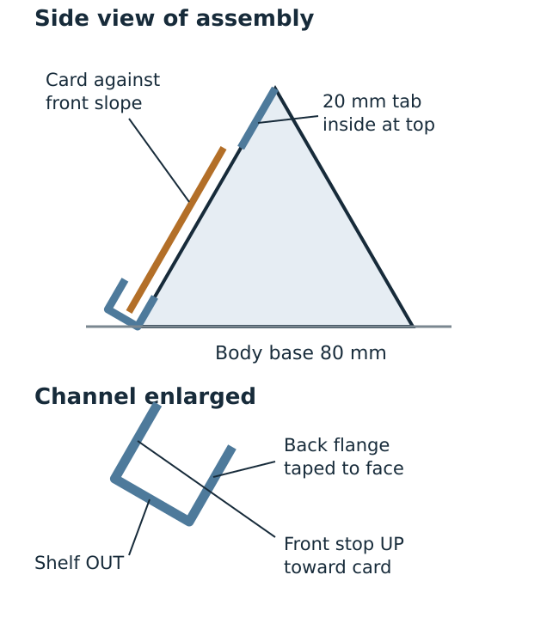
Original diagram. Not to scale. The body base is 120 mm wide by 80 mm deep. The channel projects beyond it; allow a table area 160 mm wide by 120 mm deep for the whole model.

