Measured parts and fold marks
Design and Technology LAUNCH Spring 2 Week 2 Thursday 4 March 2027 P1 Year A
Use the pupil’s approved Week 1 design. This is the default adult model. Any revision needs matching new sizes and adult approval.
Part | Qty | Written size
Body blank | 1 | 120 mm wide by 260 mm long
U channel strip | 1 | 100 mm long by 30 mm wide
Landscape test card | 1 | 80 mm wide by 60 mm high

Measure before cutting
Use ruler zero. Mark the body folds 80, 160 and 240 mm from the SAME short edge. The last tab is 20 mm. Mark two LONG folds on the channel at 10 and 20 mm from the SAME long edge.

Check for accuracy
Aim within 2 mm of each planned cut size and fold position. This guides improvement; it is not a grade. Recheck before cutting or folding. Do not measure a printed diagram.

Record actual sizes
Body actual width ___ length ___. Body fold marks ___. Channel actual length ___ width ___. Channel fold marks ___. One difference and action ___. Adult-prepared parts or help ___.

Flat parts diagram
Design and Technology LAUNCH Spring 2 Week 2 Thursday 4 March 2027 P1 Year A
Original teaching diagram. Not to scale. Written ruler measurements govern.
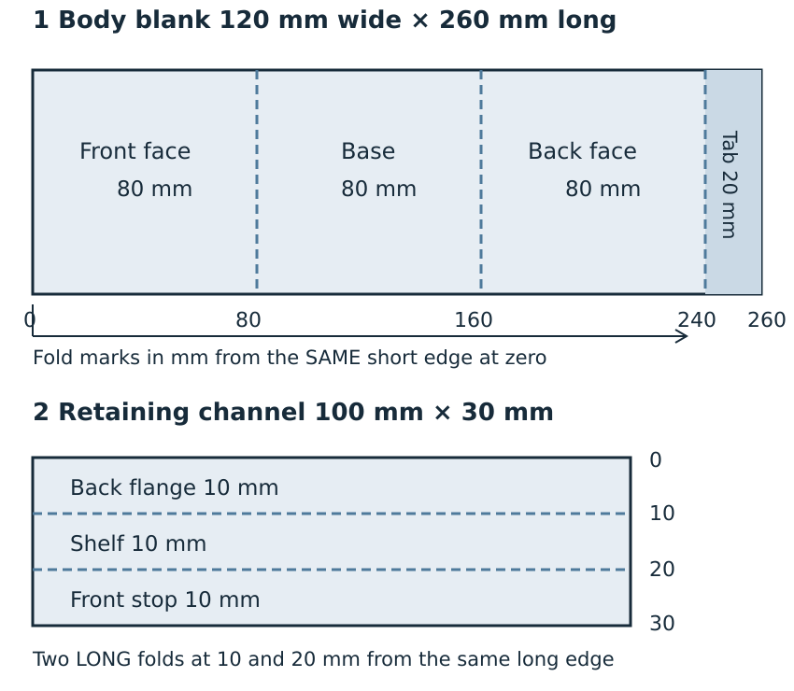
Body folds go across the width. Channel folds run along its length. Three body panels are each 80 mm; the tab is 20 mm.

