Earthquake records and data cards
Tuesday 2 March 2027 | P2 | 40 minutes | Year A
Humanities | LAUNCH | Spring 2 Week 2 | HUM-LAUNCH-S2-W02
Pink paper version. Read quietly, point, write, type, speak privately or direct a scribe who reads your words back. You may pass. No public answer or reading aloud is required.
Original learning summaries based on checked facts. No source extract, map or picture is reproduced. C codes identify the cards. G codes link to research titles and records in SOURCE_MANIFEST.json.

C1 A frozen online record
Selected British Geological Survey records, frozen on 30 October 2026. All times below are UTC. These are three observed events from October 2026, not a complete list, a forecast or a live March 2027 feed. Magnitudes and locations may be revised after more analysis. Read each column before comparing. Research basis: G1.
Code | UTC date and time | Region | Magnitude | Depth km | Latitude and longitude
A | 25 Oct 2026  02:09:23.8 | Bonin Islands, Japan | 6.5 | 492 | 27.795 N  139.618 E
B | 24 Oct 2026  02:31:30.5 | Vanuatu | 6.9 | 10 | 14.056 S  165.546 E
C | 9 Oct 2026  17:56:10.1 | Panama | 7.7 | 12 | 7.587 N  80.769 W

Earthquake records and data cards
Tuesday 2 March 2027 | P2 | 40 minutes | Year A
Humanities | LAUNCH | Spring 2 Week 2 | HUM-LAUNCH-S2-W02
Pink paper version. Read quietly, point, write, type, speak privately or direct a scribe who reads your words back. You may pass. No public answer or reading aloud is required.

C2 Read the field and unit
UTC is a shared time standard. Magnitude reports the size of the event. Depth tells how far below the surface it began, in km. Latitude tells north or south. Longitude tells east or west. Do not swap a depth value for a map coordinate. A number needs its label. Research basis: G1, G2.

C3 Plot the place
Use whole degrees for a clear classroom plot. A is 28 N, 140 E. B is 14 S, 166 E. C is 8 N, 81 W. D2 models A. On D1 find the latitude first, then the longitude. Plot between the 30-degree grid lines and label the point. Keep the exact source coordinates in C1 unchanged. The grid has no coastlines. Research basis: G1.

Earthquake records and data cards
Tuesday 2 March 2027 | P2 | 40 minutes | Year A
Humanities | LAUNCH | Spring 2 Week 2 | HUM-LAUNCH-S2-W02
Pink paper version. Read quietly, point, write, type, speak privately or direct a scribe who reads your words back. You may pass. No public answer or reading aloud is required.

C4 Compare and question
Among A–C, A is newest on 25 October 2026. C has the largest magnitude at 7.7. B is shallowest at 10 km. A is deepest at 492 km. These claims use different fields. The table gives no damage totals. Large magnitude alone does not prove the largest impact. We also need evidence about people, buildings, ground conditions and protection. Three selected records cannot show a global trend. Research basis: G1, G2.

C5 Keep the historic case separate
H is the Tohoku region of Japan earthquake on 11 March 2011 at 05:46:24 UTC. The frozen comparison uses the current event record: magnitude 9.1, depth 29 km, latitude 38.297 N, longitude 142.373 E. For plotting only, use 38 N, 142 E. H continues the Week 1 case. It is historic, not a recent October 2026 event. Research basis: G3.

D1 World coordinate grid
Tuesday 2 March 2027 | P2 | 40 minutes | Year A
Humanities | LAUNCH | Spring 2 Week 2 | HUM-LAUNCH-S2-W02
Pink paper version. Read quietly, point, write, type, speak privately or direct a scribe who reads your words back. You may pass. No public answer or reading aloud is required.
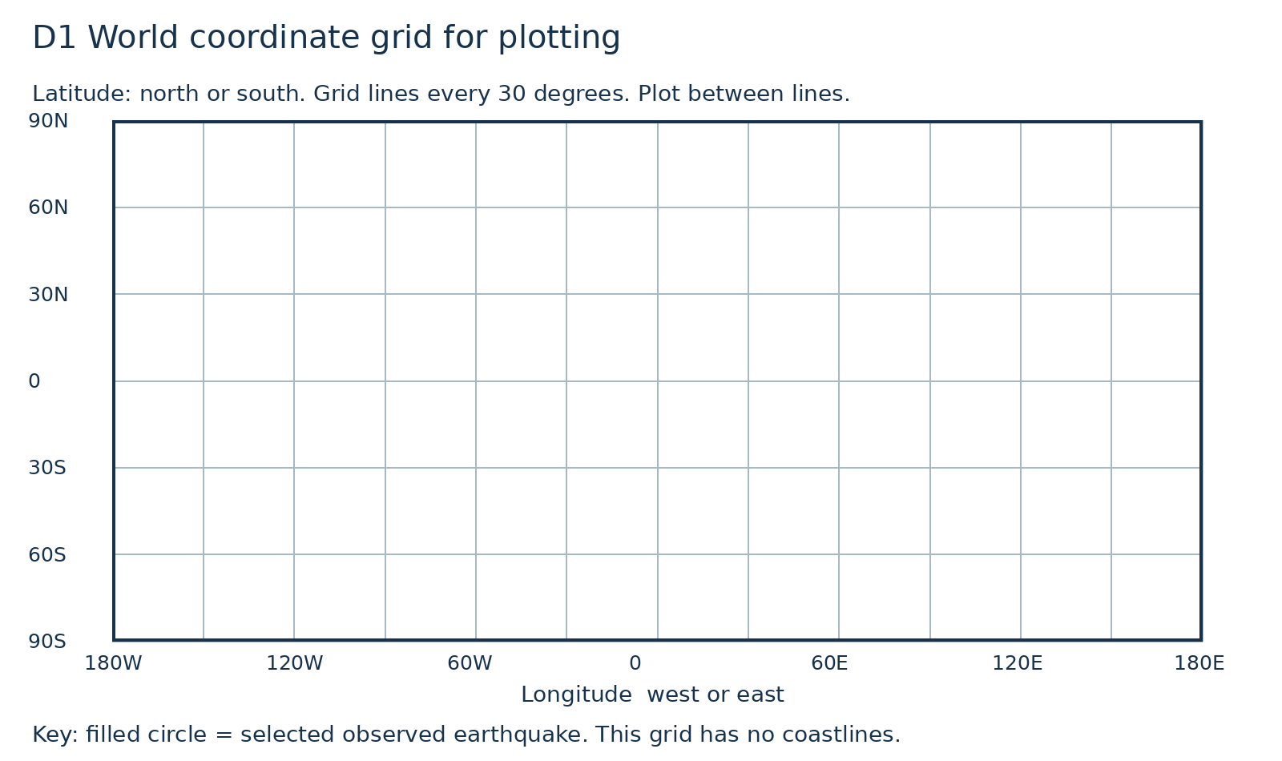
Plot and label A–C. Use N or S and E or W carefully.
Original equirectangular coordinate grid. It has no coastlines and is for point plotting, not navigation. A filled circle represents a selected observed earthquake.

D2 A worked location
Tuesday 2 March 2027 | P2 | 40 minutes | Year A
Humanities | LAUNCH | Spring 2 Week 2 | HUM-LAUNCH-S2-W02
Pink paper version. Read quietly, point, write, type, speak privately or direct a scribe who reads your words back. You may pass. No public answer or reading aloud is required.
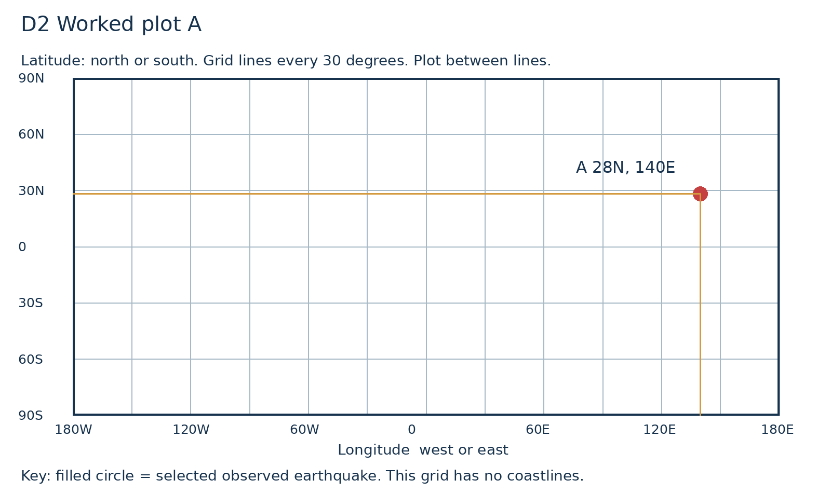
Trace the latitude north from the equator, then the longitude east from zero. Now plot B and C on D1.
Only A is modelled. Whole-degree coordinates are rounded for classroom plotting. The exact catalogue values remain in C1.

D3 Fields and limits
Tuesday 2 March 2027 | P2 | 40 minutes | Year A
Humanities | LAUNCH | Spring 2 Week 2 | HUM-LAUNCH-S2-W02
Pink paper version. Read quietly, point, write, type, speak privately or direct a scribe who reads your words back. You may pass. No public answer or reading aloud is required.
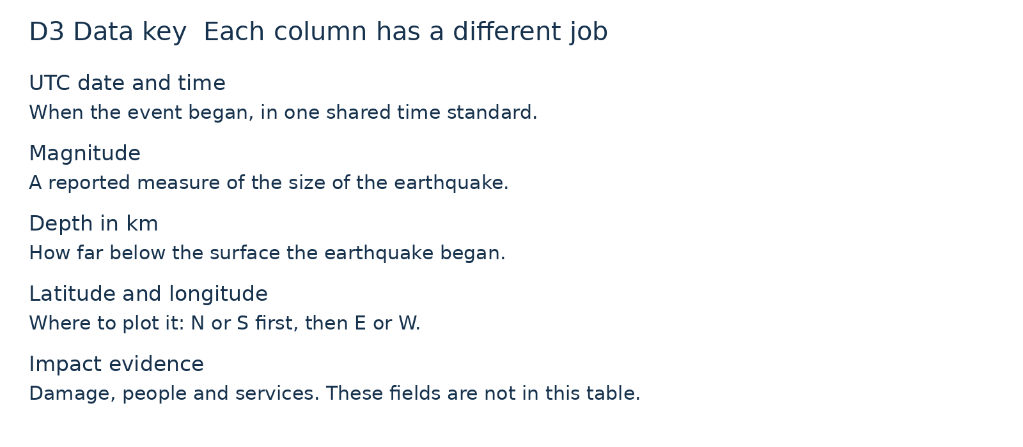
Choose a value from C1. Point to its matching field and explain what it tells you.
Field labels matter. Magnitude, depth and date answer different questions. This key does not predict future events.

