Hazard data and case evidence cards
Tuesday 23 March 2027 | P2 | 40 minutes | Year A
Humanities | LAUNCH | Spring 2 Week 5 | HUM-LAUNCH-S2-W05
Pink paper version. Read quietly, point, write, type, speak privately or direct a scribe who reads your words back. You may pass. No public answer or reading aloud is required.
Original learning summaries based on checked facts. No source extract, map or picture is reproduced. C codes identify the cards. G codes link to research titles and records in SOURCE_MANIFEST.json.

C1 Frozen recent records
The three BGS records below are selected observed October 2026 events, frozen on 30 October 2026. Times are UTC. Values may be revised later. This is not a complete catalogue, live March 2027 feed or forecast. Use only A–C for recent-record calculations. Research basis: G1.
Code | UTC date and time | Country or region | Magnitude | Depth km | Latitude and longitude
A | 25 Oct 2026  02:09:23.8 | Bonin Islands, Japan | 6.5 | 492 | 27.795 N  139.618 E
B | 24 Oct 2026  02:31:30.5 | Vanuatu | 6.9 | 10 | 14.056 S  165.546 E
C | 9 Oct 2026  17:56:10.1 | Panama | 7.7 | 12 | 7.587 N  80.769 W

Hazard data and case evidence cards
Tuesday 23 March 2027 | P2 | 40 minutes | Year A
Humanities | LAUNCH | Spring 2 Week 5 | HUM-LAUNCH-S2-W05
Pink paper version. Read quietly, point, write, type, speak privately or direct a scribe who reads your words back. You may pass. No public answer or reading aloud is required.

C2 An example and your own analysis
Worked example: MAX of recent A–C magnitudes is 7.7. In the workbook this is Analysis B18, using Records E6:E8. H is excluded. This is a model, not your own evidence. Now find the newest recent record and shallowest depth. Calculate C minus A magnitude values or A minus B depth, or both. Keep your finding, method and evidence. A magnitude gap is not a simple energy multiplier. Magnitude and depth alone do not rank damage. Research basis: G1, G2.

C3 Keep the historic case separate
H is Tohoku region Japan on 11 March 2011 at 05:46:24 UTC. Use the same USGS solution: magnitude 9.1, depth 29 km, latitude 38.297 N and longitude 142.373 E. The Pacific plate sinks beneath northern Japan. A locked fault stored strain, then slipped and released waves. Strong shaking affected buildings and transport. Sea-floor movement displaced water, causing a tsunami and coastal flooding. Some road, rail and service effects involved both processes. Research basis: U1, J1, R1.

Hazard data and case evidence cards
Tuesday 23 March 2027 | P2 | 40 minutes | Year A
Humanities | LAUNCH | Spring 2 Week 5 | HUM-LAUNCH-S2-W05
Pink paper version. Read quietly, point, write, type, speak privately or direct a scribe who reads your words back. You may pass. No public answer or reading aloud is required.

C4 Management facts for your judgement
Resistant buildings and retrofits can reduce shaking damage. Coastal barriers can reduce some impacts, but some were overtopped or damaged in 2011. Practised routes, education and supplies help preparedness. Early warning followed detection of an earthquake already under way. The first tsunami warning was at 05:49 UTC, about three minutes after the earthquake; initial estimates were too low and updated. Scientists cannot reliably predict exact earthquake time, place and magnitude. Explain how a measure helps and what limit remains. Research basis: U2, U3, J1, J2, M1, R4.

C5 Your own report and evidence
Make your own report, not a copy of the model or a partner’s paragraph. Use a case fact, explain the because link, and judge a measure with a limit. Put your recent-data findings in a separate part and explain what they cannot prove about impacts. Books, the editable DOCX template and the offline XLSX are options. Actual analysis and authoring modes must be recorded. Paper or adult-directed typing does not prove the learner used spreadsheet formulas or authored digitally. The six-row grid records authentic evidence and gaps; staff check the unit award separately.

D1 Keep evidence roles clear
Tuesday 23 March 2027 | P2 | 40 minutes | Year A
Humanities | LAUNCH | Spring 2 Week 5 | HUM-LAUNCH-S2-W05
Pink paper version. Read quietly, point, write, type, speak privately or direct a scribe who reads your words back. You may pass. No public answer or reading aloud is required.
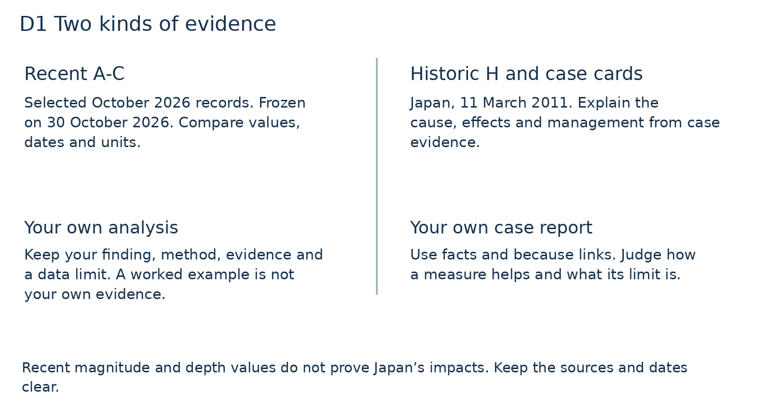
Which source supports your numeric comparison? Which supports Japan’s effects and management?
Original evidence guide. Recent magnitude and depth values do not prove historic impacts. H stays outside recent-record calculations.

D2 Explain and judge
Tuesday 23 March 2027 | P2 | 40 minutes | Year A
Humanities | LAUNCH | Spring 2 Week 5 | HUM-LAUNCH-S2-W05
Pink paper version. Read quietly, point, write, type, speak privately or direct a scribe who reads your words back. You may pass. No public answer or reading aloud is required.
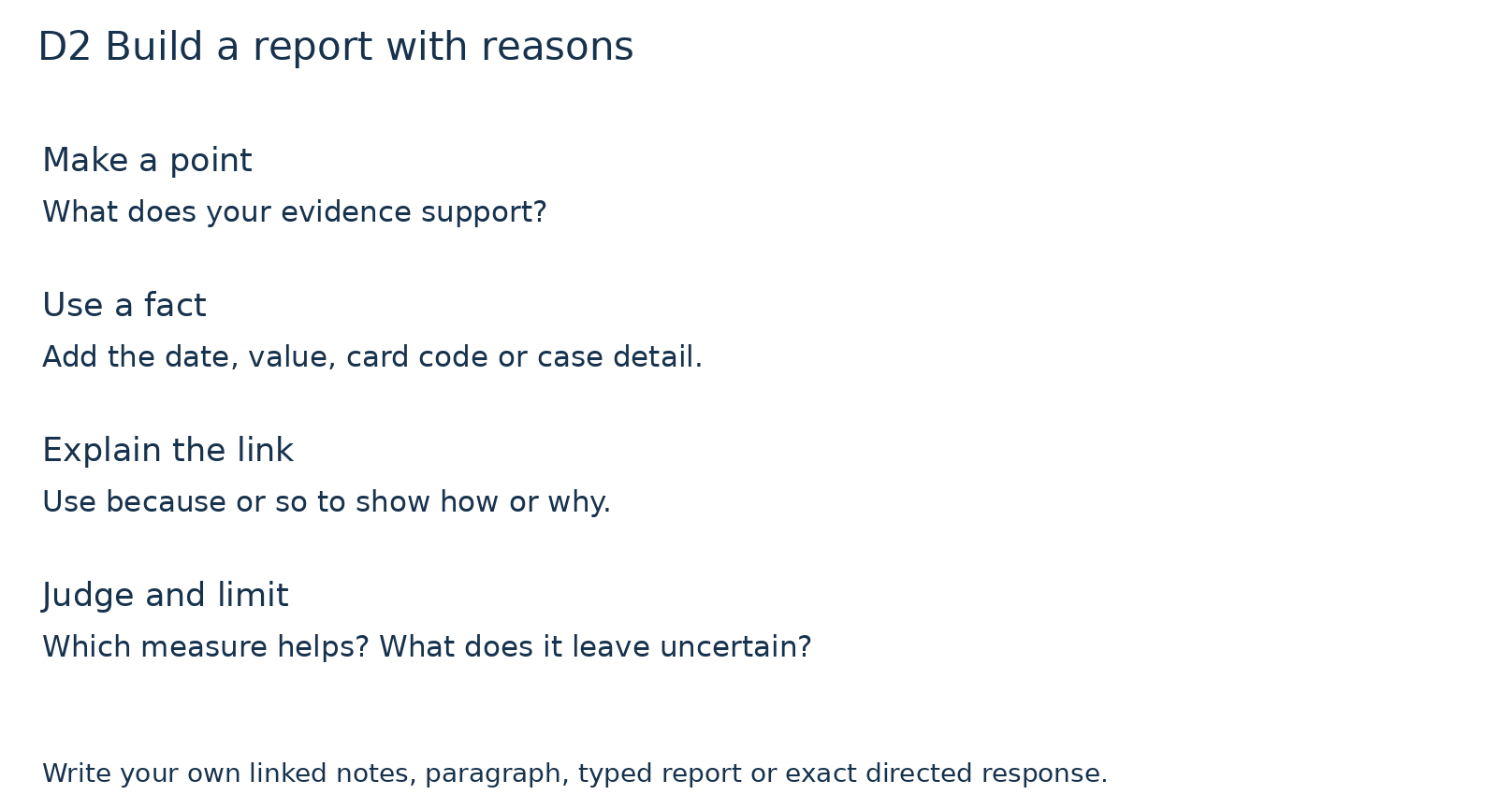
Choose your own fact and finish a because link. Then state how your chosen measure helps and what it cannot guarantee.
These prompts are a structure, not a completed report. Use your own work, linked notes, typing or exact directed response.

D3 Response and evidence checks
Tuesday 23 March 2027 | P2 | 40 minutes | Year A
Humanities | LAUNCH | Spring 2 Week 5 | HUM-LAUNCH-S2-W05
Pink paper version. Read quietly, point, write, type, speak privately or direct a scribe who reads your words back. You may pass. No public answer or reading aloud is required.
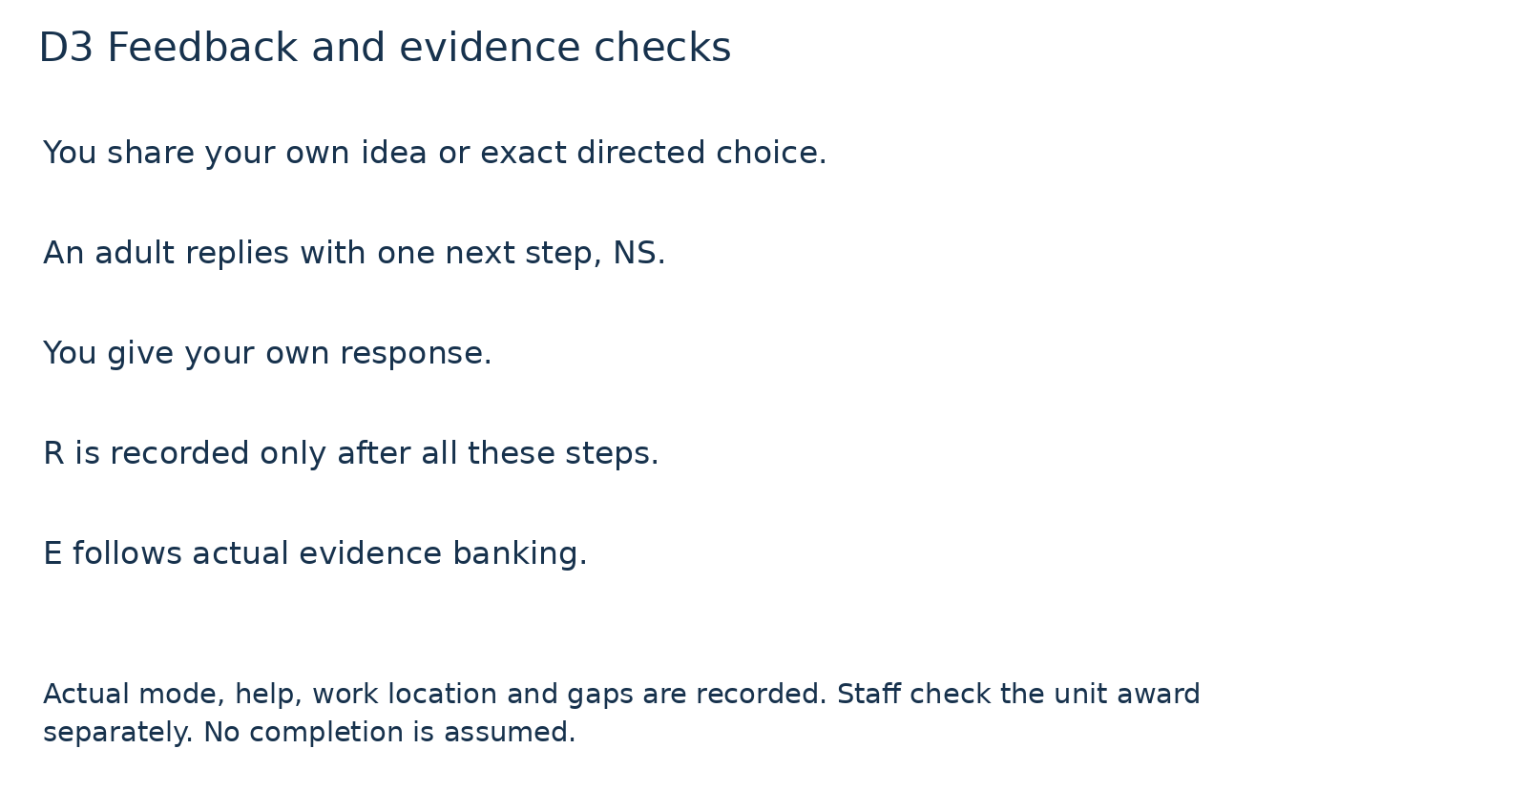
What has actually happened? Keep missing steps blank and agree a next check privately.
R and E are recorded only after their stated prerequisites. Staff check the unit award separately. No completion is assumed.

