Arrival
Look at a safe sample or roof card.
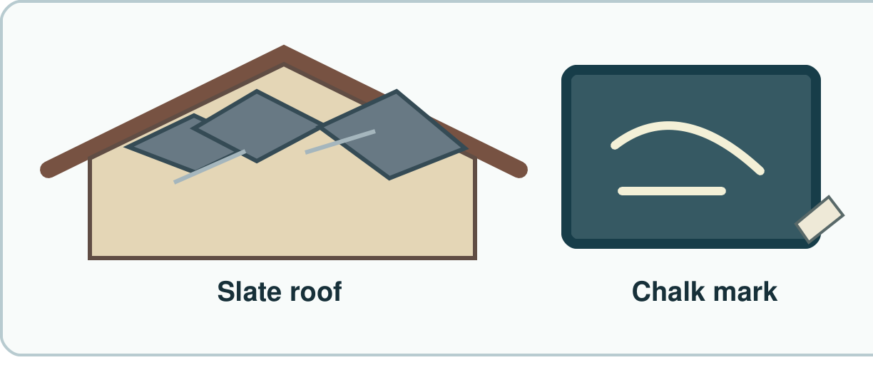
My response

Starter
Think back. Say, sign or point.
1. What two checks did we use on rocks?

2. Name one way to sort rocks.

3. What helps bones move?

Talk-then-sort
Match each sample to a possible job.
This sample leaves a mark on the small board. I match it to ____.
Choices: Roof · Marking · Path
Card or step | My group or match
Thin slate tile
Safe sample that leaves a mark
Small firm stone pieces

Choose a sample and show its use.
Independent F
Match one sample to one job.
I match ____ with ____.
My response

Independent M
Choose a rock and say what feature helps.
This ____ can do the job as it is ____.
My response

Independent H
Why could a soft rock fail on a busy path?
For a ____, I choose ____ as ____.
My response

Go deeper
Can one rock suit two jobs? Show the need for each job.
My response

Choose a sample for a roof and a mark. Test each reason.
My response

Exit
Tell an adult why your match fits.
My exit response

Read it back: I am learning to match a rock to a job.
My feedback was… I showed…
Next I need to… try one small fix.
Word help
Word | Meaning | Example | My language
rock | a solid thing from the ground | This is a safe rock sample.
hard | not easy to mark or change | This hard rock takes little mark.
slate | a rock that can split into thin sheets | A slate tile can cover a roof.
property | a thing you can check | This slate is thin.

