Arrival
Hold a safe raw rock. Look at a brick card.
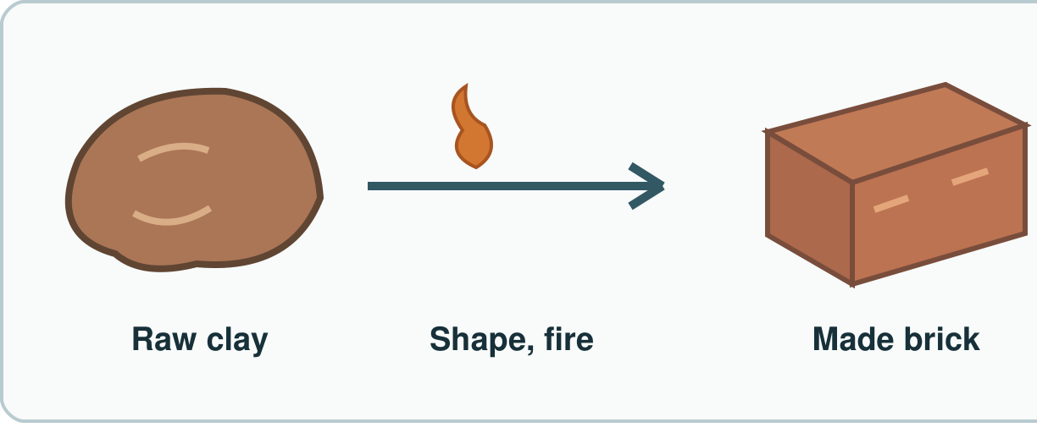
My response

Starter
Think back. Say, sign or point.
1. Name one use of a rock.

2. What does a water test check?

3. What do people and animals get from food?

Talk-then-sort
Sort safe samples and cards.
People shape and fire clay to make a brick. I write brick in the ____ row.
Choices: Natural raw item · Human-made item
Card or step | My group or match
Raw rock
Leaf on a branch
Finished clay brick
Glass bottle

Make a row for raw and made items.
Independent F
Put one raw and one made item in groups. Fill one row.
This ____ goes in the ____ group.
My response

Independent M
Sort four items. Add two rows to a table.
I put ____ in the table as ____.
My response

Independent H
Why is clay natural but a brick made?
The raw ____ is ____, but the finished ____ is ____.
My response

Go deeper
An object has two materials. How can your table show both?
My response

Choose a made item with two raw materials. Plan a fair row.
My response

Exit
Show your row to an adult.
My exit response

Read it back: I am learning to sort things from nature and things people make.
My feedback was… I showed…
Next I need to… try one small fix.
Word help
Word | Meaning | Example | My language
natural | from nature, not made into a new item | A raw rock is natural.
human-made | made or changed by people | People make a brick from clay.
material | what a thing is made of | The brick has clay in it.
table | rows and columns for facts | This row says brick: made.

