Arrival
See two rocks and a dropper.
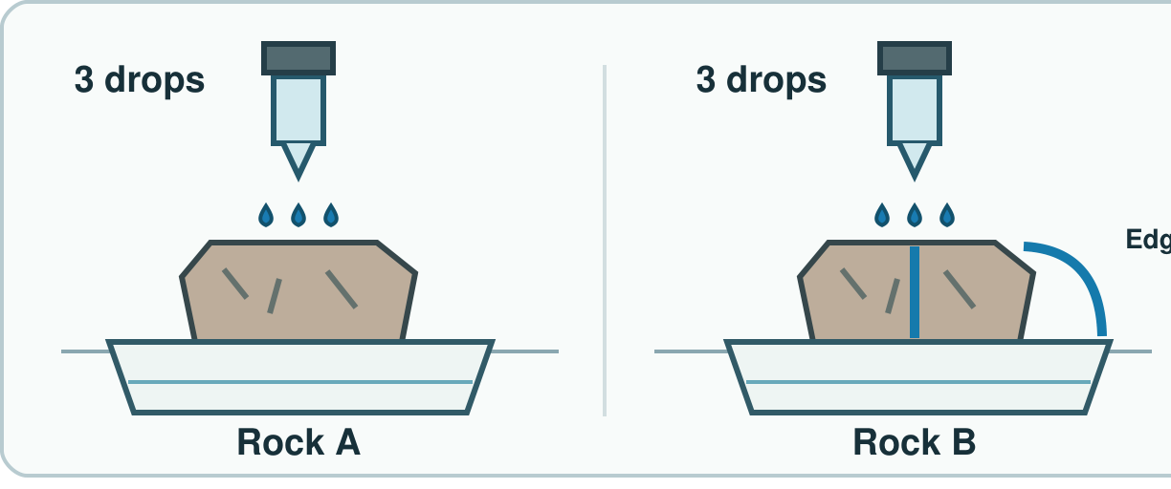
My response

Starter
Think back. Say, sign or point.
1. Name one raw and one made item.

2. Why can slate suit a roof?

3. How can food help a body?

Talk-then-sort
Plan and run the same steps.
A gets three drops. B gets ____ drops. I wait the same time.
Choices: Keep the same · Change
Card or step | My group or match
Use three drops each time
Wait for the same count
Test a second rock
Use the same tray each time

Test two rocks. Record what you see.
Independent F
Point to what stays the same.
I keep ____ the same.
My response

Independent M
Plan one fair water check.
I change ____ and keep ____ the same.
My response

Independent H
One rock is much larger. How could you compare?
The check may fail if ____; I will ____.
My response

Go deeper
Drops run off an edge. Did water pass through? Fix it.
My response

Find two unfair steps. Fix them.
My response

Exit
Say what stayed the same.
My exit response

Read it back: I am learning to keep a rock test the same each time.
My feedback was… I showed…
Next I need to… try one small fix.
Word help
Word | Meaning | Example | My language
fair test | a check with one planned change | I use three drops each time.
same | not changed in each try | I use the same water.
change | make one thing different | I change the rock.
result | what the check showed | A drop stayed on top.

