Arrival
Place a dot on the ball. Point to the side lit by the torch.
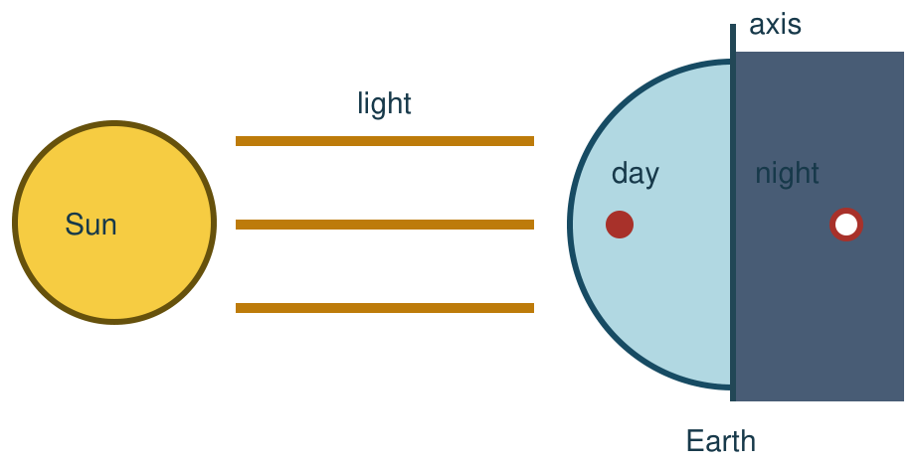
My response

Starter
Think back. Say, point or write one answer for each question.
1. What goes around Earth?

2. Name one mechanism from our forces work.

3. Name one force from our first science week.

Talk-then-sort
Now try the same model. Two steps are done. Complete the last step: turn the dot away and name what comes next.
Torch still → dot faces the torch: day → turn the ball → dot faces away: ____.
Choices: day · night
Card or step | My group or match
The missing word is

Show day and night at the dot. Explain why the Sun seems to move, even when our torch stays still.
Independent F
Point to the lit side and the dark side.
I point to ___ for day and ___ for night.
My response

Independent M
Explain what the dot sees as Earth turns.
The dot has night when ___ because ___.
My response

Independent H
Explain why the Sun seems to move across our sky while the model torch stays still.
The Sun seems to move because ___. The model shows ___.
My response

Go deeper
Mark two dots on opposite sides. Explain why one has day while the other has night.
My response

Two dots, one turn: test the claim that the Sun goes round Earth each day. Show the motion that explains both dots. Name one limit of the torch model.
My response

Exit
Show how you know. Tell us your feedback and next step. Say, point, sign, draw or write.
My exit response

Word help
Word | Meaning | Example | My language
rotation | one turn around an axis | Earth’s rotation brings day and night.
axis | an imagined line a planet spins around | Earth turns around its axis.
shadow | an area where an object blocks light | The ball makes a shadow on the desk.
orbit | a curved path around another object | Earth’s orbit takes it around the Sun.

