Arrival
Choose the body that makes its own light: Sun, Earth or Moon.
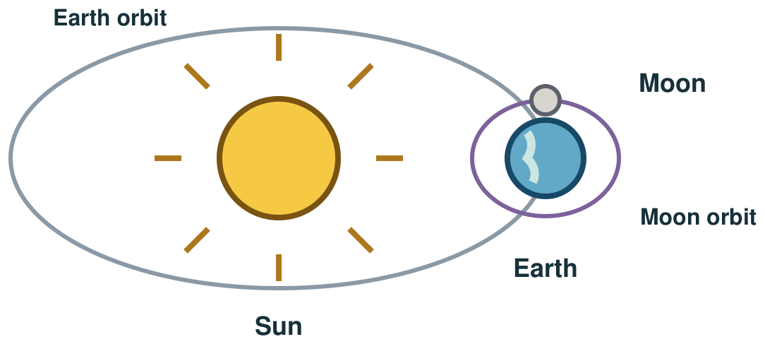
My response

Starter
Think back. Say, point or write one answer for each question.
1. What shape is the Moon roughly?

2. Why do we get day and night?

3. What goes round Earth?

Talk-then-sort
Card A is matched to Sun is a star. Card B has a fact but no label. Find the missing source label for Earth goes round the Sun.
Claim: The Moon goes round Earth → card C says the same → cite card ____.
Choices: Card A · Card B · Card C
Card or step | My group or match
Sun is a star
Earth orbits the Sun
Moon orbits Earth

Share two facts about the Solar System. Name the class card that supports each fact. Correct one claim if its card does not match.
Independent F
Point to one fact and its source card.
Card ___ says ___.
My response

Independent M
Share two facts and name each matching card.
My fact is ___; card ___ supports it.
My response

Independent H
Use two cards to explain Earth’s place, then repair a false label.
Card ___ supports ___, but it cannot show ___ because ___.
My response

Go deeper
A poster calls the Moon a planet. Use two class cards to repair the label and name both sources.
My response

Two cards disagree about the Moon. Choose the supported claim, then name a reliable source for a further check.
My response

Exit
Say one checked fact and point to the matching class card. Say which source label you fixed.
My exit response

? Read it back: check a source and share a fact about the Solar System.
My feedback was… say what changed. Next I need to… name a fix.
Word help
Word | Meaning | Example | My language
Solar System | the Sun and the objects that move around it | Earth is part of our Solar System.
planet | a large, nearly round body that moves around a star | Earth is a planet that moves around the Sun.
star | a hot body in space that makes its own light | The Sun is a star.
source | where a fact or idea comes from | Card B is my source for Earth’s orbit.

