Arrival
Match each question to a kit card: toy and surface, globe and torch, or warming chain.
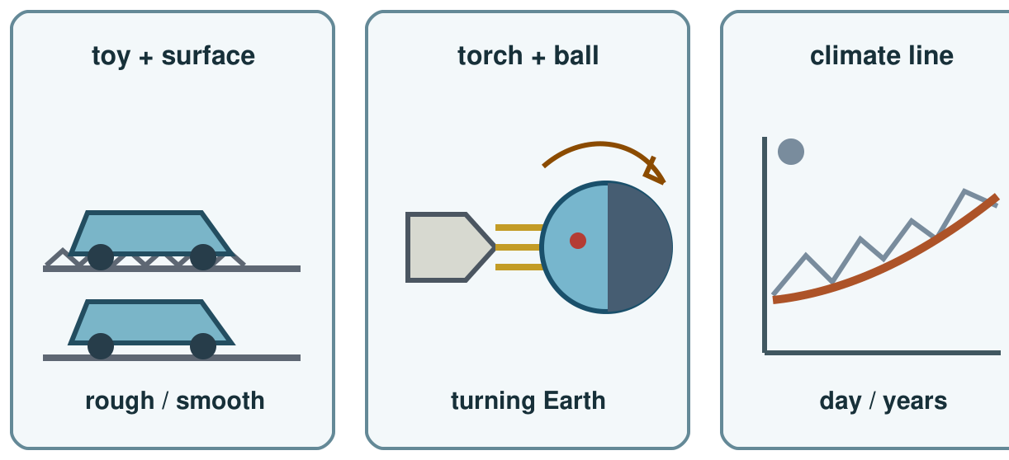
My response

Starter
Think back. Say, point or write one answer for each question.
1. Give one link in the warming chain.

2. Name one fact our Solar System cards support.

3. How can friction affect a moving toy?

Talk-then-sort
Torch and ball are chosen for day and night. Add the missing clue. Say why it fits.
Day and night question → choose torch and ball → observe ____ → explain Earth’s turn.
Choices: toy and surface · torch and ball · warming cards
Card or step | My group or match
Why did the toy slow?
Why is a place in night?
Why is climate warming?

Choose two stations. Give a claim and matching clue for each. Name one limit.
Independent F
Match a question to a model.
For ___, I choose the ___ model.
My response

Independent M
Give an answer and a matching clue.
My claim is ___; the clue is ___.
My response

Independent H
Compare two models, clues and limits.
The ___ model fits because ___, but it cannot show ___.
My response

Go deeper
Compare two models: what can each show and miss?
My response

Two toy runs differ on one surface. Can friction alone explain this? Choose one control that would help.
My response

Exit
Name a model, claim and clue. Say what changed after feedback.
My exit response

? Read it back: choose a model that fits a science question and use a matching clue.
My feedback was… say what changed. Next I need to… name a fix.
Word help
Word | Meaning | Example | My language
force | a push or pull on an object | Friction is a force that can slow a toy.
rotation | a turn around an axis | Earth’s rotation brings day and night.
evidence | an observation or result that supports a claim | The shorter run is evidence for my answer.
climate | weather patterns over many years | A hot day alone does not show a climate trend.

