Arrival
Look at this week’s seedling and skin-repair model. Point to one detail you notice.
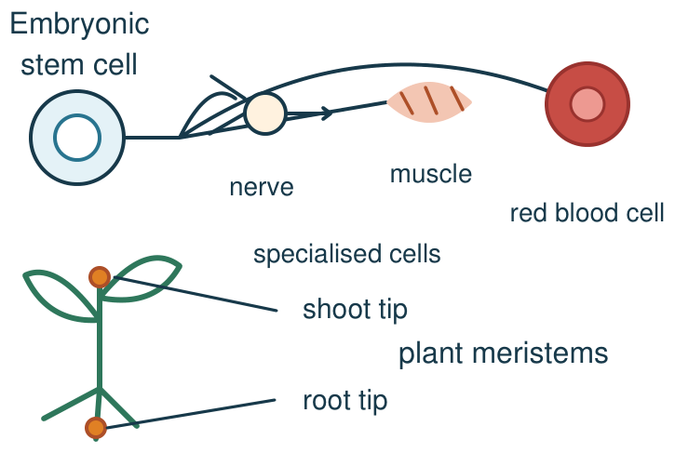
My response

Starter
Recall three ideas from earlier lessons. Show one answer at a time.
1. What two matching products follow body-cell mitosis and cell splitting?

2. Which process moves particles from low to high concentration using energy?

3. In which part of a eukaryotic animal cell are chromosomes found?

Talk-then-sort
Complete the missing step in the part-done model. Speak, then match the cards.
Skin: mitosis adds cells → differentiation gives a job. Shoot: meristem adds cells → ________ lengthens cells → differentiation.
Choices: differentiation · division · elongation
Card or step | My group or match
Makes more cells
Plant cells become longer
Cell gains a tissue job

A skin model shows division. What gives a new cell its job?
Independent F
Place divide, elongate and differentiate cards on the skin/shoot branches; omit elongate on the skin branch.
In the shoot, first cells …; then they …
My response

Independent M
Explain why mitosis alone does not give a new cell its specialised tissue job.
More cells are made by …, but a job develops when …
My response

Independent H
Compare growth in animal tissue with a plant shoot, including an appropriate stem-cell region and what each process adds.
Both organisms …; however, the plant also … because …
My response

Go deeper
A tissue gains more cells but no new cell types. What does the model explain, and what is missing?
My response

Correct a diagram labelling new skin cells “stem cell”; justify two changes.
My response

Exit
Show what you know with a model and explain one reason.
My exit response

My feedback was … Name what you heard at Review.
Next I need to … Add the step showing how one newly made cell takes on a specialised role.
Word help
Word | Meaning | Example | My language
differentiation | a cell becoming specialised for a particular job | A developing skin cell differentiates to do a job in skin.
stem cell | a cell that can divide and form specialised cell types | Some adult stem cells make replacement blood cells.
meristem | a plant region whose cells divide to make new cells | A root tip contains a meristem.
growth | an increase in size, including by making more cells | A shoot grows as its cells divide and elongate.

