Arrival
Look at this week’s fictional stem-cell proposal card. Point to one detail you notice.
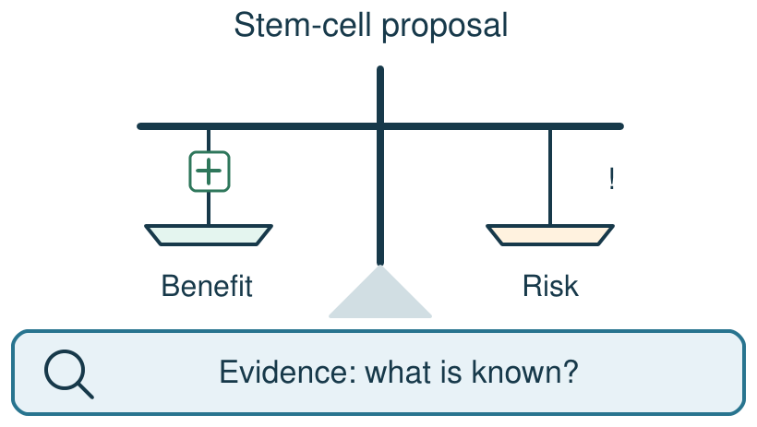
My response

Starter
Recall three ideas from earlier lessons. Show one answer at a time.
1. What is the name for a cell gaining a specialised job?

2. What two cells follow mitosis and cell splitting?

3. In which direction do particles spread by diffusion?

Talk-then-sort
Complete the missing step in the part-done model. Speak, then match the cards.
Possible benefit: may replace damaged cells. Possible risk: ________. Evidence needed: a fair check of benefit and harm.
Choices: evidence request · possible benefit · possible harm · unsupported assertion
Card or step | My group or match
The trial records how much damaged tissue changes.
A treatment may help a damaged tissue.
It must work because many people want it.
A study could find a harmful effect.

A fictional stem-cell proposal lacks safety results. Decide what to test next.
Independent F
Sort the fictional proposal statements under possible benefit, possible risk and evidence needed.
A possible benefit is …; a possible risk is …
My response

Independent M
Explain why a proposal needs evidence of both effect and harm before a decision.
The claim is not yet proven because we need evidence that …
My response

Independent H
Evaluate whether to support further research with a qualified reason, risk and evidence request.
I would support/review further research if …; however, before treatment use I would need …
My response

Go deeper
If a careful new study showed no improvement, how should the panel change its recommendation and why?
My response

Separate further research from routine treatment; explain the evidence needed for each.
My response

Exit
Show what you know with a model and explain one reason.
My exit response

My feedback was … Name what you heard at Review.
Next I need to … Add one precise piece of benefit or safety evidence you would request before deciding.
Word help
Word | Meaning | Example | My language
stem cell | a cell that can divide and form specialised cell types | Stem cells are being studied for possible medical uses.
benefit | a possible helpful result | A possible benefit would be replacing damaged cells.
risk | a possible harmful result or uncertain effect | A study must consider a risk to volunteers.
evidence | information that tests or supports a claim | The trial needs evidence of both benefit and harm.

