Arrival
Look at this week’s string-and-clip DNA model. Point to one detail you notice.
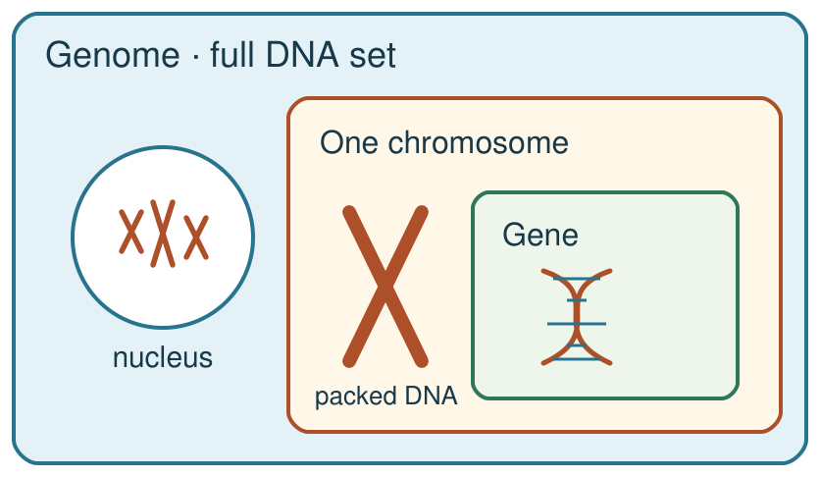
My response

Starter
Recall three ideas from earlier lessons. Show one answer at a time.
1. What is one reason a claim of a new stem-cell treatment needs evidence?

2. Which structure carries the matching chromosome sets after mitosis?

3. Where are chromosomes found in a eukaryotic animal cell?

Talk-then-sort
Complete the missing step in the part-done model. Speak, then match the cards.
DNA cord → a short marked ________ codes for a protein → chromosome package → the genome contains all DNA.
Choices: DNA · chromosome · gene · genome
Card or step | My group or match
short coloured DNA section
whole genetic molecule
long DNA package
all of the organism’s DNA

Two diagrams label a gene differently. Choose the accurate model and explain one reason.
Independent F
Label a gene, DNA, chromosome and genome on the model.
This short marked section is a …; the long package is a …
My response

Independent M
Explain why a gene is a DNA section, not another material.
A gene is part of … and codes for …
My response

Independent H
Correct a faulty gene label and explain the protein instruction.
The faulty label is …; it should be … because …
My response

Go deeper
What distinctions disappear if the whole genome is called one gene?
My response

Repair two faulty diagrams: DNA inside a gene, and one chromosome as the entire genome. Justify both.
My response

Exit
Show what you know with a model and explain one reason.
My exit response

My feedback was … Name what you heard at Review.
Next I need to … Use “section of DNA” and “codes for a protein” precisely in one sentence.
Word help
Word | Meaning | Example | My language
DNA | the molecule that stores genetic instructions | DNA contains the instructions for making proteins.
gene | a section of DNA that codes for a specific protein | The coloured section of the model stands for one gene.
chromosome | a long DNA molecule packaged with proteins in a cell | A chromosome contains many DNA sections, including genes.
genome | the entire DNA of an organism | The genome includes all of the organism’s chromosomes and other DNA.

