Knowledge organiser
I can name what I change and what I keep the same.
I can record what happened in a small test.
I can explain one way to make the test more dependable.

I am learning to… plan a fair investigation, record a result and explain a limit.
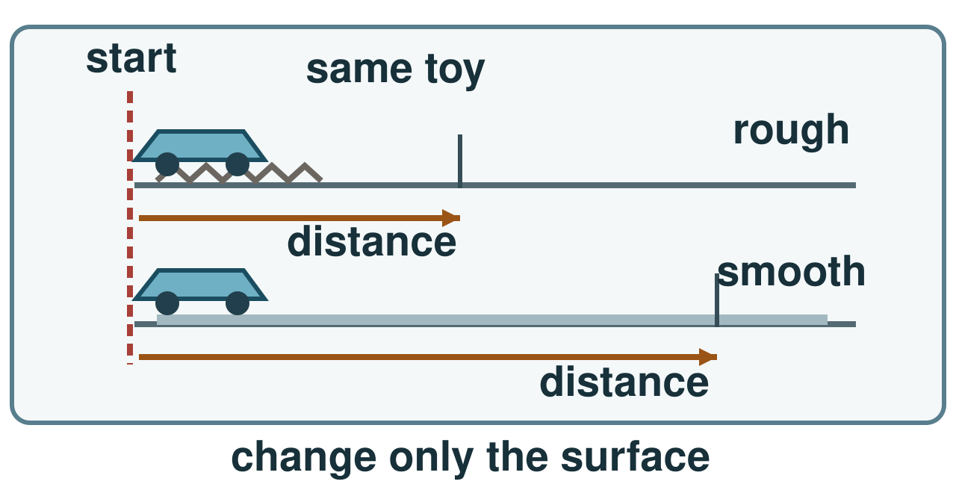
Use the same toy and start line. Change only the surface; measure distance. End marks are examples, not results.
I can name what I change and what I keep the same. I can record what happened in a small test. I can explain one way to make the test more dependable.

Word page
I can name what I change and what I keep the same.
I can record what happened in a small test.
I can explain one way to make the test more dependable.

Word | It means | Example
variable | a factor that can change in a test | The surface is our changed variable.
fair test | a test that changes one key factor and keeps other key factors the same | We use the same toy in both runs for a fair test.
result | what you observe or measure in a test | Our result is the distance the toy travelled.
repeat | do the test again under the same conditions | We repeat each run to check our result.

Change one thing. Keep the toy, start and launch the same. Measure each run, keep each result and give a limit.

Arrival and starter
I can name what I change and what I keep the same.
I can record what happened in a small test.
I can explain one way to make the test more dependable.

Choose the question card: does surface change how far this toy goes? Point to what we will change.
Think back. Say, point or write one answer for each question.
1. What should match a science claim?
2. Name an effect of added greenhouse gases.
3. What do we keep the same in a fair test?
You may point, sign, say or write your first ideas.

I do · model and check
I can name what I change and what I keep the same.
I can record what happened in a small test.
I can explain one way to make the test more dependable.

I mark a start line. I keep the toy and launch the same. I change the surface, measure distance and repeat. Runs may still vary.
Watch: Change rough/smooth surface → keep toy, start and launch the same → measure distance → repeat.
Show me: If I change the surface, should I also change the toy?
Use the same toy and start line. Change only the surface; measure distance. End marks are examples, not results.

We do · sort and explain
I can name what I change and what I keep the same.
I can record what happened in a small test.
I can explain one way to make the test more dependable.

The plan has a fixed toy and start line. Add the missing launch control. Name the surface to change.
Our turn: Change ____ → keep toy and ____ the same → measure distance.
Talk, then sort.
Card | Choose a group
Surface type | change / keep same / measure
Toy | change / keep same / measure
Start line | change / keep same / measure
Travel distance | change / keep same / measure

Supported: Use a visual card for toy, start mark and launch; point to the missing control.
Independent: Name two controls and record a result.
Aspire: Explain how a different launch could make a surface comparison misleading.

We do 2 · choose and explain
I can name what I change and what I keep the same.
I can record what happened in a small test.
I can explain one way to make the test more dependable.

What should you do if two repeat runs disagree?
A. Keep results and check the method
B. Alter one result to match
All of us: A team compares carpet and vinyl using one trolley. Which plan lets them test the surface fairly?
A. Same push; change start and surface.
B. Same start; change trolley and surface.
C. Same surface; change trolley and push.
D. Same start and push; change surface.
Show your choice and say why. You may use a point, card, board or sign. Take one quiet minute to reset.

Independent · Supported
I can name what I change and what I keep the same.
I can record what happened in a small test.
I can explain one way to make the test more dependable.

Test two runs per surface or observe. Record distance. Name what changed, stayed the same and could limit the test.
Talk first. You can plan in any language.
Point, sign, speak, draw, type, write, use a scribe or show a staff-captured photo.
Point to the factor that changes.
Say first: I change the ___; I keep ___ the same.
Surface | Run 1 (cm) | Run 2 (cm)
Rough | ________ | ________
Smooth | ________ | ________

Choose one route within the full 8 minutes. Keep your own response.

Independent · Independent
I can name what I change and what I keep the same.
I can record what happened in a small test.
I can explain one way to make the test more dependable.

Test two runs per surface or observe. Record distance. Name what changed, stayed the same and could limit the test.
Talk first. You can plan in any language.
Point, sign, speak, draw, type, write, use a scribe or show a staff-captured photo.
Name two controls and record a result.
Say first: I changed ___ and kept ___ the same. My result was ___.
Surface | Run 1 (cm) | Run 2 (cm)
Rough | ________ | ________
Smooth | ________ | ________

Choose one route within the full 8 minutes. Keep your own response.

Independent · Aspire
I can name what I change and what I keep the same.
I can record what happened in a small test.
I can explain one way to make the test more dependable.

Test two runs per surface or observe. Record distance. Name what changed, stayed the same and could limit the test.
Talk first. You can plan in any language.
Point, sign, speak, draw, type, write, use a scribe or show a staff-captured photo.
Explain why repeat runs help and identify a method limit.
Say first: My result suggests ___, but I would repeat ___ because ___.
Go deeper: Two runs differ. Name a reason and fix a method step.
Fair test repair: Two repeats differ. Name a safe conclusion, then improve the method for the next test.
Surface | Run 1 (cm) | Run 2 (cm)
Rough | ________ | ________
Smooth | ________ | ________

Choose one route within the full 8 minutes. Keep your own response.

Practical model · safe steps and record
I can name what I change and what I keep the same.
I can record what happened in a small test.
I can explain one way to make the test more dependable.

Guess first: Will the toy go farther on rough or smooth paper? Give a reason.
Kit: Small toy · Low launch guide · Rough and smooth paper · Start-line tape · Ruler
Mark one start and use the same toy.
Launch twice on rough paper in the same way.
Measure and record each distance.
Repeat on smooth paper; change only the surface.
Compare runs and name a limit.
Risk: A launched toy may hit someone or drop off the track.
Safe: Keep the track low and clear. Retrieve the toy only after it stops.
Surface | run 1 (cm) | run 2 (cm)
Rough | ___ | ___
Smooth | ___ | ___

Use the kit your teacher has checked. A picture or adult-led model is a valid route.

Review and exit
I can name what I change and what I keep the same.
I can record what happened in a small test.
I can explain one way to make the test more dependable.

Check the controls and result with a partner. Fix one label before you conclude.
VF: hear one comment. NS(+): name a next step. //: edit one part. ?: ask for a read-back. Take one quiet minute.
Name the change, one control, one result and a next step.
? Read it back: plan a fair investigation, record a result and explain a limit.
My feedback was… say what changed. Next I need to… name a fix.
How I know: I can name what I change and what I keep the same. I can record what happened in a small test. I can explain one way to make the test more dependable.
The adult hears you and chooses our next example. Take one quiet minute.

Staff answers and checks
Starter: a claim needs an observation or result from a suitable model. Added greenhouse gas slows net heat loss and contributes to warming. A fair test keeps key conditions alike apart from the changed factor. Source locators are Autumn 2 Week 5, Autumn 2 Week 4 and Autumn 1 Week 5; check actual coverage.
Model: change rough/smooth surface, keep toy, start and launch the same, measure distance and repeat. The show-me answer is No, keep the toy the same. Diagram endpoint marks are examples, not results from this class.
We do: add a consistent launch control and name surface as the changed factor. Sort in source order: Change, Keep the same, Keep the same, Measure. A changed push can confound the surface comparison.
Step check: A, keep both results and check the method. Hinge: D, same start and push; change surface. A also changes start, B also changes trolley, C keeps the surface fixed and changes trolley and push. Hear each learner’s reason before moving on.

Staff answers · task, limits and next move
Parallel check: felt versus foil with a sliding block. Keep block and push the same; surface changes. Re-model for an unsure learner, then use this new case. Do not apply a class percentage to a pair.
Practical: predict with a reason. Use the same toy, start mark and launch method, measure two rough runs and two smooth runs in centimetres. Keep all actual results. The low clear track and stop-before-retrieval rule apply. No raised drops or mains kit. Do not invent measurements.
Supported identifies the changed factor with visual controls. Independent names two controls and records a result. Aspire explains why repeats help and names a method limit; when two runs differ, give a cautious conclusion and improve the next method. Different launch force or a shifting start can cause variation. Repeats reveal variation but do not remove bias by themselves.
Review controls and result labels, keep actual feedback and the learner’s own edit. Exit names change, control, result and next step. Week7 reviews and evidences autumn science. A quality tester repeats a controlled check before recommending a product change.

Staff guidance · pair, access and feedback
The pair works with a shared model and individual evidence. One explains and one asks for the clue, then they swap. Hear both independent reasons before moving on. Re-model an unsure learner’s step and use a fresh parallel question while the other continues.
No cold calling or forced public reading. A learner may pass. Point, sign, speak, draw, type, write, direct an adult or use exact scribing. Read the task exactly when needed. Keep the science challenge and allow planning in any language. EAL is language, not SEN.
Use a stable tray or large cards and the agreed accessible input. Give processing time. Agree a quiet supervised pause and a brief first–then cue. Re-enter at the last completed step. Do not gather evidence while a learner is distressed.
Record actual VF, WS, I, NS(+), E, R, // and ? only when they occur. Keep deepest adult prompt separate from the pupil response. A real adult receives and names back the science. R requires the pupil’s response to an NS(+) next step and real Audience; never award it for a click or completion. Keep the pupil’s own wording and own-colour response.

Staff guidance · evidence and handover
Keep each first response, result or labelled explanation, the feedback and the pupil’s edit or justified decision to keep it. E requires an observable curriculum action on [SYS]. Use SCI-GROW-A2-W06 for written, spoken, practical or photographic evidence. Record prompt level, response mode, support faded and what was independent.
At Independent agree actual adult roles and swap across the week. If one adult attends, use the actual staffing plan. Follow individual support and behaviour plans. Record access, regulation and curriculum actions against the learner’s own targets without recording a diagnosis as evidence.
If behind, preserve Test two runs per surface or observe. Record distance. Name what changed, stayed the same and could limit the test. and the safety teaching. After a secure check shorten repeated oral rehearsal. Record any change, reason and coverage impact. Pass checked understanding, deepest prompt and unresolved errors to Week 7. Do not replace incomplete individual work with a group product.
Evaluation: date taught; delivered as planned; criteria met; actual adaptations and reasons; changes to the scheme and coverage; evidence banked. Source evidence mapping remains [AWARD] [QUAL]; no unit or qualification award is claimed by this lesson.

TA brief · access, kit and safety
Small toy, low launch guide, rough and smooth paper, start-line tape, ruler and a four-result table. Keep the same toy, start and launch method. An adult-led test or observation route retains the same science decisions.
Follow the school risk assessment and approved practical guidance. Keep the track low and clear. Retrieve only after the toy stops. Keep hands and faces clear. No raised drops or mains equipment. Keep every actual result.
The pair works with a shared model and individual evidence. One explains and one asks for the clue, then they swap. Hear both independent reasons before moving on. Re-model an unsure learner’s step and use a fresh parallel question while the other continues.
No cold calling or forced public reading. A learner may pass. Point, sign, speak, draw, type, write, direct an adult or use exact scribing. Read the task exactly when needed. Keep the science challenge and allow planning in any language. EAL is language, not SEN.
Use the least prompt needed, then fade it. Keep prompts separate from the pupil’s response.

TA brief · prompt ladder and stage handover
1. Point to the relevant place / instruction.
2. Ask one short question: "What is it asking you to find?"
3. Rephrase the instruction in simpler language.
4. Provide a scaffold or limited choice.
5. Model the first step only, then return the task to the pupil.
Arrival: predictable start and private choice. Starter: hear first attempts before answers. I do: point to the model and let the learner track each step. We do: leave the missing step to the learner. Independent: protect an individual first try.
Review and Exit: the adult receives the learner’s own science, names it back and agrees a precise next move. Record the deepest prompt and what was independent. No physical prompting; pass and pause remain available.
Timing: Arrival 5 min, Starter 3 min, I do 5 min, We do 7 min, We do 2 5 min, Independent 8 min, Review 4 min, Exit 3 min. Total 40 minutes. Alternative route views share the same task time.

