Real group growth record
Pink supported edition
Record growth (links Science).

Actual group figures
Original tray code ____
Method and precision ____
Record real values only.
Shoot code | Height cm | Whole leaves | Condition
____ | ____ | ____ | ____
____ | ____ | ____ | ____
____ | ____ | ____ | ____
____ | ____ | ____ | ____
____ | ____ | ____ | ____

The adult shows the whole-leaf unit.
A missing value stays unavailable.

Real group growth record continued
Pink supported edition

One real repeated series
Selected tray and marked shoot code ____
Use that same shoot over time.
Week | Verified height in cm
1 | ____
2 | ____
3 | ____
4 | ____
5 | ____

Keep earlier records.
Do not join different plants as one growth story.
Do not copy the invented model.

Real group growth record continued
Pink supported edition

Our real graph
Write equal height steps at the blank ticks.
Use a scale that fits the real heights.
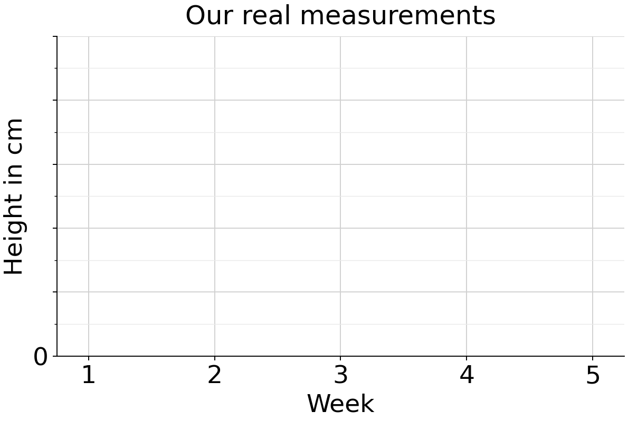
Leave a gap for unavailable values.
One value means one point, without a trend.

