Growth measurements and model graph
Pink supported edition
Record growth (links Science).

Measure carefully
Use the same tray, marked shoot and method.
Read height in centimetres. Do not pull the plant.

Leaves and condition
The adult shows one whole open pea leaf group at the main stem.
Count it once, not each leaflet or tendril.
Describe colour, firmness or leaning.
Taller does not always mean healthier.
Missing measurements stay missing.

Growth measurements and model graph continued
Pink supported edition

Invented model only
Fictional shoot M. Not our plants or a growth target.
Week | Invented height in cm
1 | No shoot visible; no height point
2 | 3
3 | 6
4 | 8
5 | 10

From Week 2 to Week 5: 10 minus 3 = 7 cm.
These figures do not prove a cause.

Growth measurements and model graph continued
Pink supported edition

Invented model graph
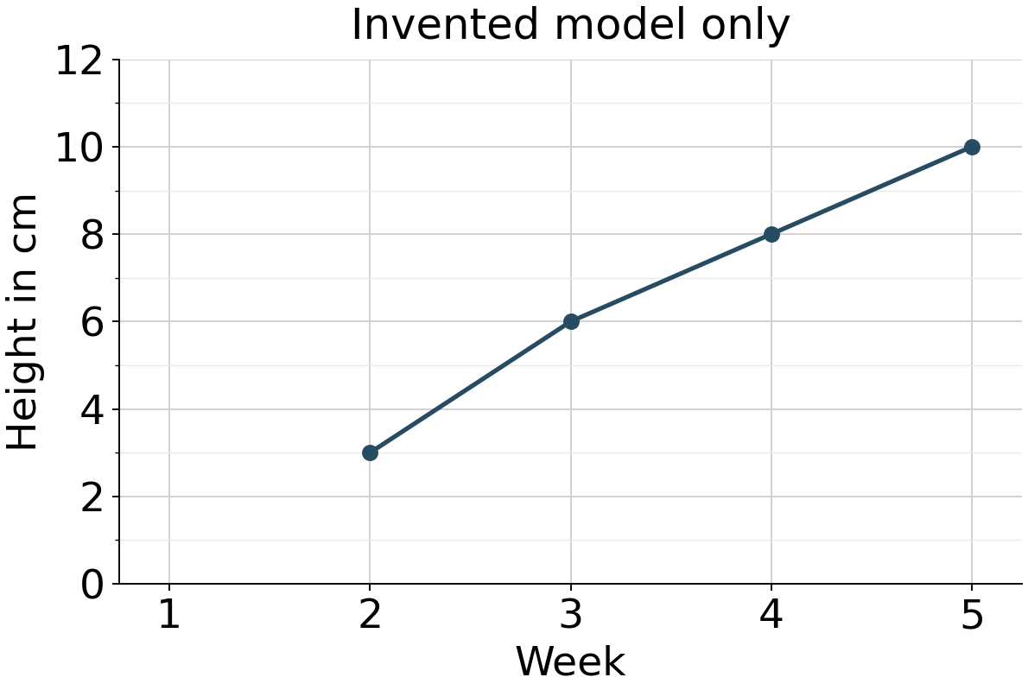
Week goes across. Height in cm goes up.
Week 1 has no height point.
Use only real figures on your own graph.

