A soft breath
Use the soft breath steps you know at school. No force, no hold. You can stop or pick a new card.
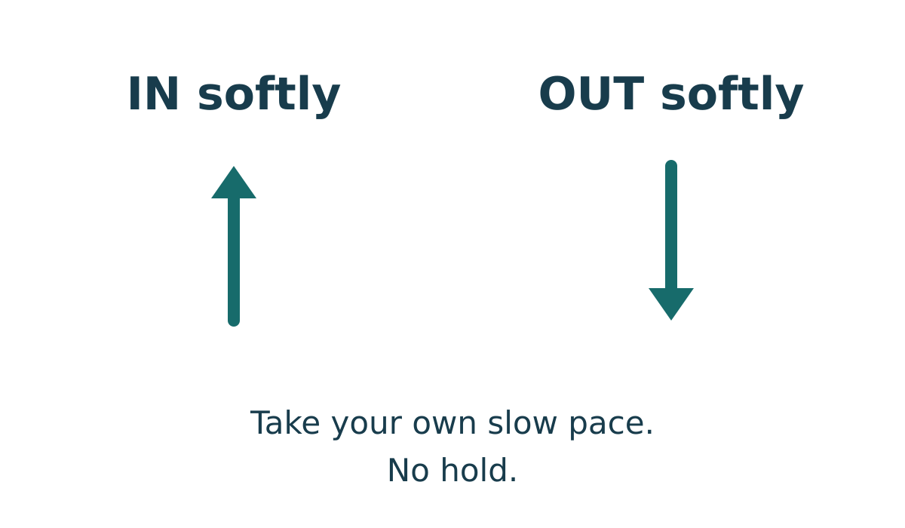
IN softly. OUT softly. Take your own slow pace. No hold.

A soft breath
1. Sit or stand in a safe, comfy way.
2. Use IN for a soft breath in.
3. Use OUT for a soft breath out. Go at your own slow pace.
4. Stop if it does not feel good. Ask for help or change.
Words: in · out · soft · stop.
Start: “In ... . Out ... .”
Model: Soft breath in; soft breath out. No hold.

B and C calm step cards

B look and count
1. Look for three things you can see.
2. Notice two safe points of touch, like feet on the floor and a seat.
3. Notice one sound you can hear.
4. You can stop or pick a new card if this does not suit you.
Use your usual safe aids. Keep eyes open. Do not touch a new thing or a person. Pick a new card if a sound or touch does not suit you.

C small hand move
1. Sit in your usual safe way. Rest your hands where comfy.
2. Open your hands softly.
3. Close them softly, with no tight grip. Let them rest.
4. You can stop or pick a new card if this does not suit you.
Words: three · two · one · open · close · rest.
Start: “First ... . Then ... .”
Model: A uses IN, then OUT, at their own pace.

Three calm stories
All stories are made up. Use them to see a choice. No one has to feel bad to start.

Story A A wait for a turn
A young person waits for a turn. They pick the soft breath card. They look at IN and OUT and try a soft breath.

Story B A new short task
A young person will try a new short task. They pick look and count. They notice things in the room, safe touch and a sound.

Story C A pause in drawing
A young person pauses in a drawing task. They pick the small hand move. They open and close their hands softly, then rest.
Words: breath · count · move · stop.
Start: “They could pick ... .”
Model: Story A picks soft breath. Other safe cards can fit.
You can pass, stop, change or ask for help. You do not have to say what made you feel a big feeling.

My calm step keep card
Keep this card in your book or the place you use for aids. Pick one. You can stop, change or pass.

A soft breath
1. Sit or stand in a safe, comfy way.
2. Use IN for a soft breath in.
3. Use OUT for a soft breath out. Go at your own slow pace.
4. Stop if it does not feel good. Ask for help or change.

B look and count
1. Look for three things you can see.
2. Notice two safe points of touch, like feet on the floor and a seat.
3. Notice one sound you can hear.
4. You can stop or pick a new card if this does not suit you.

C small hand move
1. Sit in your usual safe way. Rest your hands where comfy.
2. Open your hands softly.
3. Close them softly, with no tight grip. Let them rest.
4. You can stop or pick a new card if this does not suit you.
My card choice
Did it help? | My tick
Yes
A bit
No
Not sure
All four answers are OK. The tick is your own. An adult can mark what you pick. Ask a trusted adult in private if you need help.

Aids for each task
Keep words, start and model in view. Usual aids stay.

Starter
Words: card, help, stop
Start: They could pick ... .
Model: Story A picks the soft breath card.

Model check
Words: in, out, soft, stop
Start: In ... . Out ... .
Model: Soft breath in; soft breath out. No hold.

Guided count and move
Words: three, two, one, open, close, rest
Start: First ... . Then ... .
Model: A uses IN, then OUT, at their own pace.

Private hinge
Words: card, own, prompt, help
Start: They can use ... .
Model: A uses the card; the adult does not give each step.

Aids for your chosen try

Choose and plan
Words: breath, count, move, stop
Start: They could pick ... .
Model: Story A picks soft breath. Other safe cards can fit.

Timed practice and check
Words: card, try, stop, yes, no
Start: My card is ... . Did it help? ... .
Model: A tries with the card. The help tick is their own.

Feedback and exit
Words: card, help, next
Start: A next step could be ... .
Model: A can keep the card and ask for help next time.

A quiet try
Pick and set up first. An adult runs a quiet visual timer for up to 30 seconds. No alarm. Stop sooner if you wish. It does not time breaths.

Own check
Yes · A bit · No · Not sure. All four answers are OK. The tick is your own.

Help in private
Point to HELP. Ask a trusted adult in private. Use the school help route. If the adult is busy, ask another through that route. You can pass, stop or come back with help.

