Resource use and carbon dioxide
  - Pupil resources | LAUNCH Humanities Summer 1 Week 1
Explain resource use and climate change using online data.
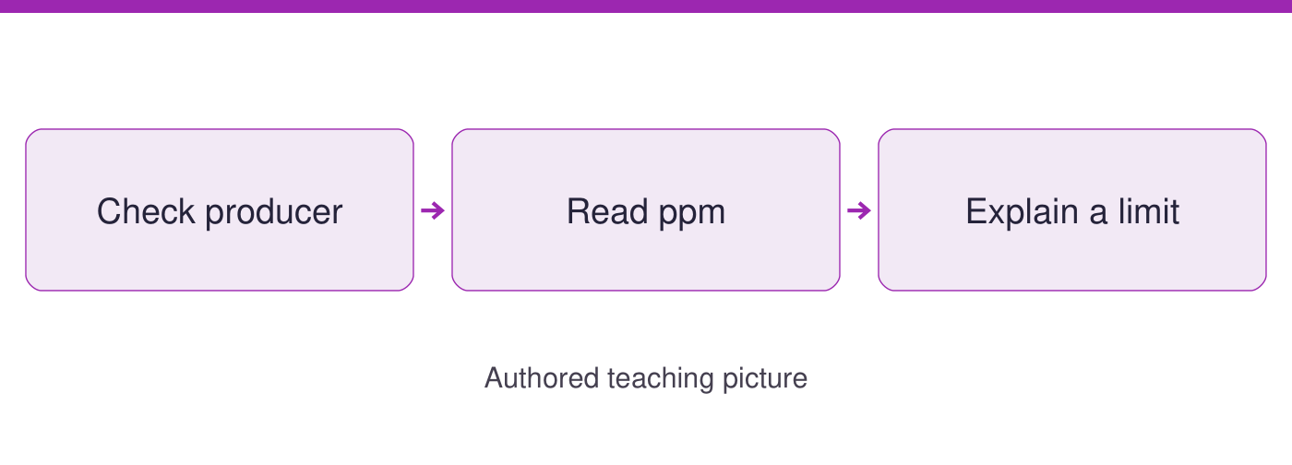
Use the evidence cards and blank spaces to give your own response. Speak, point, draw, type or write.
Start here: provenance means who made a source, when and why. Read cards A and D for units and values; no earlier lesson is needed.

Evidence cards
  - Check the source and limit before using a detail

A The measured record
NOAA Global Monitoring Laboratory publishes the Mauna Loa annual mean CO2 series to monitor atmospheric change. File created 5 September 2026; accessed 21 September 2026. The selected values run from 338.76 ppm in 1980 to 427.35 ppm in 2025.
Source: NOAA GML annual mean CO2 file; 2026 release
Limit: One observatory record is not the global average. The selected years omit changes between them; values can be revised.

B Explaining the cause
NASA explains that burning fossil fuels releases CO2 and that greenhouse gases slow heat loss to space. This connects resource use for energy with climate change. NASA made this public science explanation; page updated 13 July 2026, read 21 September 2026.
Source: NASA Causes; public explanation, updated 2026
Limit: This explanation supports a mechanism. The selected CO2 table is not a temperature record.

C A weaker claim
AUTHORED EXAMPLE created for this lesson on 21 September 2026: an unattributed post says CO2 figures prove every place warmed by the same amount. Its imagined purpose is to persuade, but it supplies no author, measurement method or evidence.
Source: Authored source-critique example; not a real post
Limit: A confident claim is not a measurement. Do not use this invented post as evidence about climate.

D What the unit measures
NOAA states that CO2 is expressed as a mole fraction in dry air, abbreviated ppm. Read ppm as parts per million. The producer is NOAA GML; the file dated 5 September 2026 makes monitoring data available for scientific and public use.
Source: NOAA GML file header; accessed 21 September 2026
Limit: Concentration is evidence about a cause of warming, not a reading of temperature. Keep those quantities separate.

NOAA Mauna Loa annual mean CO2 selected years
  - Selected annual means
Units: ppm (parts per million), dry air
Year | CO2 ppm
1980 | 338.76
1990 | 354.45
2000 | 369.71
2010 | 390.10
2020 | 414.21
2025 | 427.35
Source: NOAA GML annual mean CO2 file, created 5 September 2026; accessed 21 September 2026.
https://gml.noaa.gov/webdata/ccgg/trends/co2/co2_annmean_mlo.csv
One observatory is not the global average. CO2 concentration is evidence of a cause, not a measure of temperature. Selected years omit intervening values; data can be revised.
My annotations: producer, date and purpose
________________________________________________________________
________________________________________________________________
A pattern using two values
________________________________________________________________
________________________________________________________________

Arrival task
  - Supported
Start here: provenance means who made a source, when and why. Read cards A and D for units and values; no earlier lesson is needed.

1 Who produced card A?
Help: Read its source line.
My response
________________________________________________________________

2 Which unit is printed for CO2?
Help: Use the table heading and card D.
My response
________________________________________________________________

3 Which selected year has the highest value?
Help: Compare the six rows.
My response
________________________________________________________________

4 Can this table give the air temperature?
Help: Read card D.
My response
________________________________________________________________

Arrival task
  - Standard
Start here: provenance means who made a source, when and why. Read cards A and D for units and values; no earlier lesson is needed.

1 What does provenance ask us to check?
Help: Use the glossary.
My response
________________________________________________________________

2 Name the first and last selected values.
Help: Read the endpoint rows.
My response
________________________________________________________________

3 How does NASA link fossil fuels to CO2?
Help: Read card B.
My response
________________________________________________________________

4 Why is card C weaker for a factual claim?
Help: Check its authorship and evidence.
My response
________________________________________________________________

Arrival task
  - Stretch
Start here: provenance means who made a source, when and why. Read cards A and D for units and values; no earlier lesson is needed.

1 Why does a clear source date matter?
Help: Compare an observation year with file date.
My response
________________________________________________________________

2 Does a rise between selected rows describe every intervening year?
Help: Look at the gaps in years.
My response
________________________________________________________________

3 Can one observatory equal a global average?
Help: Read the limit on card A.
My response
________________________________________________________________

4 What extra evidence would test a temperature claim?
Help: Name the quantity needed.
My response
________________________________________________________________

Shared investigation
  - Use the evidence; explain and check together
1. Read cards A to D. Check producer, date and purpose, then annotate the six NOAA rows and distinguish the authored weak source.
2. Plot the checked table with year and ppm labels. Describe its pattern, connect fossil-fuel use with CO2 using NASA, and state a limit.
Horizontal axis / vertical axis / units
________________________________________________________________
________________________________________________________________
Pattern using two checked values
________________________________________________________________
________________________________________________________________
Resource use, CO2 and the source of my explanation
________________________________________________________________
________________________________________________________________
A limitation of the evidence
________________________________________________________________
________________________________________________________________

Independent task
  - Supported
Explain resource use and climate change using online data.
1. Read the highlighted 1980 and 2025 rows and label the units with the word bank.
2. Check the plotted values with an adult reader, then annotate producer and date.
3. Independently explain one resource-use link using card B and one limit.
Help: Use highlighted evidence and the frame. An adult may read or scribe your own words.
Producer date purpose and unit
________________________________________________________________
Pattern with two checked values
________________________________________________________________
Resource-use explanation and source
________________________________________________________________
Evidence limit and next check
________________________________________________________________
Further challenge: Explain a second detail if ready.

Independent task
  - Standard
Explain resource use and climate change using online data.
1. Annotate producer, date, purpose and units for the NOAA table.
2. Plot all six rows and describe a pattern with two values.
3. Independently explain the resource-use link and compare the usefulness of cards A and C.
Help: Use the cards and organiser. Choose your own evidence and explanation.
Producer date purpose and unit
________________________________________________________________
Pattern with two checked values
________________________________________________________________
Resource-use explanation and source
________________________________________________________________
Evidence limit and next check
________________________________________________________________
Further challenge: Compare your reasoning with one alternative.

Independent task
  - Stretch
Explain resource use and climate change using online data.
1. Audit the selected years, provenance and the distinction between concentration and temperature.
2. Plot all six rows; explain what the missing intervening years could conceal.
3. Use NASA to explain the mechanism without claiming the table alone proves every impact.
4. Independently justify the stronger source and propose a further evidence check.
Help: Use the source limits and test a different priority or assumption.
Producer date purpose and unit
________________________________________________________________
Pattern with two checked values
________________________________________________________________
Resource-use explanation and source
________________________________________________________________
Evidence limit and next check
________________________________________________________________
Further challenge: Propose a further evidence check and explain its value.

Exit tickets
  - Use your chosen route and give your own response

Supported
1. Name a selected CO2 value with its unit. Use a named detail and your own explanation.
________________________________________________________________
2. Give one limit of that record. Use a named detail and your own explanation.
________________________________________________________________

Standard
1. Explain the resource-use link with a source. Use a named detail and your own explanation.
________________________________________________________________
2. What can the selected table not establish? Use a named detail and your own explanation.
________________________________________________________________

Stretch
1. Why is your chosen evidence more useful than the weak example? Use a named detail and your own explanation.
________________________________________________________________
2. Which further check would strengthen your explanation? Use a named detail and your own explanation.
________________________________________________________________

