Judging climate responses
  - Pupil resources | LAUNCH Humanities Summer 1 Week 2
Evaluate responses to climate change.
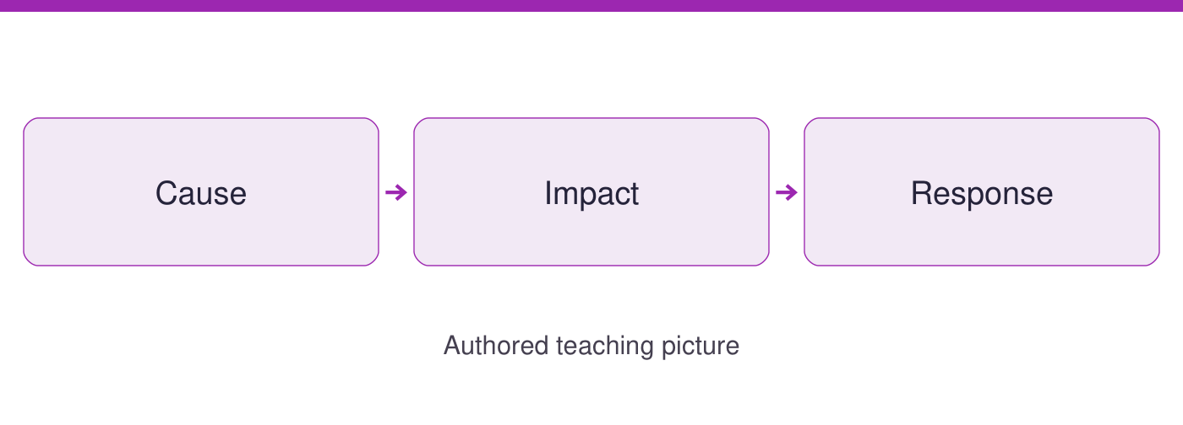
Use the evidence cards and blank spaces to give your own response. Speak, point, draw, type or write.
Start here: a cause contributes to change, an impact is an effect, and a response is an action. Cards A to C supply the climate examples.

Evidence cards
  - Check the source and limit before using a detail

A Cause impact response
NASA links fossil-fuel burning to added CO2. Its response page describes sea-level rise as a climate impact and flood defences as an adaptation example. Keep cause, impact and response in separate parts of the decision grid.
Source: NASA Causes; NASA Mitigation and Adaptation
Limit: A general example does not establish the risk at our school.

B Mitigation option
Mitigation reduces greenhouse-gas emissions or increases their removal. AUTHORED OPTION: an adult reviews avoidable fossil-fuel energy use in a community building. Intended benefit: reduce a source of emissions. Check actual energy use before claiming a saving.
Source: NASA Mitigation and Adaptation; authored application
Limit: Reducing emissions does not instantly remove existing climate impacts. Costs and feasibility need local evidence.

C Adaptation option
Adaptation adjusts to actual or expected climate impacts. AUTHORED OPTION: a community assesses flood protection. Intended benefit: reduce exposure to a stated impact. Use a checked local risk assessment before choosing a design.
Source: NASA Mitigation and Adaptation; authored application
Limit: A flood defence is not, by itself, a reduction in fossil-fuel emissions. Do not promise protection everywhere.

D The decision test
Use a response grid: stated problem, response type, expected benefit, limitation and evidence needed. Different choices can be justified with different priorities. Our options are authored scenarios, not approved works or instructions to pupils.
Source: Authored evaluation framework, 21 September 2026
Limit: The classroom cards cannot establish a real building budget, energy saving or flood risk.

Arrival task
  - Supported
Start here: a cause contributes to change, an impact is an effect, and a response is an action. Cards A to C supply the climate examples.

1 What does mitigation target?
Help: Read card B.
My response
________________________________________________________________

2 What does adaptation target?
Help: Read card C.
My response
________________________________________________________________

3 Is fossil-fuel burning a cause or a response in card A?
Help: Follow the CO2 link.
My response
________________________________________________________________

4 Which option concerns flood protection?
Help: Read the option titles.
My response
________________________________________________________________

Arrival task
  - Standard
Start here: a cause contributes to change, an impact is an effect, and a response is an action. Cards A to C supply the climate examples.

1 How do cause and impact differ?
Help: Use the separate examples on card A.
My response
________________________________________________________________

2 What intended benefit does mitigation offer?
Help: Read card B.
My response
________________________________________________________________

3 What limitation applies to the flood option?
Help: Read card C.
My response
________________________________________________________________

4 Can a general NASA source establish our school’s flood risk?
Help: Check coverage.
My response
________________________________________________________________

Arrival task
  - Stretch
Start here: a cause contributes to change, an impact is an effect, and a response is an action. Cards A to C supply the climate examples.

1 Why might a community use both response types?
Help: Compare their targets.
My response
________________________________________________________________

2 Why is a promised saving not a measured saving?
Help: Think about baseline and follow-up.
My response
________________________________________________________________

3 What evidence could change a response choice?
Help: Use the decision grid.
My response
________________________________________________________________

4 How can people disagree without rejecting the evidence?
Help: Consider priorities.
My response
________________________________________________________________

Shared investigation
  - Use the evidence; explain and check together
1. Place cause, impact and response in the decision grid using card A. Work through the three decision cards and explain each match.
2. Compare mitigation and adaptation: benefit, limitation and needed evidence. Agree a provisional choice for an authored scenario and justify it.
Cause | Impact | Response
Approach | Benefit and source | Limitation
Mitigation
Adaptation
My justified choice
________________________________________________________________
________________________________________________________________

Independent task
  - Supported
Evaluate responses to climate change.
1. Use the cause, impact and response labels with card A.
2. Complete one mitigation/adaptation row using highlighted benefit and limit details.
3. Independently choose a response for the stated problem and give a reason.
Help: Use highlighted evidence and the frame. An adult may read or scribe your own words.
Problem and response type
________________________________________________________________
Benefit and supporting source
________________________________________________________________
Limitation and evidence needed
________________________________________________________________
Preferred response and reason
________________________________________________________________
Further challenge: Explain a second detail if ready.

Independent task
  - Standard
Evaluate responses to climate change.
1. Complete the grid for both mitigation and adaptation options.
2. Use a cited detail to identify a benefit and a limitation of each.
3. Independently choose one for a stated problem and explain what needs checking locally.
Help: Use the cards and organiser. Choose your own evidence and explanation.
Problem and response type
________________________________________________________________
Benefit and supporting source
________________________________________________________________
Limitation and evidence needed
________________________________________________________________
Preferred response and reason
________________________________________________________________
Further challenge: Compare your reasoning with one alternative.

Independent task
  - Stretch
Evaluate responses to climate change.
1. Compare each response against the same problem, timescale and evidence needs.
2. Explain why mitigation and adaptation can complement one another.
3. Challenge one unsupported promise in an option discussion.
4. Independently justify a choice and a condition that could change it.
Help: Use the source limits and test a different priority or assumption.
Problem and response type
________________________________________________________________
Benefit and supporting source
________________________________________________________________
Limitation and evidence needed
________________________________________________________________
Preferred response and reason
________________________________________________________________
Further challenge: Propose a further evidence check and explain its value.

Exit tickets
  - Use your chosen route and give your own response

Supported
1. Name a response and its type. Use a named detail and your own explanation.
________________________________________________________________
2. Give one benefit or limit. Use a named detail and your own explanation.
________________________________________________________________

Standard
1. Justify one response using evidence. Use a named detail and your own explanation.
________________________________________________________________
2. What local evidence is still needed? Use a named detail and your own explanation.
________________________________________________________________

Stretch
1. How could mitigation and adaptation complement each other? Use a named detail and your own explanation.
________________________________________________________________
2. Which condition could change your choice? Use a named detail and your own explanation.
________________________________________________________________

