A measurable community contribution
  - Pupil resources | LAUNCH Humanities Summer 1 Week 5
Link learning to local action with Community Project links.
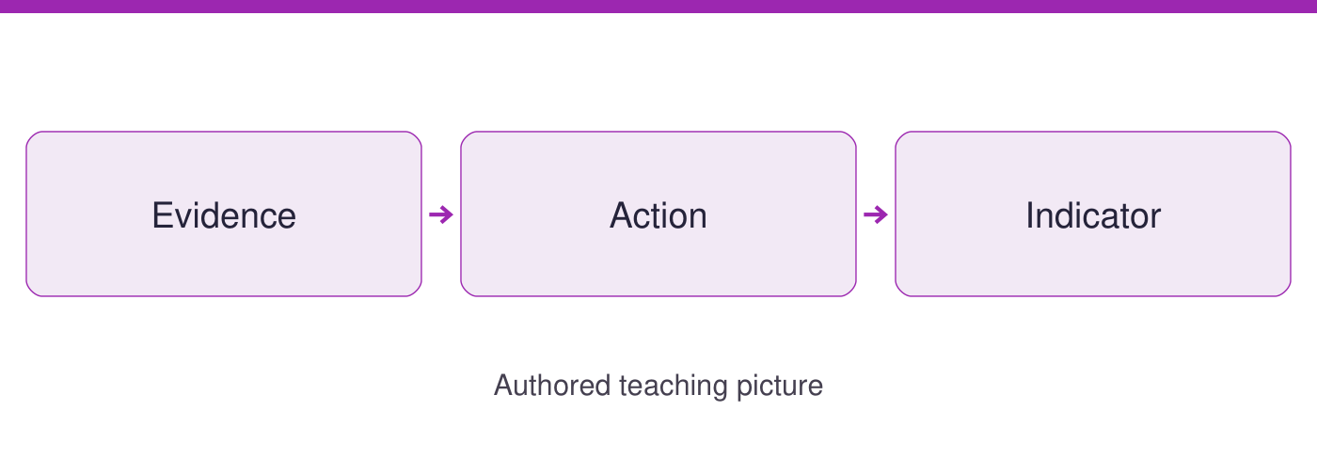
Use the evidence cards and blank spaces to give your own response. Speak, point, draw, type or write.
Start here: a baseline is a starting count; an indicator checks progress. Card B gives a complete labelled practice example if local evidence is unavailable.

Evidence cards
  - Check the source and limit before using a detail

A Use local evidence first
The teacher supplies a dated, anonymised record of new sheets issued for one repeated classroom task. Label the task, period, group size and counting method. If no record is available, use card B as AUTHORED PRACTICE, not a fact about our school.
Source: Teacher-supplied evidence requirement; authored method
Limit: No real school count or Teesside claim is supplied in this pack.

B Practice before and after
AUTHORED PRACTICE: the same task uses 12 new sheets before a reuse tray and 8 during the trial, with the same group size. The difference is 4 fewer new sheets. These numbers are invented to practise comparison.
Source: Authored practice record, 21 September 2026
Limit: One trial does not prove the tray caused the change. Task difficulty, attendance or counting could differ in real use.

C Roles for a small action
AUTHORED PLAN: the adult checks permission and suitable paper. A tray monitor organises clean sheets. A recorder counts new sheets issued; a checker repeats the count. Agree a review date and rotate pupil roles. No names go in the shared record.
Source: Authored Community Project planning example
Limit: Pupils do not handle confidential paper, electrical equipment or household records.

D Check the contribution
Use the same task, group size and counting rule when comparing. An indicator is new sheets issued per repeated task; a proposed target is fewer than the baseline, not a promised result. Share an anonymised conclusion with the class and agree one next check.
Source: Authored indicator and review framework
Limit: A sheet count is not a CO2 measurement. Do not claim an emissions saving from these numbers.

Arrival task
  - Supported
Start here: a baseline is a starting count; an indicator checks progress. Card B gives a complete labelled practice example if local evidence is unavailable.

1 What is a baseline?
Help: Use the glossary.
My response
________________________________________________________________

2 How many new sheets are in the practice baseline?
Help: Read card B.
My response
________________________________________________________________

3 How many are in the practice trial?
Help: Read card B.
My response
________________________________________________________________

4 Are these real school findings?
Help: Read the heading.
My response
________________________________________________________________

Arrival task
  - Standard
Start here: a baseline is a starting count; an indicator checks progress. Card B gives a complete labelled practice example if local evidence is unavailable.

1 What difference do the practice counts show?
Help: Subtract the trial from the baseline.
My response
________________________________________________________________

2 Which role repeats the count?
Help: Read card C.
My response
________________________________________________________________

3 What is the indicator in card D?
Help: Name exactly what is counted.
My response
________________________________________________________________

4 Why keep conditions comparable?
Help: Think about task and group size.
My response
________________________________________________________________

Arrival task
  - Stretch
Start here: a baseline is a starting count; an indicator checks progress. Card B gives a complete labelled practice example if local evidence is unavailable.

1 Does one before-and-after comparison prove cause?
Help: Consider other changing factors.
My response
________________________________________________________________

2 What makes a target measurable?
Help: Name a quantity and period.
My response
________________________________________________________________

3 How could a pupil contribute without handling private paper?
Help: Use the role plan.
My response
________________________________________________________________

4 What would you report if the target was not met?
Help: Separate result from intention.
My response
________________________________________________________________

Shared investigation
  - Use the evidence; explain and check together
1. Build the practice chain: 12 new sheets before, a reuse-tray trial, then a count of 8 using the same task. Identify evidence, action and indicator.
2. Agree adult, monitor, recorder and checker roles. Explain one contribution and a review date; replace practice counts with checked local evidence if available.
AUTHORED PRACTICE | New sheets for the same task
Baseline | 12
Trial | 8
Role | Agreed responsibility
Adult
Monitor
Recorder
Checker
Indicator, target and review date
________________________________________________________________
My contribution and fair comparison
________________________________________________________________

Independent task
  - Supported
Link learning to local action with Community Project links.
1. Use the practice numbers or the teacher’s checked record and label which it is.
2. Choose one role and complete evidence, action and indicator boxes with a frame.
3. Independently explain your contribution and how another person can check it.
Help: Use highlighted evidence and the frame. An adult may read or scribe your own words.
Local or practice evidence and baseline
________________________________________________________________
Action roles and my contribution
________________________________________________________________
Indicator target and review date
________________________________________________________________
Fair-check method and limitation
________________________________________________________________
Further challenge: Explain a second detail if ready.

Independent task
  - Standard
Link learning to local action with Community Project links.
1. Identify one manageable paper-use action from the supplied evidence.
2. Agree roles, baseline, counting rule, proposed target and review date.
3. Independently explain one contribution, its indicator and a limit on the conclusion.
Help: Use the cards and organiser. Choose your own evidence and explanation.
Local or practice evidence and baseline
________________________________________________________________
Action roles and my contribution
________________________________________________________________
Indicator target and review date
________________________________________________________________
Fair-check method and limitation
________________________________________________________________
Further challenge: Compare your reasoning with one alternative.

Independent task
  - Stretch
Link learning to local action with Community Project links.
1. Check whether baseline and trial conditions can be compared fairly.
2. Plan roles and a measurable indicator with an anonymised recording method.
3. Explain another factor that could change the result and how to check it.
4. Independently justify your contribution and the next action if the target is not met.
Help: Use the source limits and test a different priority or assumption.
Local or practice evidence and baseline
________________________________________________________________
Action roles and my contribution
________________________________________________________________
Indicator target and review date
________________________________________________________________
Fair-check method and limitation
________________________________________________________________
Further challenge: Propose a further evidence check and explain its value.

Exit tickets
  - Use your chosen route and give your own response

Supported
1. Name your role and contribution. Use a named detail and your own explanation.
________________________________________________________________
2. What will be counted and when? Use a named detail and your own explanation.
________________________________________________________________

Standard
1. Explain how your contribution supports the action. Use a named detail and your own explanation.
________________________________________________________________
2. How will the indicator be checked fairly? Use a named detail and your own explanation.
________________________________________________________________

Stretch
1. What other factor could affect the result? Use a named detail and your own explanation.
________________________________________________________________
2. How would you improve the action or its measurement? Use a named detail and your own explanation.
________________________________________________________________

