Job cards
White Standard sheet
Make a choice and say why.

A Sort cards
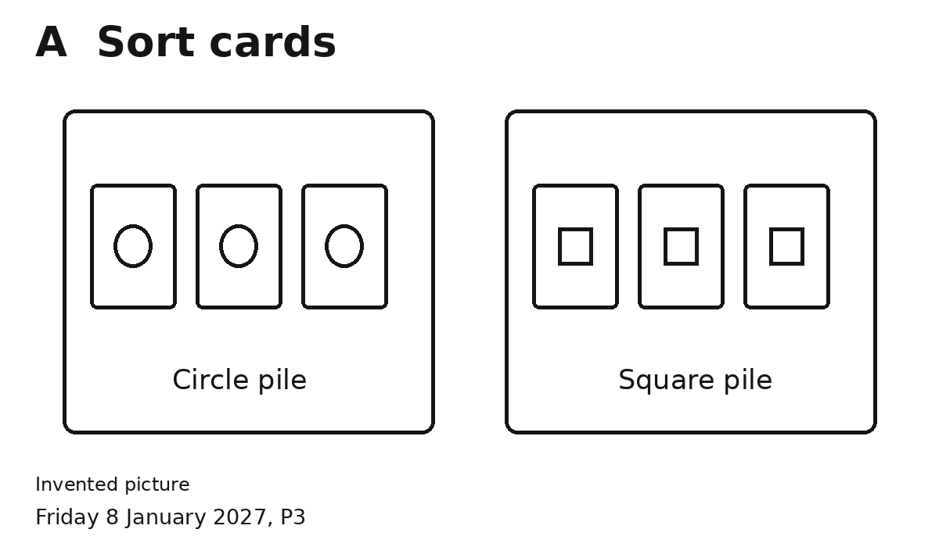
You have six cards.
1 Count or set your space first.
2 Do the other one.
3 Put the same shapes in a pile.
4 Check each pile.
I chose this job because ...

B Pack cards
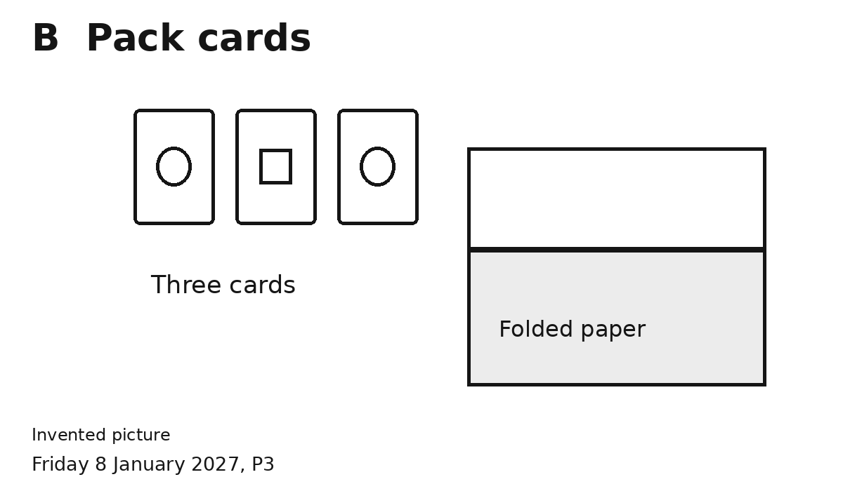
You need three cards.
1 Count or set your space first.
2 Do the other one.
3 Put three cards in the fold.
4 Open it. Count three. Close it.
I chose this job because ...
Ask for help or a break.

