Our role choice
Pink Supported sheet
Work with a partner to complete a task.
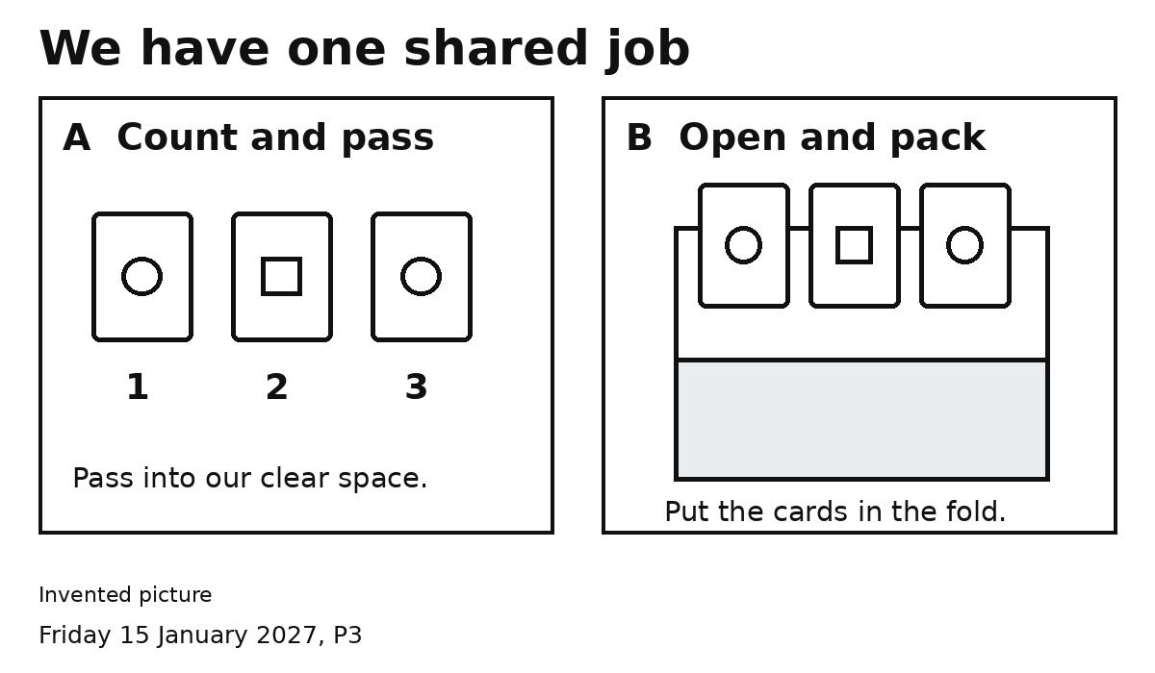
A I count three cards and pass them.
B I open the fold and put them in.
Both We check three cards together.
My pick: A or B
My partner picks the other role.
Pick together. Ask for help.

