Our visible turn cards
White Standard sheet
Take turns and share a role.
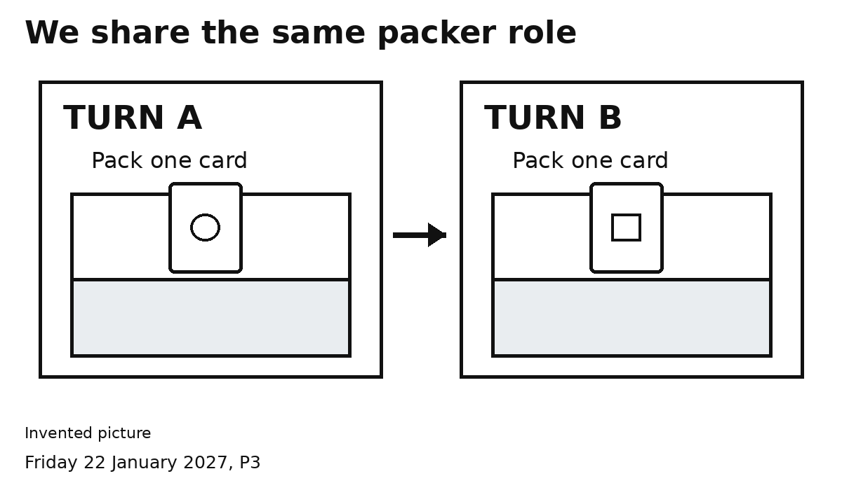

A TURN
A packs one card. B waits.

B TURN
B packs one card. A waits.
Point to A or B to show the turn.
We share the same packer job.

Our swap signal

SWAP
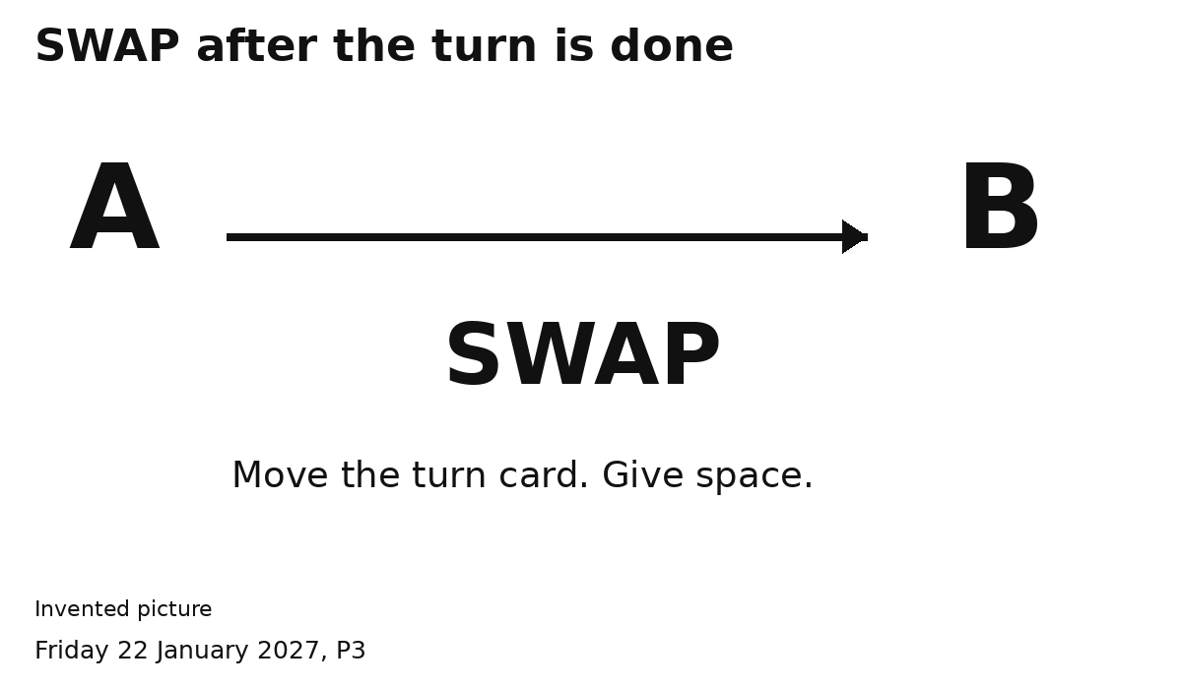
1 Finish putting one card in.
2 Put hands clear of the shared space.
3 Show or say SWAP.
4 Point to the other turn card.
My turn. Your turn.

