My turn and your turn record
White Standard sheet
Take turns and share a role.
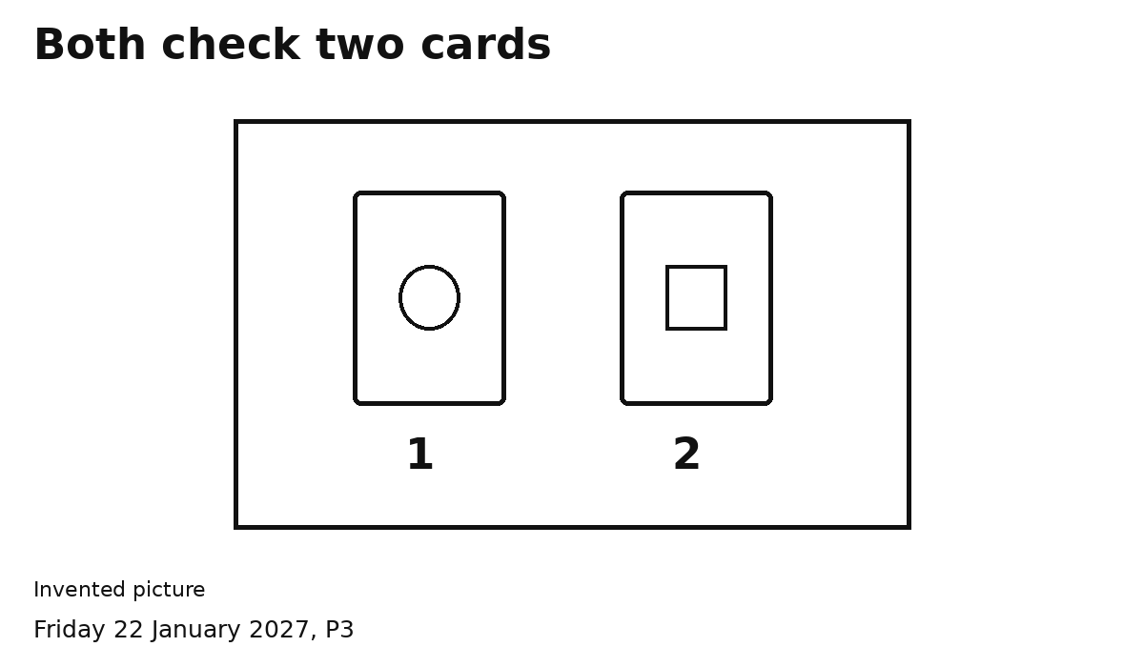

MY TURN
I packed one card.
Point or tick: Yes / Not yet

YOUR TURN
My partner packed one card.
Point or tick: Yes / Not yet
We both shared the packer role. We checked two cards.
Ask an adult to write if you wish.

