Our turn taking task
Pink Supported sheet
Take turns and share a role.
We help in a small packing room. It is made up.
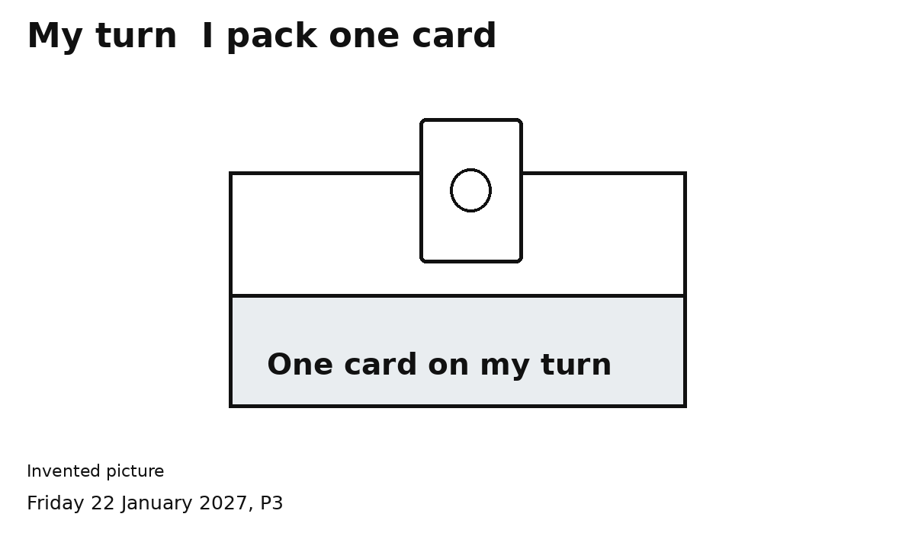
We both do the packer job.
1 Pack one card on your turn.
2 Show SWAP. Let your partner pack.
Check two cards together.
My turn. Your turn.
You can point or speak. Ask for help.

