Our problem solving job card
White Standard sheet
Solve a simple everyday problem.
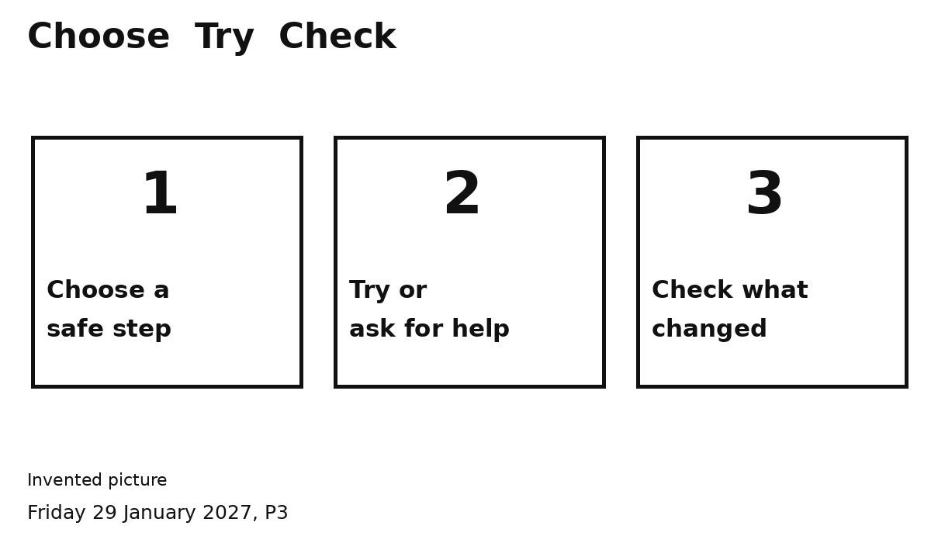
1 Look. What is the problem?
2 Pick a safe step.
3 Try it or get adult help.
4 Check what changed.
For a spill: STOP. Stay back. Tell an adult.
The adult deals with the spill.

