Our workplace problem cards
Pink Supported sheet
Solve a simple everyday problem.

A missing card
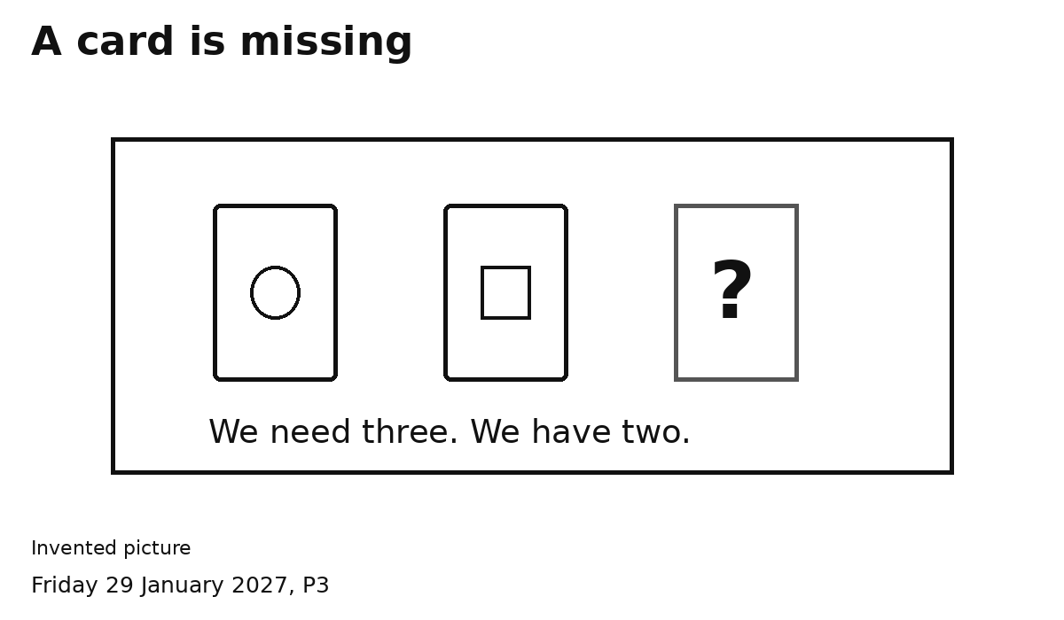
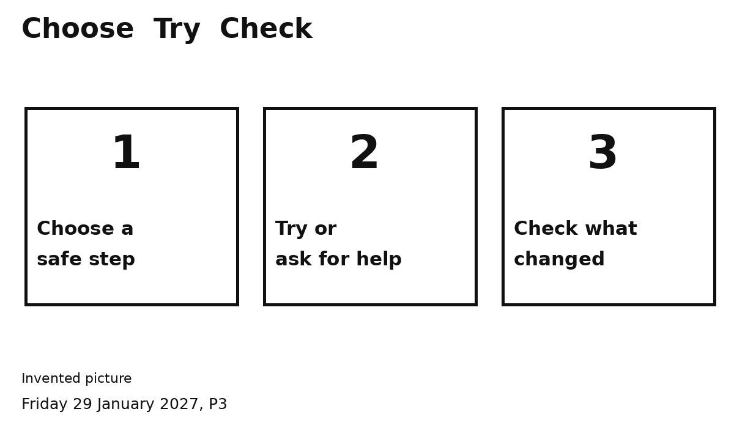
1 Look for one card or ask an adult.
2 Count again. Have we got three?

A picture spill
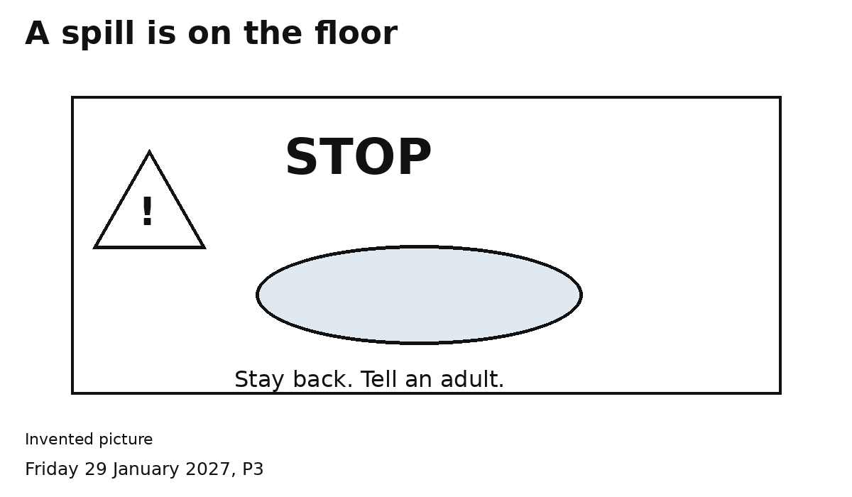
1 STOP. Stay back. Tell an adult.
2 Check the adult knows. Keep clear.
This is a pretend spill. An adult deals with it.

A pretend customer waiting
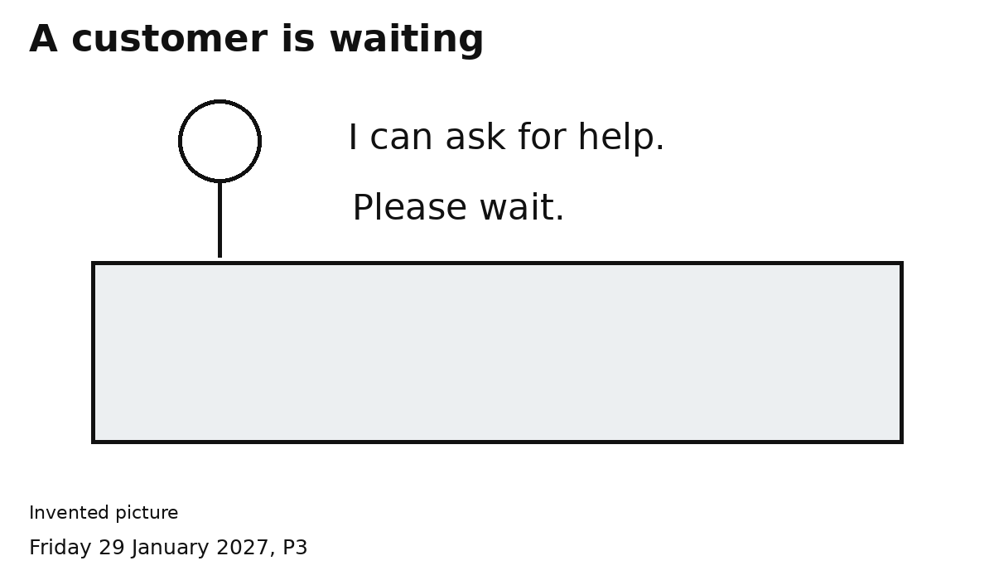
1 Show Please wait. Ask an adult.
2 Check the adult knows.
The customer is pretend. We ask for help.

