My packing job card
Pink Supported sheet
Follow instructions in a practical task.
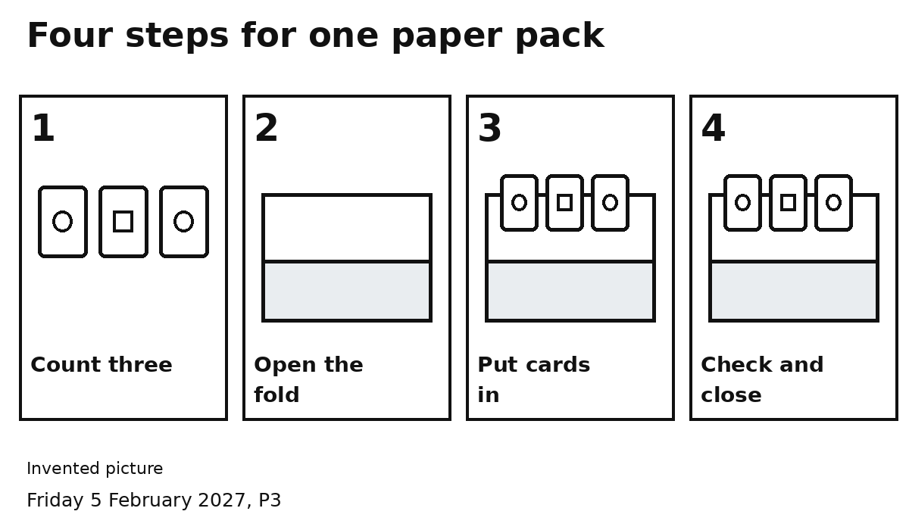

Steps 1 and 2
Count three cards. Open the fold.

Steps 3 and 4
Put three cards in. Check three. Close the fold.
My checker can point to the next step.
I can ask for one step to be shown.

