My packing job card
White Standard sheet
Follow instructions in a practical task.
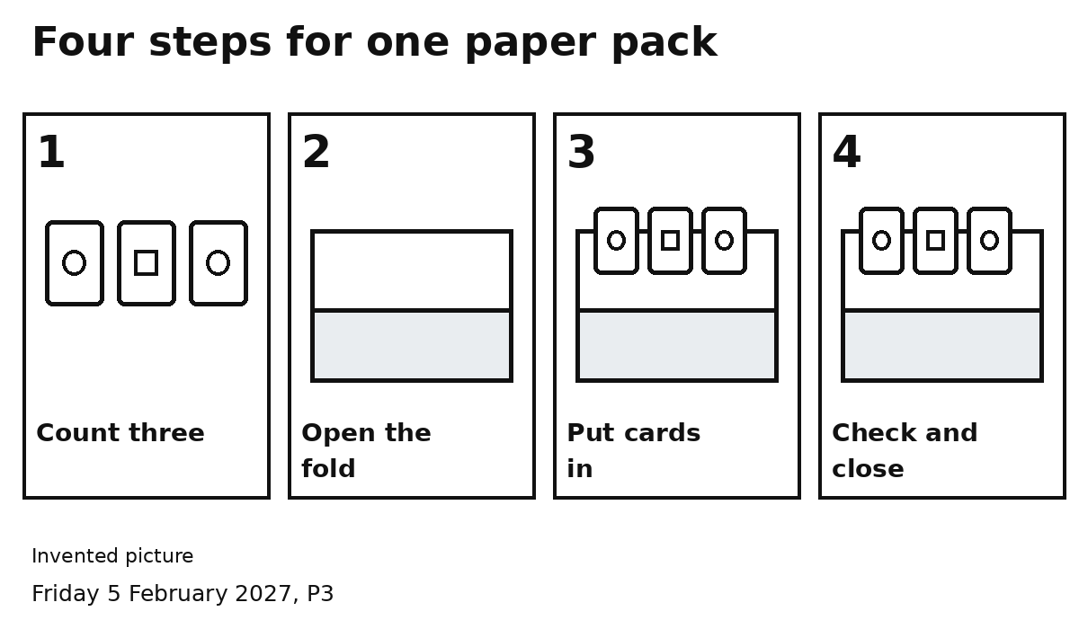
1 Count three cards.
2 Open the folded sheet.
3 Put three cards inside.
4 Check three cards. Close the fold.
My checker can point to the next step.
I can ask for one step to be shown.

